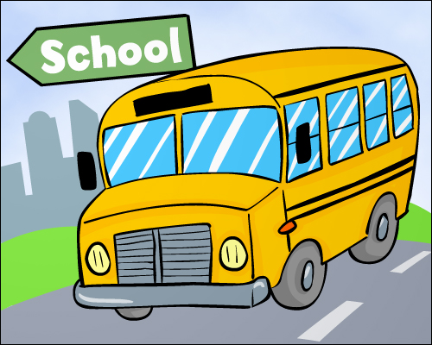
This Week in 2S
O
October 1-5, 2012

Literacy

For Daily 5, we will introduce Read to Someone this week. We are working on recounts (writing about something that already happened or retelling something) for writing.

Today, students received their individual spelling lists to practice each night. We will test students on their words each Friday.

Try to get your child to read every night. Books are available if needed.

At-home Literacy activity: Help your child brainstorm ideas for recount writing. Remind them about trips, activities, favourite movies, television shows, or books. This will give them an idea bank so they don’t get stuck trying to come up with a writing topic.

Math

We are working on using a number line to help solve addition and subtraction Math facts for 0-10. We will also begin working on patterns.

At-home Math activity: Review the 0-10 Math facts. Ask them questions to solve (ex: 10 – 3=). If they are having trouble, get them to use objects to help (ex: spoons).

 Communication is important. Please be sure to contact me whenever you need to. I will do the same. I can be reached at the school via telephone, 658-5334) or via e-mail (darrah.sawyer@nbed.nb.ca).

We will be sending home new student information sheets for those who have not yet returned theirs. We need you to check that the information is correct and return the sheet.

Our Book Fair takes place this Wednesday to Friday (October 3 – 5). Classes will visit the fair on Wednesday morning to browse books and students will be called to the library each afternoon if they are planning to buy books. The Book Fair is open from 1:00-3:30 Wednesday and Friday and 1:00-6:00 on Thursday.
Spelling words

- _______________________________

- _______________________________

- _______________________________

- _______________________________

- _______________________________
There is no school next Monday (Thanksgiving) and Tuesday (Professional Learning Day for teachers and educational assistants).

