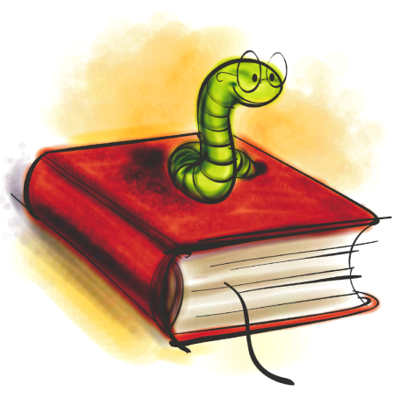Take a look at our new and improved classroom website: http://mrs.mcelman.ca
This Week in Grade 3 M
October 8 - 12, 2012
Monday | Tuesday | Wednesday | Thursday | Friday
8  Thanksgiving  No School | 9  PD for teachers  No School | 10 | 11 | 12 | Hot Lunch and Milk forms due every Friday
15 | 16 | 17 | 18 | 19
22 | 23 | 24 | 25 | 26
29 | 30 | 31  Halloween | Nov 1 | 2
5 | 6 | 7 | 8 | 9
Literacy

- Students have recently started our newest Daily 5 element: Read to Someone. This new activity is always a favourite among students. Students have a chance to read with a partner and work on their fluency.

- Remember – students need to be reading at least 15 minutes every night at home. This is crucial for their continued success throughout Grade 3.

- Writing – Talk to your child about how we use a ‘Go Map’ to help plan and organize our ideas before we begin writing!
Important Info!!!
- Please be sure to send in INDOOR shoes, if you haven’t already.

- We have a brand new classroom website, with lots of info to share. Take a look and see what’s new. AND, don’t forget to check back often for new additions! :o)

- Check out our new and updated school website. http://centennial.nbed.nb.ca
A+
Math
- This week, we will be working on recognizing and creating increasing patterns with both pictures and numbers.

- We will continue looking at the mental math strategies of ‘making 10’ and ‘doubles’.

- This week we are going to attempt a new math structure of Daily 5 Math. It uses a similar structure as in Literacy. Stay tuned for updates on how it goes!

