
This Week in 2S
O
January 21 - 25, 2013

Share a Favourite Book

Each Wednesday a student will be asked to share a favourite book. Sharing this week is: Triftin.

Literacy

This week’s word family is -ake .

This week’s grade two sight words are: caught, I, people, that’s, and will.

For reading, students are trying to use and practice the reading strategy that they each picked. We are also working on fluency – making our reading sound smooth.

February’s writing genre is poetry. For writing, we will begin to explore different types of poetry.

Try to get your child to read every night. Books are available if needed.

At-home Literacy activity: Get your child to make up couplets (a two line rhyming poem) with our weekly word family or sight words.

Math

This week we are going to do a check-in assessment to see where everyone is with their learning of outcomes taught. We will also work on learning about 2D and 3D objects.

At-home Math activity: Practice doubles from 0 to 10 with your child. They are: 0+0, 1+1, 2+2, 3+3, 4+4, 5+5, 6+6, 7+7, 8+8, 9+9, and 10+10. We have been getting the students to understand that if they know these doubles by heart, then they can add any doubles.

Communication is important. Please be sure to contact me whenever you need to. I will do the same. I can be reached at the school via telephone, 658-5334 or via e-mail .(darrah.sawyer@nbed.nb.ca).

February’s Bee Attitude is friendship.

Hot lunch orders for the week of Feb. 11th – Feb. 15th are due Friday.

 Our field trip to the New Brunswick Museum is taking place on Thursday. Don’t forget to send in your child’s permission slip, if you haven’t already done so. If you’ve misplaced the form and need a new one, let us know and we’ll send another home in the Communication Book.

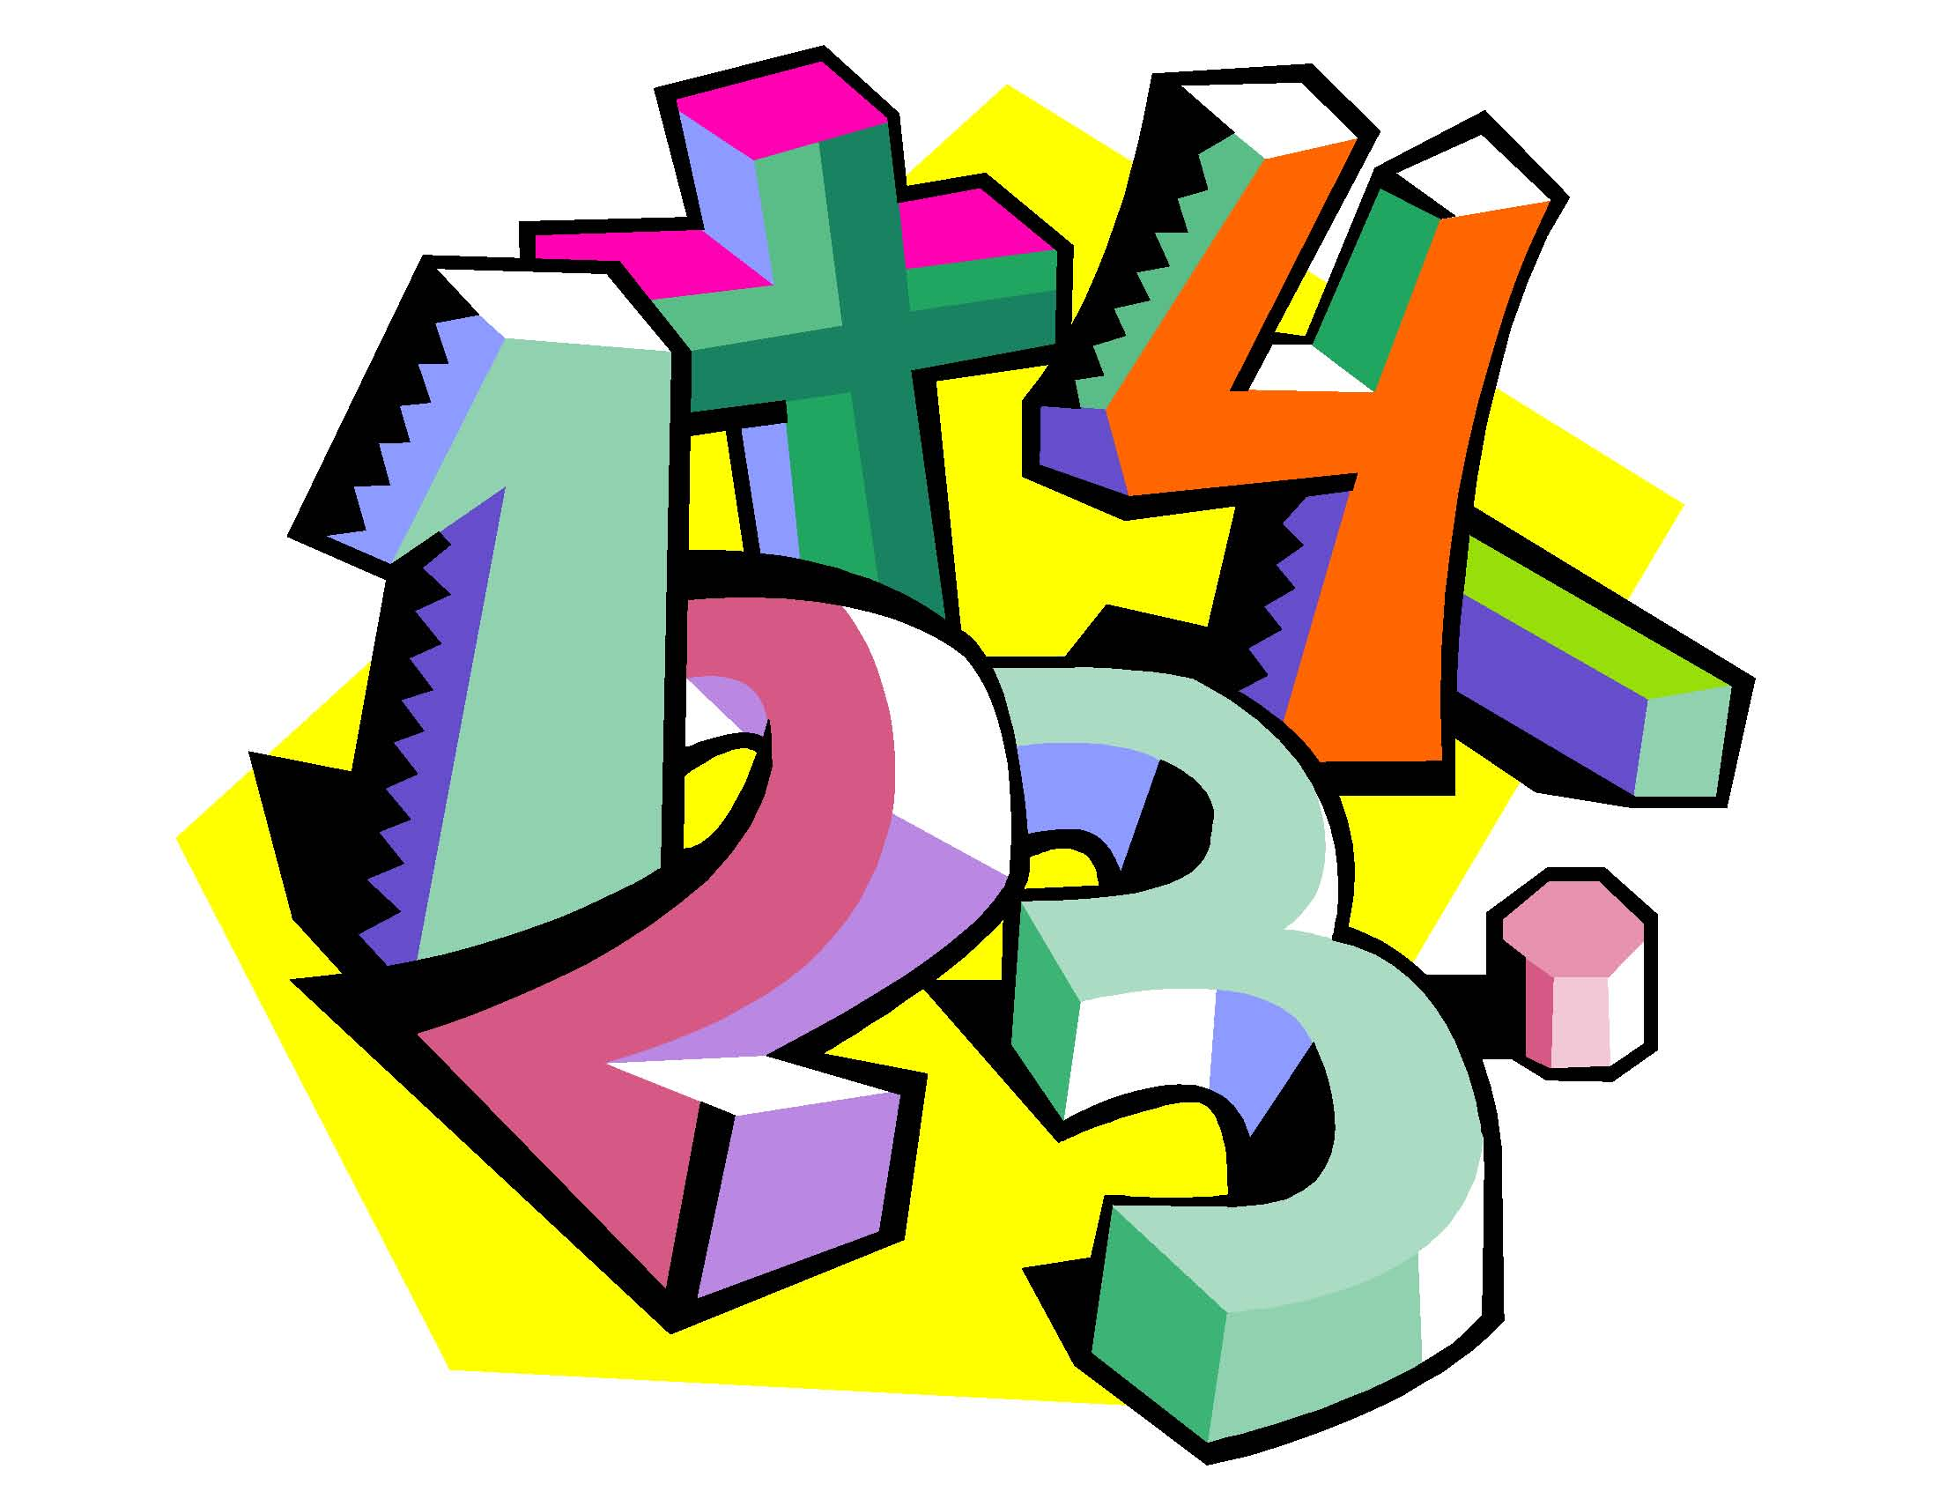For those who sent back their RSVP, don’t forget our Math game parent session taking place on Wednesday at 3:30.
Spelling words

- __________________________________

- __________________________________

- __________________________________

- __________________________________

- __________________________________

