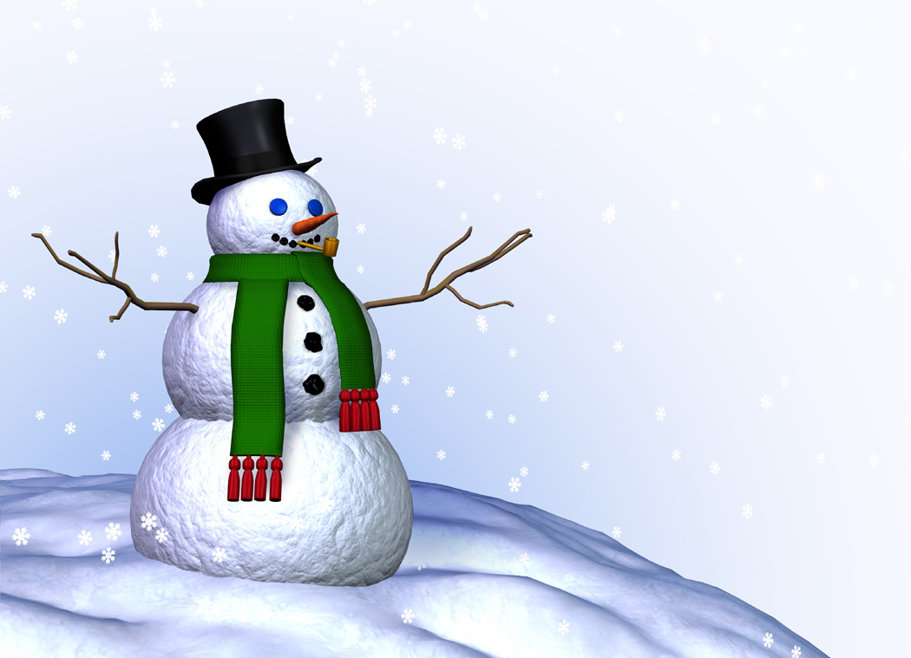
This Week in 2S
O
December 3-7, 2012

Literacy

This week’s word family is -ide .

This week’s grade two sight words are: best, green, not, snap, and went.

In December we will work on letter writing. This week we are finishing up the writing and illustrating of our narratives.

Try to get your child to read every night. Books are available if needed.

At-home Literacy activity: When reading, get your child to pick out the main character(s) in the story and tell you what is happening to them (what the problem may be).

Math

This week’s learning goals are: I can make doubles. I can tell about a strategy to solve doubles. I can answer questions about a graph or pictograph.

At-home Math activity: Keep on practicing basic Math facts. To help, there is a 1-10 addition table that you can keep at home. You can make flash cards or you could ask your child to solve the subtraction question that goes with the addition question (ex: If 2 + 7 = 9, then you ask them what 9 – 2 =).

 Communication is important. Please be sure to contact me whenever you need to. I will do the same. I can be reached at the school via telephone, 658-5334 or via e-mail .(darrah.sawyer@nbed.nb.ca).

Hot lunch forms for the week of Dec. 10th are due Friday.

Spelling words

- _______________________________

- _______________________________

- _______________________________

- _______________________________

- _______________________________

Share a Favourite Book

Each Wednesday a student will be asked to share a favourite book. Sharing this week is: Laura.

We are learning a song called “What I am” with our reading buddies. The song talks about understanding how special we are and never giving up. A copy of the lyrics is included with this newsletter. Get your child to sing it to you. If you have a computer and internet access, then you can get them to sing along to a Sesame Street video of the song. Here is the link: http://www.youtube.com/watch?v=cyVzjoj96vs or you can go to Youtube and type “Sesame Street – What I am song” into the search box.

