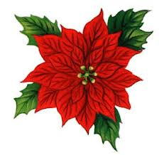
This Week in 2S
O
December 10-14, 2012

Literacy

This week’s word family is -ell .

This week’s grade two sight words are: black, gym, off, sometimes, and were.

For writing, we are working on friendly letters.

Try to get your child to read every night. Books are available if needed.

At-home Literacy activity: Get your child to write you a letter.

Math

This week’s learning goals are: I can ask a question that can be answered by gathering information about myself and others.I can organize data as it is collected using objects, tallies, checkmarks, charts or lists. I can answer questions about a graph or pictograph. I create a graph to display data and draw conclusions.

At-home Math activity: Practice doubles from 1 to 10. Ask questions like “What number will you get if you double 5?” or “What number is doubled to get 12?”

 Communication is important. Please be sure to contact me whenever you need to. I will do the same. I can be reached at the school via telephone, 658-5334 or via e-mail .(darrah.sawyer@nbed.nb.ca).

Hot lunch forms for the week of Dec. 17th are due Friday.

Our annual Christmas Bazaar is on Tuesday, December 18th. Students will do Christmas present shopping for family members at home. Presents cost 25¢.

This year’s Christmas Pageant is on Wednesday, December 19th. More information will be sent home as to the time of the pageant. The snow date for the pageant is Thursday, December 20th.

Friday, December 21st is the last day before Christmas break.

We are fundraising for Harbour Lights. Please send in any spare pennies, if you would like to contribute.

Spelling words

- _______________________________

- _______________________________

- _______________________________

- _______________________________

- _______________________________

Share a Favourite Book

Each Wednesday a student will be asked to share a favourite book. Sharing this week is: Karter.

