November 5 – November 9

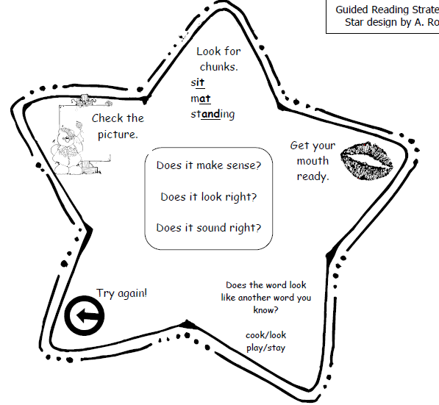
Literacy
We have been working on several reading strategies that help decode unknown words. On the right is a picture of the strategies we have been using in class.
Please try using these strategies with your child this week instead of always using “sounding it out.”

Sight Words & Word Family
an ap
their cap
than tap
can map
we lap
Math!
This week tell your child: “I have 11 spoons and forks. How many of each might I have?” Give your child spoons and forks to find out the different combinations to make 11.

Monday |  | Tuesday | Wednesday | Thursday | Friday
5 |  | 6  CNC | 7  CNC  Book orders | 8  CNC | 9  Hot Lunch $ Due
12  Remembrance  Day!  No School! |  | 13  CNC | 14  CNC | 15  CNC | 16  Hot Lunch $ Due
19 |  | 20  CNC | 21  CNC | 22  CNC | 23  Hot Lunch $ Due
 | 26 | 27  CNC | 28  CNC | 29  CNC | 30  No School Student-Led

Reminders!

- Book orders are due on Wednesday.

- Please listen to your child read and sign their Reading Log each night. This is the only homework I expect your child to complete.

