November 19 – November 23

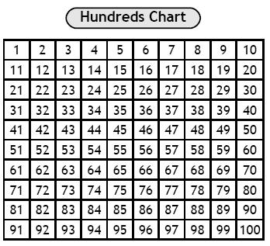
Literacy
This week in reading we are focusing on the strategy “Using expression when reading”. When your child reads with you, have them pay close attention to punctuation and reading with expression.

This week in writing we are working on interesting word choices.
Math

Please work with your child on numbers to 100. You can have them count by 2’s, 5’s, and 10’s. You can also have them count forwards and backwards. Finally you can ask them 1more, 1less, 2more and 2 less than any given number you pick.

Sight Words & Word Family
would ap
out cap
if map
some nap
so tap

Monday |  | Tuesday | Wednesday | Thursday | Friday
5 |  | 6 | 7 | 8 | 9
12  Remembrance  Day!  No School! |  | 13  CNC | 14  CNC | 15  CNC | 16  Hot Lunch $ Due
19 |  | 20  CNC | 21  CNC | 22  CNC | 23  Hot Lunch $ Milk $  Parent Survey
 | 26  Report Cards go home | 27  CNC | 28  CNC  Student-led (evening) | 29  CNC | 30  No School Student-Led  (afternoon)

- Please return Parent survey to me by Friday, November 23rd.

- Report cards go home on Monday, November 26th.

- Milk orders due Friday, November 23rd.

Reminders!

