Giant Hogweed Identification Key:

1. Flower Color
a. Yellow flower - wild parsnip (not giant hogweed) Do not touch this plant! Wild parsnip can cause skin irritation and blistering.
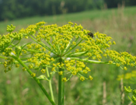
wild parsnip flower
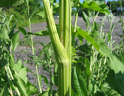
wild parsnip stem - note the grooves
and lack of hairs
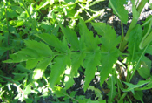
wild parsnip leaf
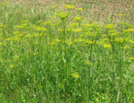
wild parsnip plants
b. White Flower - go to #2.

2. Flower Shape
a. Ball shaped flower - angelica (softball sized and shaped flower) (not giant hogweed)
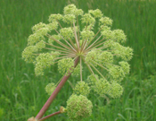
angelica flower
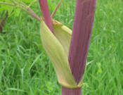
angelica stem

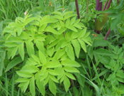
angelica leaves
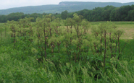
angelica plants
b. Flat-topped - go to #3.

3. Flower Size
a. Small flower cluster (less than 6 inches) - poison hemlock or queen anne's lace (not giant hogweed)
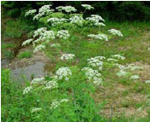
poison hemlock credit:
Brother Alfred Brousseau,
St. Mary's College of CA
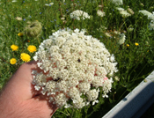
Queen Anne's lace
b. Large flower cluster (greater than 12 inches) - go to #4.

4. Stem
a. Green to slightly purple, no purple blotches, fine/fuzzy hairs, no stiff hairs/bristles - cow parsnip (not giant hogweed) Do not touch this plant! Cow parsnip can cause skin irritation and blistering.
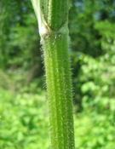
cow parsnip stem
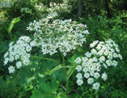
cow parsnip flower

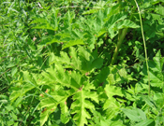
cow parsnip leaves
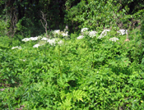
cow parsnip plants
b. Green with extensive purple blotches and stiff white hairs/bristles - giant hogweed
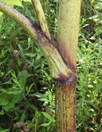
giant hogweed stem

Characteristics of the giant hogweed plant:
1. White flowers (The main flower of giant hogweed has 50-150 flower rays. Cow parsnip has 15-30 flower rays.)
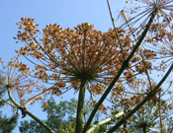
giant hogweed flower in
seed showing 50+ rays
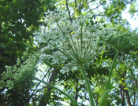
cow parsnip flower showing
15-30 rays
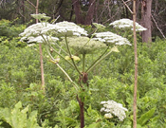
giant hogweed flower
2. more than 8 feet tall (unless previously mowed or cut)
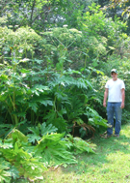
giant hogweed plants
3. Huge leaves, incised and deeply lobed
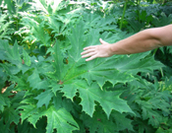
giant hogweed leaf
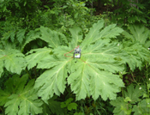
giant hogweed leaf
4. green stem with purple blotches and coarse white hairs
giant hogweed stem

http://www.dec.ny.gov/animals/41009.html

