November
2020
Celebrating Across Cultures
At Centennial we value inclusion & diversity!  We are beginning a new school-wide initiative where we will celebrate a different culture each month. We will begin with celebrating Somalia during the month of November. We would like to extend a special thank you to the Abdi family who will be highlighted this month and sharing some of their family traditions. We are really looking forward to this, thank you!  Please see below some various cultural special occasions for this month! | 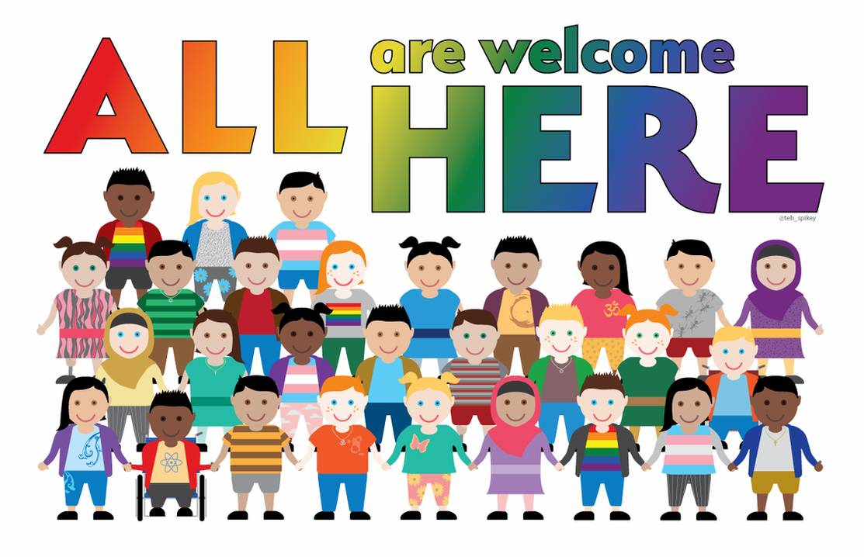
Sunday | Monday | Tuesday | Wednesday | Thursday | Friday | Saturday
1 | 2 | 3 | 4 | 5 | 6 | 7
All Saints’ Day | All Souls’ Day
8 | 9 | 10 | 11 | 12 | 13 | 14
 |  |  | Veterans Day |  |  | Diwali, the Hindu, Jain and Sikh 5 day light festival
15 | 16 | 17 | 18 | 19 | 20 | 21
 |  |  |  |  | Transgender Day of Remembrance
22 | 23 | 24 | 25 | 26 | 27 | 28
Feast of Christ the King |  |  | Nativity Fast begins
29 | 30

