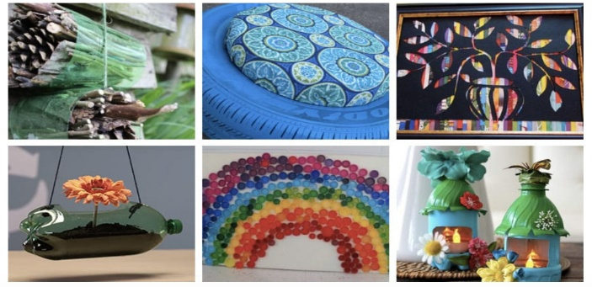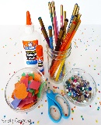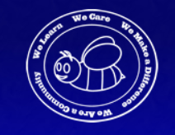

# Science Activity:

# Investigate renewable energy, while exploring the water cycle! Students magically turn salt water into fresh water with the help of solar energy!

# **How to:** 1. Pour 2 cups of water into a large bowl. 2. Mix 3 tsp of salt into the water. Taste the water, it’s super salty! 3. Place a small empty bowl or cup inside of the larger bowl. 4. Cover with plastic wrap and place outside in the sun. 5. Either place a rock on top of the bowl or secure the wrap with a rubber band (to keep plastic wrap tightly secured on the bowl). 6. Keep the bowl outside for 1 to 3 days (until you get enough purified water into your small bowl to taste).

# ***Compare the water in the larger bowl to the water in the smaller bowl. Do you taste the difference?!***

# **The sun’s rays will heat the water, causing it to evaporate! Salt is too heavy to evaporate; so, it stays in the larger bowl. Condensation will occur, creating water droplets on the plastic wrap. Gravity makes the large droplets drip into the “collection container” (your small bowl) – creating fresh water!**

.

Math Activity:

Sort your recycling. Tally how many cans, how many plastic containers and how many paper products you have.

The average Canadian produces 2.7 kg of garbage in a day. How much garbage do they produce in a week?

Maker Challenge:

What can you make out of recycled materials from around your house? Create something useful, something beautiful, or something fun. Reuse or reinvent something. Imagine, Create, Improve. We will feature what you made in an episode of LIVE AT THE HIVE if you Email us a picture to:

Joann.watters@nbed.nb.ca

Centennial Stingers EARTH Day Challenge

April 2020

# Physical Activity:

# Grab some gloves and an adult and go for a walk. Pick up as many pieces of garbage as you can. Count how many pieces of garbage you were able to collect and put in the garbage can.

# Writing Activity:

# Make an Earth Day Pledge. What can you do to help REDUCE/REUSE/RECYLE? Write it down and draw a picture of you keeping your pledge.

**Reading**:

Enjoy The Lorax Read Aloud

<https://www.youtube.com/watch?v=EdWesdMfyd4>



joann.watters@nbed.nb.caoto Caption