December
2020
Celebrating Across Cultures
At Centennial School we value inclusion & diversity!  During the month of December we will be celebrating Dubai, part of the United Arab Emirates. We would like to send a special thank you to the Abdelaal family who will be featured this month and sharing some of their family traditions. Please see below some cultural special occasions for this month! | 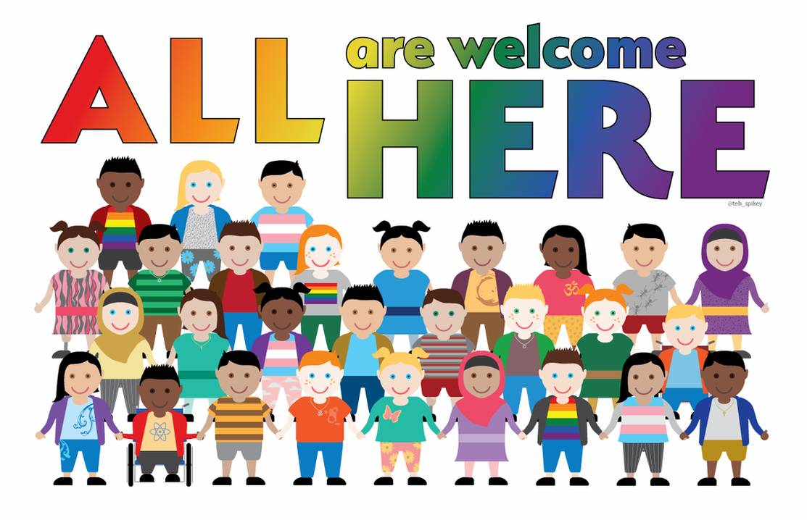
Sunday | Monday | Tuesday | Wednesday | Thursday | Friday | Saturday
 |  | 1 | 2 | 3 | 4 | 5
 |  | World AIDS Day  (United Nations) | International Day of the Abolition of Slavery  (United Nations) | International Day of Persons with Disabilities  (United Nations)
6 | 7 | 8 | 9 | 10 | 11 | 12
National Day of Remembrance and Action on Violence Against Women (Canada) |  | St. Clements of Ohrid Patrons Day  (Christianity) |  | Human Rights Day  (United Nations) | Hanukkah begins  (Judaism)
13 | 14 | 15 | 16 | 17 | 18 | 19
Birthday of Imam Aga Khan  (Islam) |  |  |  |  | International Migrants Day  (United Nations)
20 | 21 | 22 | 23 | 24 | 25 | 26
 |  |  |  |  | Christmas Day  (Canadian Government & Christianity) | Boxing Day  (Canadian)
27 | 28 | 29 | 30 | 31
Kwanzaa
(African Canadian & American)

