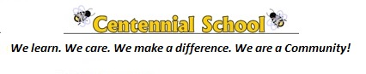
April 2018

Sunday | Monday | Tuesday | Wednesday | Thursday | Friday | Saturday
1  Easter | 2 Easter  Monday  No School | 3  Residents from Kennebec Manor Visit Grade 1 | 4 | 5 | 6 Frozen Snack Friday  $1.00  BMK Stingers Assembly | 7
8 | 9 | 10 | 11 | 12 | 13  Frozen Snack Friday  $1.00 | 14
15 | 16 Hot Lunch forms sent home | 17 PSSC @ 5:30 PM | 18 Badminton Jamboree  Achieve Literacy 1:15PM  Hot Lunch forms must be returned by Friday April 20th | 19 | 20 Frozen Snack Friday  $1.00  K’s-Cherry Brook Zoo. | 21
22 | 23 | 24 | 25  Half Day for Students Professional Learning for Staff | 26 | 27 Frozen Snack Friday $1.00 | 28
29 | 30  Mrs Brigg’s Class going to SJ Airport |  |  |  | Snowline 1-855-535-7669
Centennial Elementary School – (506) 658-5334 10 Constance St. http://centennial.nbed.nb.ca/ PSSC Facebook @centennialSchoolPSSC

