**5 Week Music Program 2019**

Live Music Connections is offering a 5 week program that allows students to explore and take lessons on various musical instruments (ukulele, guitar, drums, etc.) During the program the students have the opportunity to try out different instruments and then choose one or two instruments to learn more in-depth for the remainder of the program. We are also offering *Singing* in addition to the musical instruments exploration. Your child can choose to have the opportunity to explore singing. Learning a song, practicing a song, performing a song to live music or Karaoke (pre- recorded music) style singing with a professional sound system and stage set-up complete with backdrop and lights!

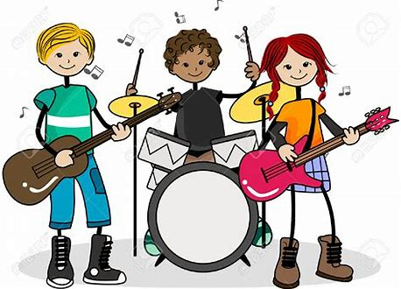 **Choices for students to try, explore, and learn throughout the program:**

\***Rhythm and Beat**-shakers, moracas, spoons

\***Percussion**-drum-buckets, electric drums, acoustic drums, congos, hand drums

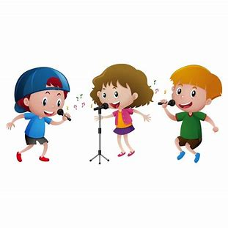 **\*String**- ukulele, guitar (acoustic and electric), bass

**\*Singing**- learning a song and performing a song (live/Karaoke)

**Fee**: $100

**Early Bird Fee:** $85(Sign up and pay on or before ***Friday Feb. 21st)***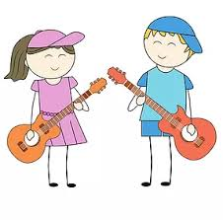

**Location:** Champlain Heights School (Bayview Students welcome to attend!)

**Day**: Mondays (February 24, March 9, 16, 23, 30)

**Time**: 5pm-6pm

[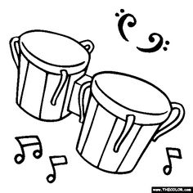](https://www.google.ca/url?sa=i&rct=j&q=&esrc=s&source=images&cd=&cad=rja&uact=8&ved=2ahUKEwimi6qVsdTeAhWU8oMKHYjeDgUQjRx6BAgBEAU&url=https://www.pinterest.com/gregmanning1954/coloring-book-pianos-musical-instruments-guitars-m/&psig=AOvVaw0V4WxtgfQ7xC14sgzTLY8A&ust=1542302043762454) **Please Note- It is very important for students to be picked up on time. This program runs on a tight schedule and the instructor leaves right after the program to go to the next location**

**Registration and Payment:**

Email Livemusicconnections2018@gmail.com the following information to register:

1. Parent Name 2. Child’s Name
2. Phone Numbers (h/w/c/) 4. School/Grade
3. Email

Preferred payment method is by e-transfer (password “musicprogram” all one word no spaces) from your online banking or bring payment to the first session with your child. (Note: You must still register your child to hold the space if you are paying on the first day as space is limited). Please **label all payments** with the school and child’s name. If you have any questions about payment and registration, please feel free to contact me at: [livemusicconnections2018@gmail.com](mailto:livemusicconnections2018@gmail.com) Thanks, Aaron ☺

***Pre-Registration through Live Music Connections (not the school) is required***

***Class sizes are limited and it will be a first come, first serve basis.***

***Students are not required to bring their own instruments, however they may bring them if they choose and please let me know when registering***

Contact Info: Aaron Gunn, Live Music Connections, [livemusicconnections2018@gmail.com](mailto:livemusicconnections2018@gmail.com), 506-639-0900