Stand Up!  I sit at home, all alone with nobody to play with. The kids at school turned everyone against me. I sit and pout all day long, wondering how life would be with friends. How it would be with no bullies.  Then I think, if I can stand up to these bullies all on my own, I’ll make friends, not enemies. I’ll have my family by me to support me. I won’t let the mean kids at school cost me a good time at school.  I am a kid against bullying. Stand up!  By Cailey G. | Bullying  Bullying bullying  Is very bad  Bullying Bullying  Makes me sad.  When I wake up  I think about “him”  Because the bully  Might break my limb.  The bully, the bully  Yells at me  And when he does  I don’t feel free.  So grab my hand  As we stand  To stop bullying!  By Paige H. | Bullies Bullies!  Bullies, bullies get out of my way  Bullies, bullies know how to start a fight.  Bullies, bullies are harder than ice.  Bullies, bullies can’t act so nice.  Bullies, bullies stay away  We can make a difference in our school today!  By Chloe B. | Bullying  Bullying is mean.  Bullying is bad.  Bullies are everywhere.  It doesn’t matter if it is a boy or a girl.  If you get bullied more than once, then tell an adult wherever you’re at.  Bullying is still mean.  Bullying is still bad.  Bullying is still everywhere.  Make sure you stick up for yourself and your friends too.  By Karley E. | Friends, Friends  Friends, friends  Friends are nice to you.  Friends play with you.  Friends make you happy.  Friends stick up for you.  Friends help you when you are sick or hurt.  Friends, friends, friends  By Karley E. | Come Play With Me  Roses are red  Violets are blue  C’mon, we’ll play,  Jump and swing on swings.  We can hop like a bunny.  If you play with me we’ll have fun!  By Emily W.
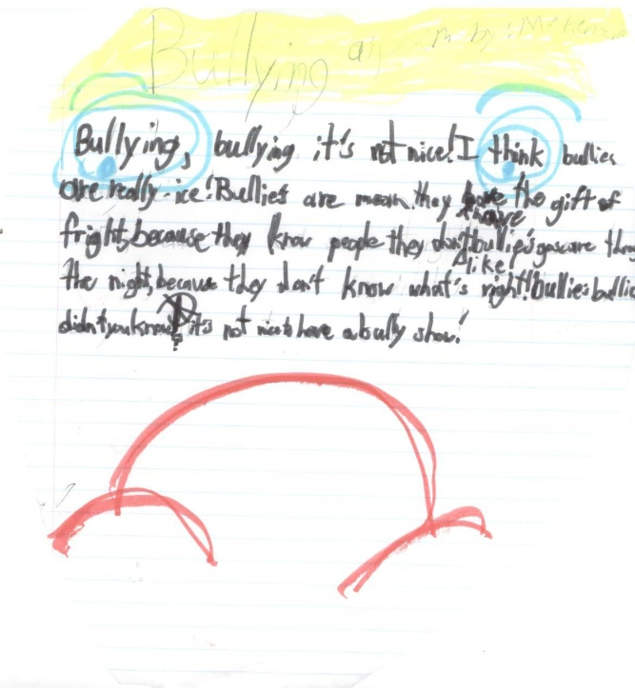
By Mekenzie B

