Winter Fest 2017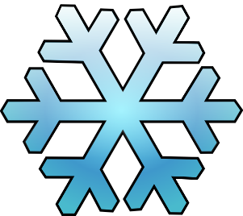
Monday March 13th | Tuesday  March 14th | Wednesday  March 15th | Thursday  March 16th | Friday  March 17th
-Snow sculptor  Competition @ lunch  *prize  March Madnes | *Comfy day*  -Movie @  Lunch  March Madness | *Summer day*  -Tropical juice 50cents  -March  Madness | *Hockey jersey day*  -Mini sticks competition  March Madness  CELEBRATE ASSEMBLY | *St. Patrick’s day*  -Green sock hop @ lunch  *Food bank

