'Move It Monday!'

- Door Greeters to kick off Wellness Week!

- Fitbit/Pedometer - classroom and staff challenge. Winning class gets a free outdoor class later in the week!

- Place your order for 'Fresh Fruit Friday' - $1.00

'Trivia Tuesday'

- Wellness Trivia before each break. Barnhill T-Shirts as prizes!

‘Wake-Up Wednesday'

- Orange Juice for everyone!

'Thirsty Thursday'

- Cool, refreshing, bottled water @ .50 cents/bottle

'Fresh Fruit Friday'

- Fresh Fruit delivered before the second morning break.
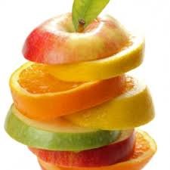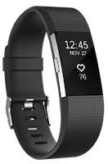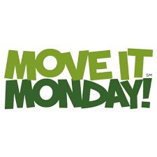
AND MUCH MORE…

