Respect and Diversity Week - November 20th – 23rd 2017

Monday, Nov. 20th
‘Healthy Relationships’

- Daily R&D Announcement
- Full House episode with a Friend (Tech. Room) – Popcorn $1.00

Tuesday, Nov. 21st
‘There’s Only One You’

- Daily R&D Announcement
- Presentations from PRUDE on Valuing Differences – grade 6 classes in the morning (schedule to follow)
- ‘Rock Art’ – must sign up to participate. (maximum 40 students) You will paint a rock that shows ‘There’s Only One You!’
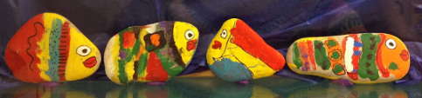

Or you may paint a ‘Word Rock’.

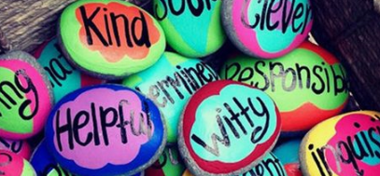

Wednesday, Nov. 22nd
‘We Are One Wednesday’

- Daily R&D Announcement
- Wear PURPLE to show school spirit and unity!
- ‘Happiness is Hot Chocolate’ – order hot chocolate to be delivered sometime during the day.

Thursday, Nov. 23rd
‘The Power of Positivity’

- Daily R&D Announcement
- Wear BRIGHT colours!!
- Presentation from Outflow on Poverty and Homelessness in Saint John – grade 7 classes (grade level assembly – time to be determined)
- Presentations from PRUDE on Valuing Differences – grade 6 classes in the morning (schedule to follow)
- Positive Post-It Blitz by BTH

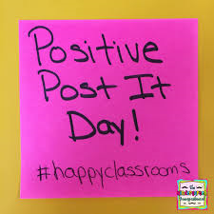

- Door Decorating – The theme is Respect and Diversity. It may be that you have a few students in your homeroom who will take this on! Judging takes place on Thursday with ice-cream treats for the top three doors!

- ‘Shout out to ______!’
Nominate peers who show respect – tell us how they’ve shown it! Homeroom teachers will have ballots and can encourage this throughout the week

- Packages will be delivered to ELA teachers and PDCP teachers. Please do your best to have meaningful conversations throughout the week on the topic of Respect and Diversity.

- Art Room – RESPECT letters

Thank you for your participation during Respect and Diversity Week!

