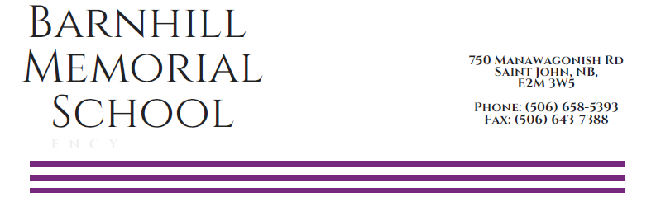

March 12th, 2018

PARENT-TEACHER-STUDENT INTERVIEWS

Dear Parents/Guardians:

Parent-Teacher-Student interviews will be by appointment only Wednesday, March 28th from 4:00 p.m. - 7:00 p.m. and Thursday, March 29th from 1:00 p.m. – 3:00p.m. Interviews will be 10 minutes in duration.

We invite and welcome all parents/guardians to take advantage of this opportunity to meet with all of your child’s teachers and encourage you to bring your child with you to the interview.

This year we will be booking appointment times in 10 minute blocks via telephone. Please be respectful of this timeframe and if you should require more than the allocated 10 minutes, a meeting can be arranged with your child’s teacher for an alternate date. We will be accepting phone calls beginning at 8:30am on Monday, March 26th through to 12:00 noon on Wednesday, March 28th. Please call the main office 658-5393 with a preferred day/time in mind, a list of teachers you would like to see, and if there are siblings in the building. Appointments are booked on a first-come, first-served basis and voicemail messages will not be accepted for appointment bookings.

We are confident by making appointments over the phone, we will alleviate wait times and help parents and guardians have smoother interview experiences. We appreciate your patience with this system and encourage your feedback after the process is over.

Thank you for your cooperation.

Sincerely,

Barnhill Staff

