Macaroni Mountain

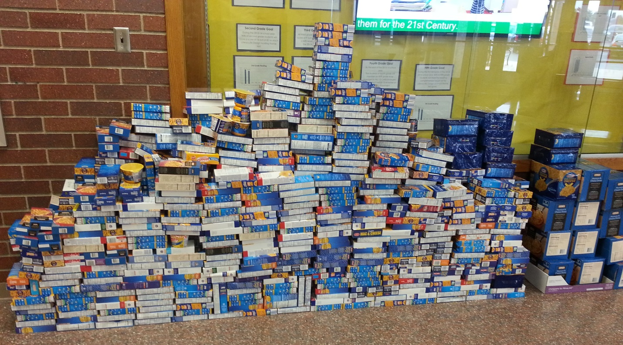

What Grade Level will build the tallest MOUNTAIN?????

Dec. 12 – 23 please bring in boxes of macaroni, pasta, Kraft Dinner to your home room. It has to be in a box.
The Winning Grade will get intramurals for a full week!!!!
All donations will go to the West Side Food Bank.

Sponsored by your Wellness Committee

