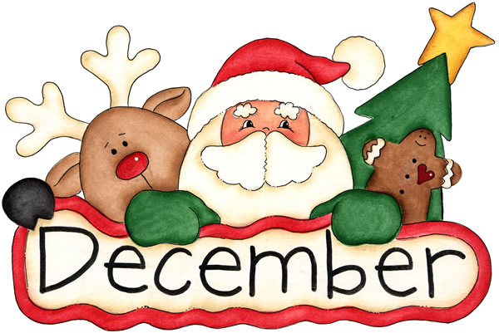
Monday | Tuesday | Wednesday | Thursday | Friday
 |  |  | 1  -Grinch activity  -Elf’s first appearance | 2  -Red and Green day  -Holiday movie @lunch  -Elf Trivia
5  -Selling candy Canes @ lunch | 6  -Grinch hearts | 7  -Selling candy Canes @ lunch | 8  -Winter semi-formal  -Candy Cane delivery | 9  -Hot chocolate@ lunch  -holiday socks day  -Elf Trivia
12  -Selling candy Canes @ lunch | 13  -Grinch hearts | 14  -Selling candy Canes @ lunch  -Snow flake making in Mme Maxwell’s room @ lunch | 15  -Candy cane delivery | 16  -Cookie decorating in Mme. Maxwell’s class @lunch  - ugly xmas sweater day  -Elf Trivia
19  -Selling candy Canes @ lunch | 20  -Grinch hearts | 21  - Selling candy Canes @lunch  -Holiday Bingo in Mme Maxwell’s class@lunch | 22  -Candy cane delivery | 23  -Elf Trivia  -Elf dress up day  -Celebrate assembly

