

**From Barnhill Memorial School to you and your family, we wish you the best during your holidays!!**

**We will see you on January 8th 2018!**

[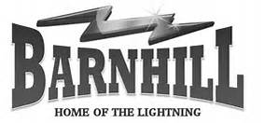](http://www.bing.com/images/search?q=barnhill+memeorial+saint+john+nb&view=detailv2&&id=62A5E8A37A81F7A2BC427F0C1B81605D8A2CDDF3&selectedIndex=6&ccid=cb2q8CQ6&simid=607994837141621546&thid=OIP.M71bdaaf0243a0898967b6b481ffd103co0)