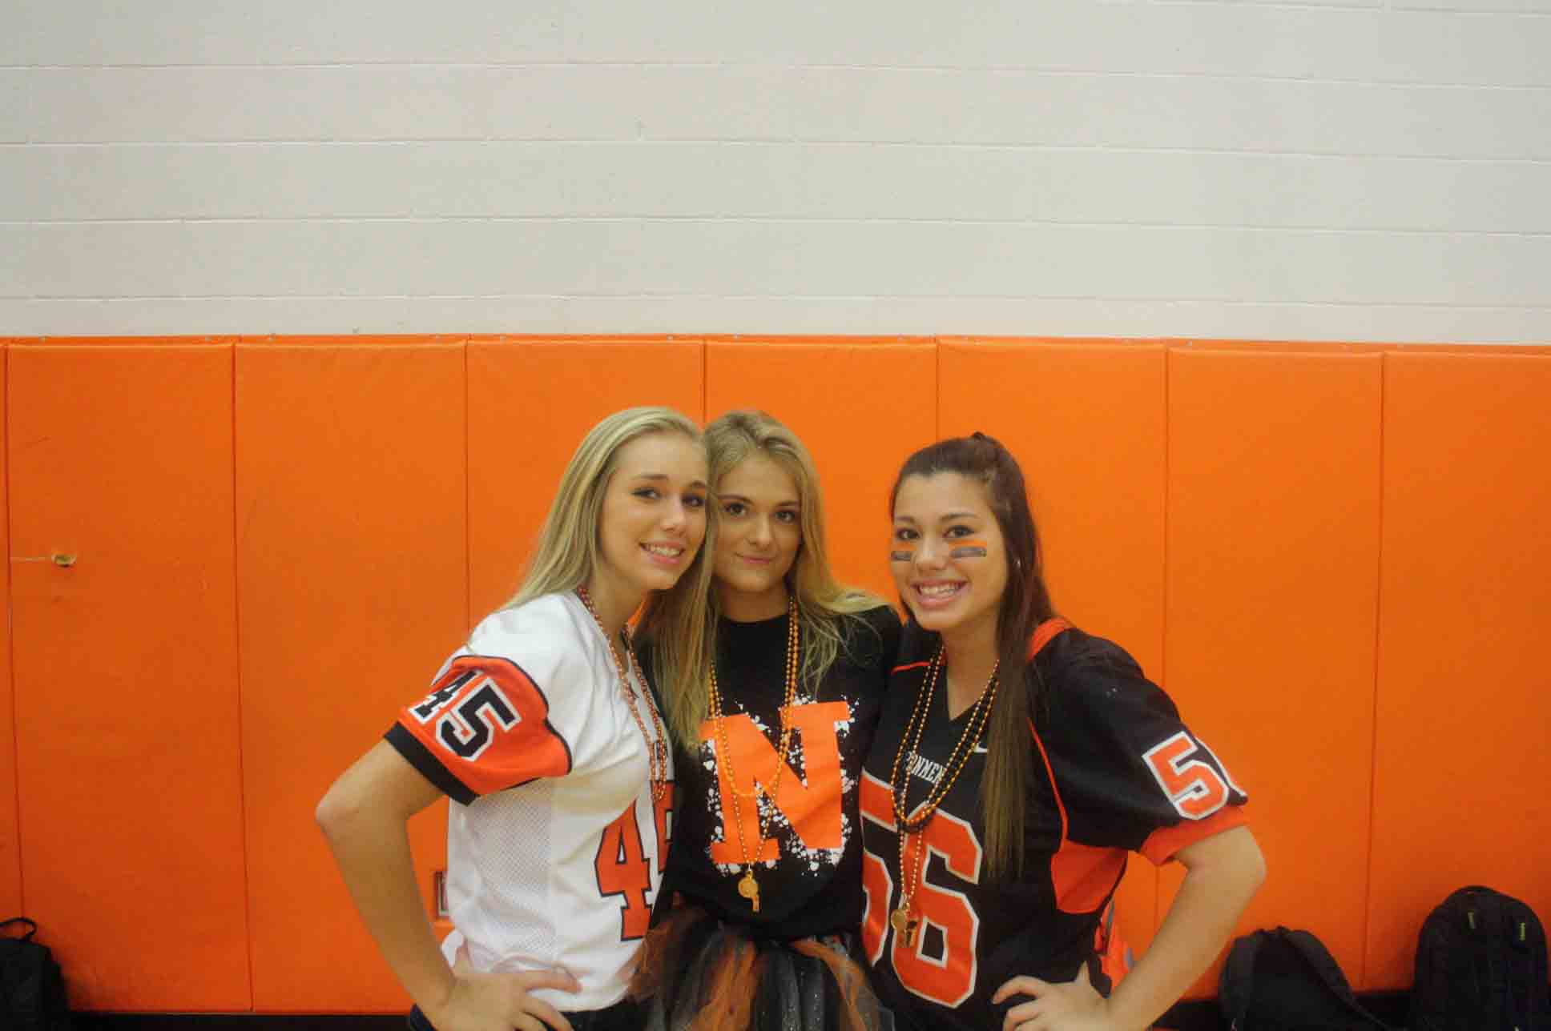
Octoberfest
October 25th – 29th
Monday – Orange and Black Day
- Door Decorating Competition Begins
- Colouring Contest Begins

Tuesday – Halloween Sock Day
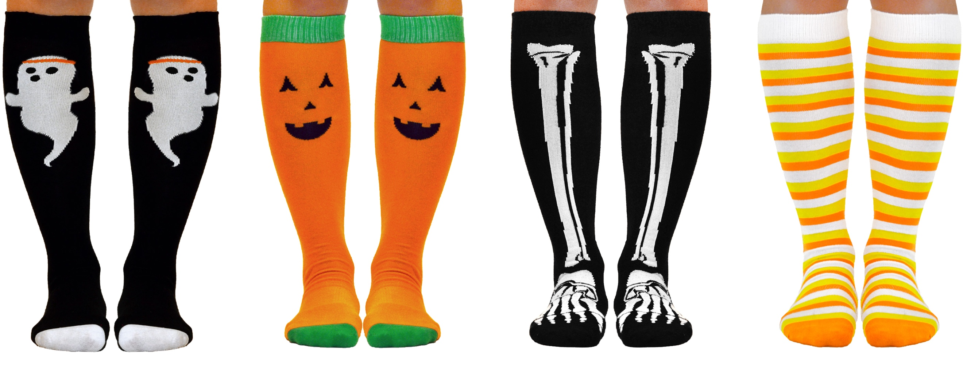
- Door Decorating Competition Continues
- Pumpkin Carving at lunch in the Outdoor Classroom (12:10 – 12:45)
- Each Homeroom Votes on One Colouring to Represent Them

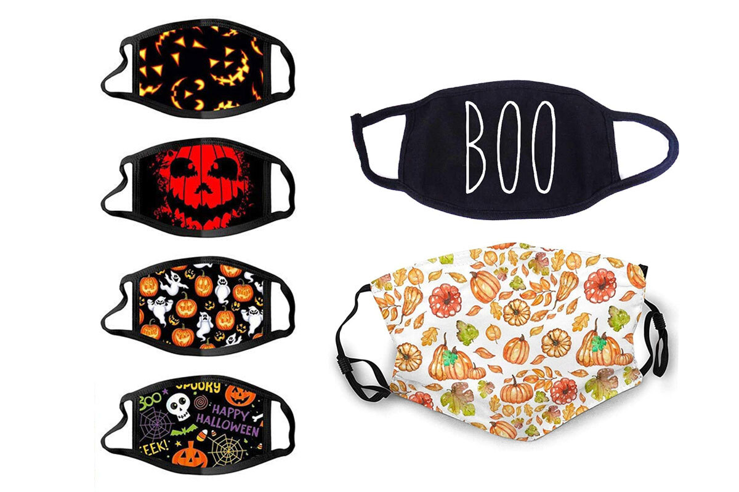
Wednesday – Halloween-Themed Masks
- Door Decorating Competition continues
- Voting Begins for Colouring Contest
- Voting Begins for Pumpkin Carving Contest
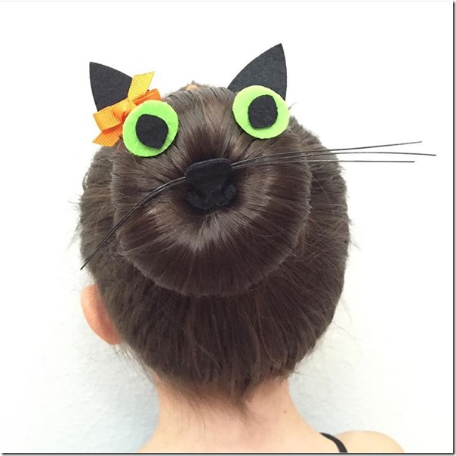
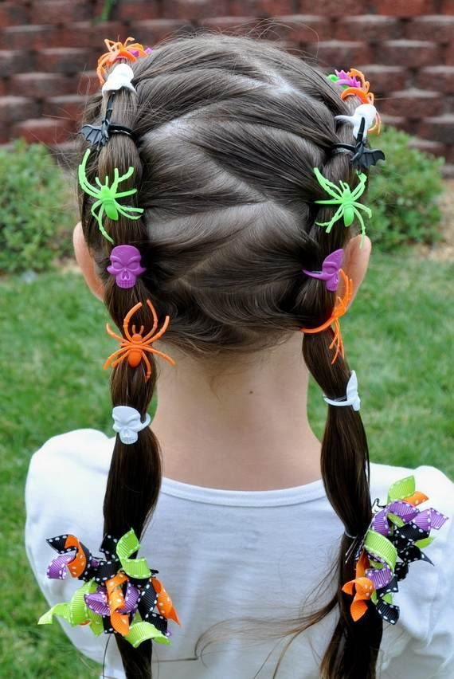
Thursday – Wacky Hair Day
- Door Decorating Competition is Done by 3:00 PM
- Voting Continues for Colouring Contest
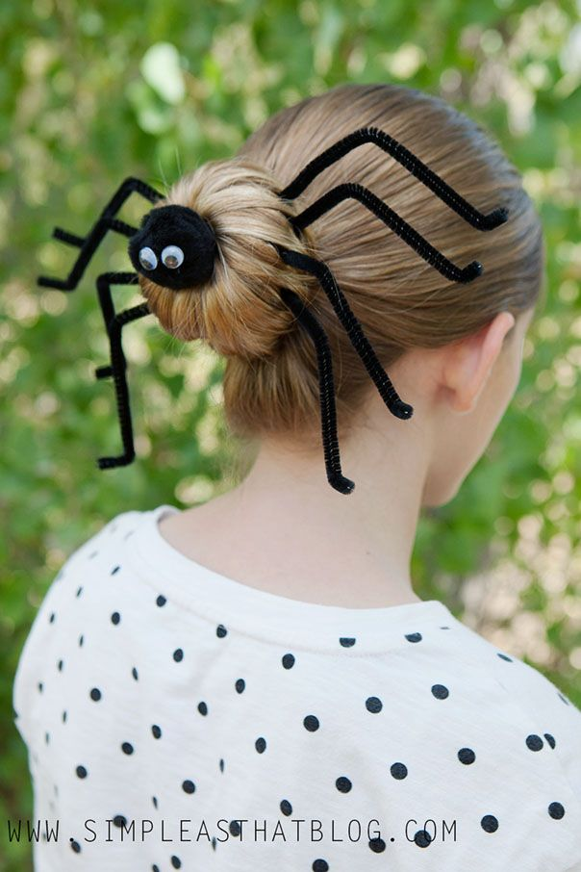
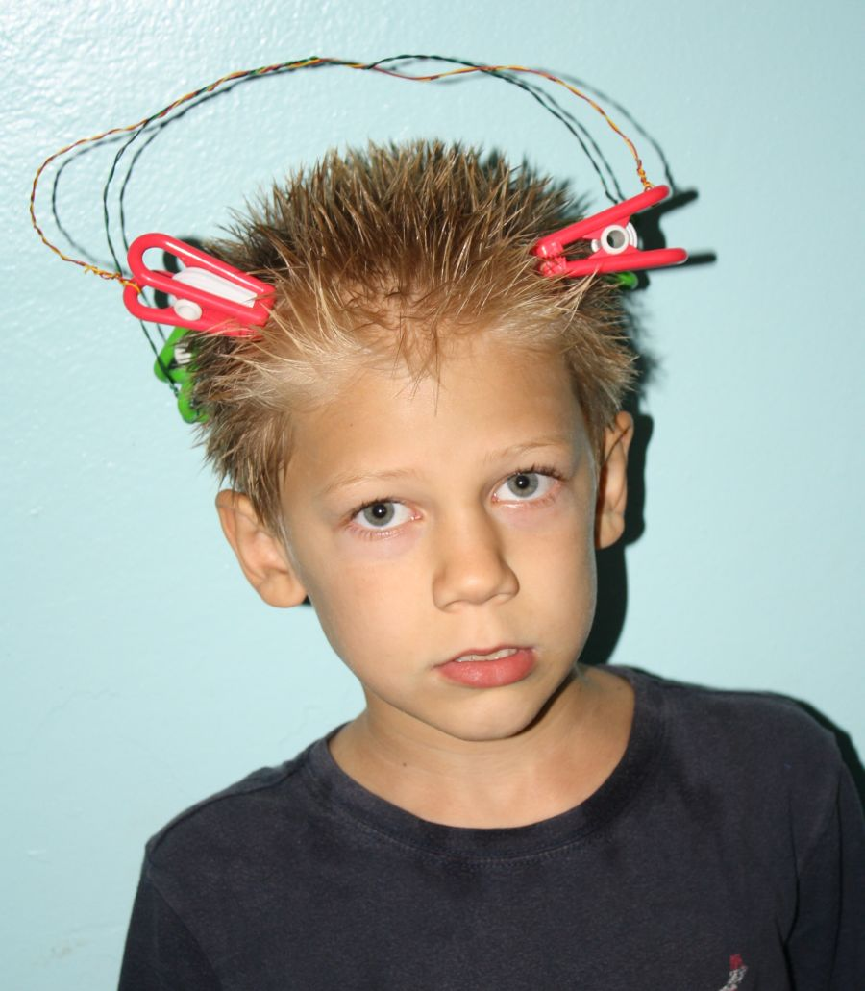
- Voting Continues for Pumpkin Carving Contest
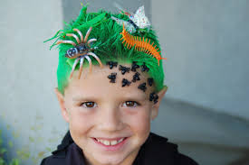

Octoberfest
October 25th – 29th

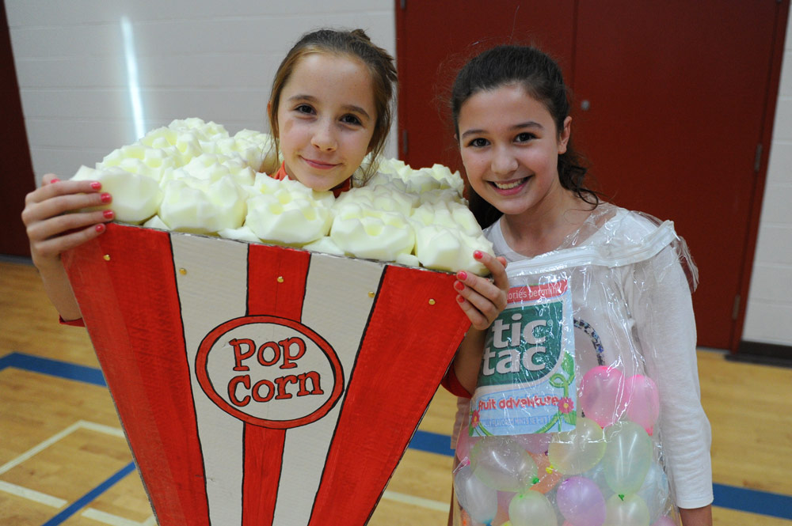
Friday – Costume Day Students must wear a costume
that abides by the school dress code. Halloween masks are
not permitted. If face paint is used, you must be
identifiable by staff. No plastic swords or wings or any other “accessory”.
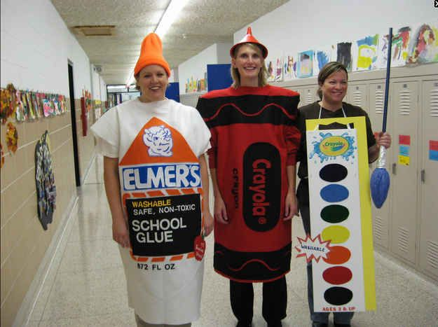
- Voting for Colouring Contest Ends at Lunch. Winner will be announced.
- Voting for Pumpkin Carving Contest Ends at Lunch. Winner will be announced.
- Winning Homeroom Announced for the Door Decorating Competition. Prize is a pizza party!
- Spook Trail in the Lunchroom. $1 Admission

