Parent/Guardian Permission & Information Letter: The Huntsman Ocean Discovery 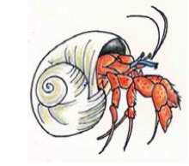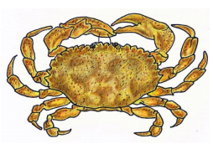

Dear Parent(s)/Guardian(s),
Our grade 6 French Immersion and English Prime Science classes have been busy preparing for our trip to “The Huntsman” in St. Andrews, as part of our unit on “Diversity of Life”. We have planned a day of learning, and fun at the Huntsman Marine.
Students will be completing activities, which include two labs: “The Unusual World of Plankton- Life in a Drop of Water” and “Invertebrate Lab- an Introduction to Classification”. The trip reinforces concepts covered with our grade 6 science units. The students will be exploring various organisms and ecosystems related to these areas of study.
We will be travelling by school bus to and from St. Andrews. The bus will leave the school at 8:45 sharp and return by 2:30 pm (prior to dismissal).
Students must wear comfortable clothes that are appropriate for the weather conditions (rain or shine) and appropriate footwear for walking. The students will be required to bring their own lunch, drinks and snacks. Students with medical conditions such as asthma, allergies, etc., please bring necessary medications to treat these conditions.
COVID-19 SCREENING will be followed according to Public Health Guidelines: Mandatory community masks, active screening & temperature check is required!
The following the schedule for grade 6 classes:
Monday, April 26th: Mrs Blanchard and Mme Beyea (English Prime classes)
Tuesday, April 27th: Mme Murphy and Mme Lise (French Immersion classes)
Wednesday, April 28th: Mme Arbeau (French Immersion class)
Please Note: It is a school and curriculum-based trip. There are absolutely NO CELL PHONES to be taken/used on this excursion.

I hereby grant permission for my child to attend on_______________________ Signature of teacher: _____________________________________________ Signature of parent/guardian: ______________________________________
Looking forward to a fabulous day of Science & Inquiry!
Madame Mary Jo Murphy (French Immersion & English Prime Science Teacher)

