EASTER

EGGStravaganza!
March 29th – April 1st (no joke!)
Monday – Easter socks

Tuesday – Easter mask

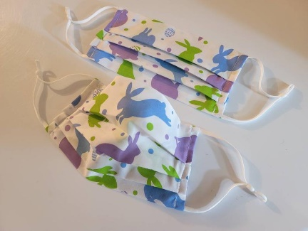
Wednesday – Pastel Colours

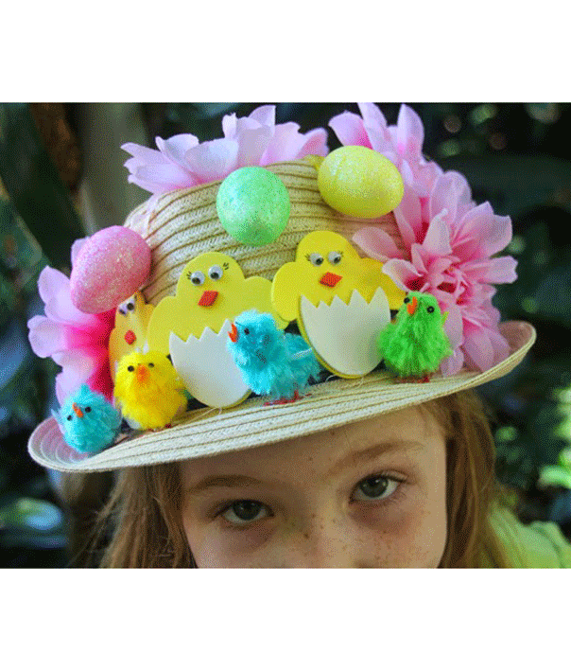

Thursday – Hat Day. You must pay S1 to
wear any type of headwear inside the
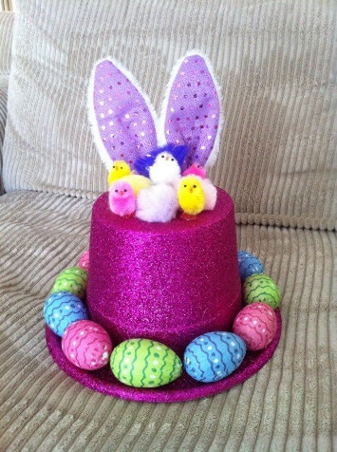
school. All donations will be given to the West
Side Food Bank.

Friday – No School – Good Friday

Egg-O-Grams
Egg-O-Grams will be on sale starting Monday. You have until Wednesday to purchase one. They are $1 each and you can buy as many as you would like! Send them to your friends in any of the other homerooms! They will be assembled Thursday morning during Foundations by the Student Leaders and given out during first break.
Every homeroom will be given 10 Egg-O-Grams at one time. It is the responsibly of the Student Leaders to sell the Grams to their classmates. Once they sell all 10, they bring the $10 to the office and they give the money to the Student Ambassador sitting at the desk. The Student Ambassador will then give the Student Leader 10 more Grams to sell.

Canteen
The canteen will be open Thursday during lunch in the Lightning Lounge. All items are S1. Students that eat first, may purchase an item (or two!) the first half. Students that eat second, may head down to the Lounge once they come inside.

