SJBKE LUNCH MENU

***Revised**** Feb. 24th - 28th 2014 ***Revised****
Monday February 24th 2014
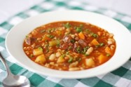
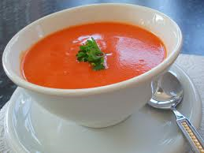
Beef Barley Vegetable Soup/Buttered Roll/Water

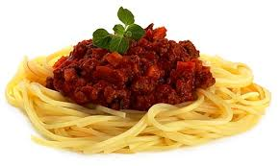
Tuesday February 25th 2014
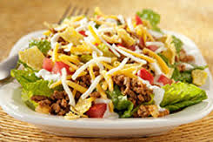
Taco Salad/Biscuit/Water/Cookie

Wednesday February 26th 2014
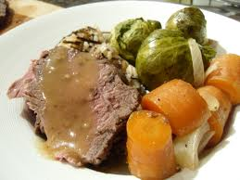
Roast Beef Dinner/Mashed Potatoes/Veg/Milk

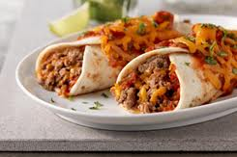
Thursday February 27th 2014
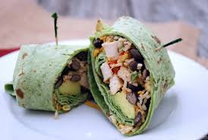
Veggie Wraps/Rice Pilaf/Water

Friday February 28th 2014
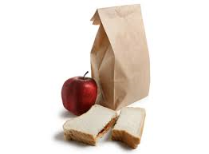
Brown Bag from Irving (Ham Salad & Chicken)

