Suggested Work Grade 4-5 – May 25 -29
Math
Mathematics: For math again this week, we are giving you two choices. You may work on both, or choose the one you are most comfortable with
*Remember to keep up your math skills by logging in a using your Prodigy Math Account.
You can also go on the Khan Academy site to help you understand a topic.
Multiplication2-digit by 2-digit: If you know your multiplication facts from 0-9 then 2-digit by 2-digit multiplication is a breeze .
There are several strategies we use to solve multiplication problems.

The first way we do this is with Base Ten Blocks – see the following video https://www.youtube.com/watch?v=ia9cWrmh_ZM.
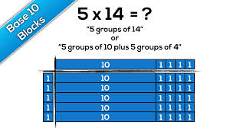

Another strategy is Distributive Properties – see the following video https://www.khanacademy.org/math/arithmetic/arith-review-multiply-divide/arith-review-place-value-area-models/v/2-digit-multiplication-with-grid.
Distributive Property Example:
43 x 12
-40 x 10 = 400
-40 x 2 = 80
-3 x 10 = 30
-3 x 2 = + 6
516

We can also use the more classic strategy to multiply the Standard Algorithm – see the following video. https://www.youtube.com/watch?v=zkUUNo90eSE.
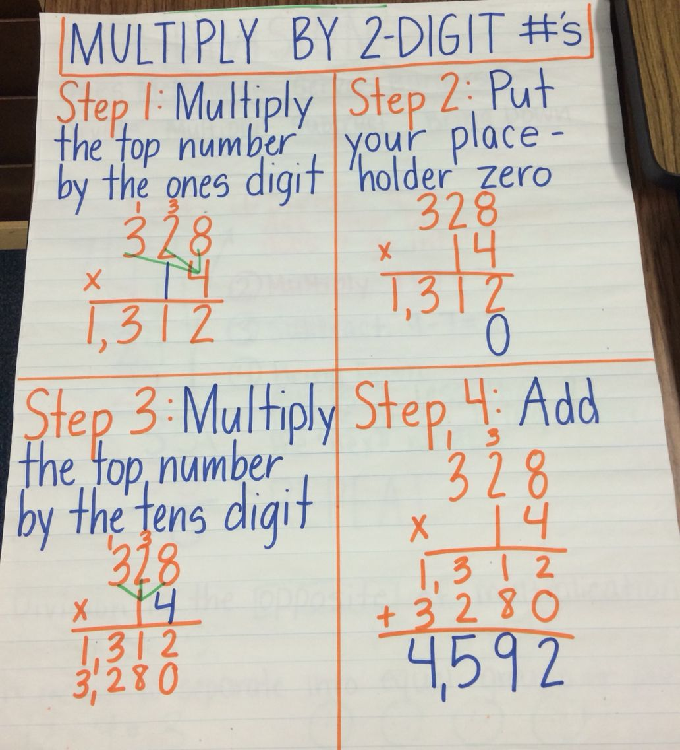
Try the following game to test your skills at 2-digit by 2-digit multiplication https://www.mathplayground.com/multiplication05.html

Addition with Regrouping: Sometimes when we are adding large numbers, we need to regroup them –To learn more about this concept please watch this video - https://www.youtube.com/watch?v=ayFAh4VNMFA
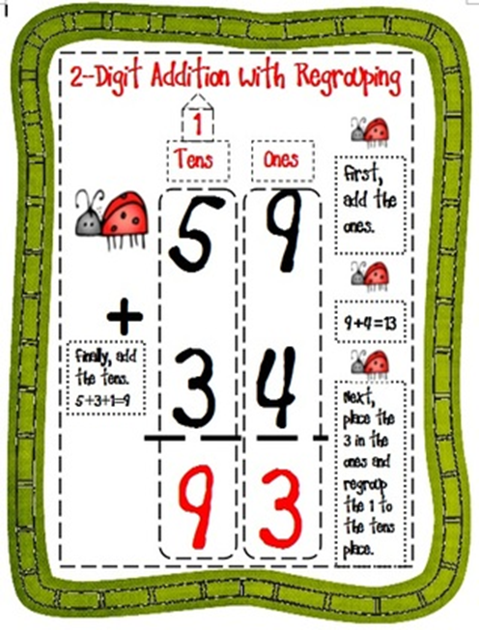
Then test your skills with the following game - https://mrnussbaum.com/math/regrouping

Science
This week for Science I am going to recommend a YouTube channel my ten-year-old son introduced me to.
It is called ‘Operation Ouch’ -https://www.youtube.com/channel/UCQJDFI9j8UeNoqra37p5OkA/about
Operation Ouch is packed with incredible facts about the human body and fronted by identical twins Dr.Chris and Dr. Xand van Tulleken who experiment and explore their way through the fascinating world of medicine and biology. This channel will de-mistify hospitals for younger viewers; no longer will the hospital be a "scary" place to go as we learn all the exciting things that go on there. Chris and Xand will let the viewer into their exclusive world of medicine and explain the awesome things our bodies can do!
Feel free to watch some of their videos to learn some amazing facts about the human body!

Language Arts
You are given three tasks this week to complete. Don’t forget about your RazKids
Posters/Pamphlets

- Gather a few posters/pamphlets.
  - What features needed to be included on a pamphlet or a poster? Why?
  - Brainstorm a list of possible writing topics for future use in creating a pamphlet or poster.
- Choose a pamphlet and a poster of choice to read
  - Talk about the different text features (e.g. Title, graphics/charts, subheadings) of each of them. Choose a couple of text features to compare on a poster and pamphlet. Which one is more effective?
  - Why?
- Design a poster or a pamphlet on a topic of your choice.
  - Remember to include text features that your audience might need.
- Show your pamphlet or poster to a family member. Discuss if
your audience understands your message and any changes you
could make.
- Add any text features that would help your audience
understand your message. (For example map, chart, list, picture,
caption, or glossary.)
- Using the rough draft create the final copy of your pamphlet or poster.
  - Celebrate completing your published work with your family.

Journal
Below is a list of ideas for writing this week. Pick the ones that are of interest to you or choose a topic of your own. I would LOVE to read some of your writing!
**Please send one of your journal entries to your teacher by Friday, May 29th . It can be sent by email. Send a picture or type it up
- What is your favorite book? Why do you like it?
- The best part about being a kid is….
- It might seem silly, but I am afraid of….
- One thing I’ve always wanted to do is….
- Write about a time you have had to apologize to someone.

Editing Checklist
Re-Read – Does my writing make sense?
Punctuation ( . ! ? )
Capital Letters
- Beginning of a Sentence
- Person’s Name
- Name of a Place
- Titles
- Day of the Week
- Month of the Year
Spelling
Paragraphs – Do I have an indent at the beginning of each paragraph?
Apostrophes – Did I use apostrophes when needed?
- Contractions (can’t)
- Possessives (Sally’s dog)

Word Work
Boggle – use the Boggle Board below to make as many words as you can. Play yourself or invite your family to play along

3 Letter Words | 1 Point
4 Letter Words | 2 Points
5 Letter Words | 3 Points
6+ Letter Words | 5 Points

S | T | N | G
E | I | A | E
D | R | L | S
S | E | P | O

Social Studies/ Art
The Sumerians in ancient Mesopotamia contributed to the development of metalworking, wheeled carts, and potter’s wheels.

They may have invented the first form of writing. They engraved pictures on clay tablets in a form of writing known as cuneiform (meaning “wedge-shaped”). The tablets were used to keep the accounts of the temple food storehouses. By about 2500 BC these picture-signs were being refined into an alphabet.

Why do you think the development of writing is so important to the growth of an early society over time?

Create your own written language using picture and symbols and write a secret message for a friend or family member to decode. Include a legend so they’re able to crack the code!

Use these videos to help you further understand.

https://omniglot.com/writing/sumerian.htm

https://www.khanacademy.org/humanities/ancient-art-civilizations/ancient-near-east1/the-ancient-near-east-an-introduction/v/cuneiform

https://www.youtube.com/watch?v=nOE8r9pdXO0

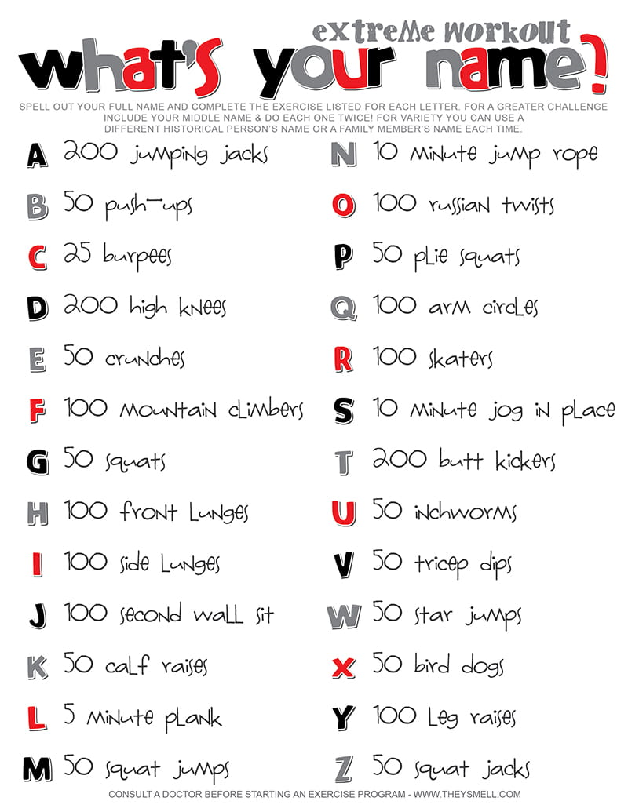
Phys. Ed

Music
Sick of listening to the same music all the time. Try making your own music with the empty bottles around your house.

Soda Bottle Organ Activity for Kids
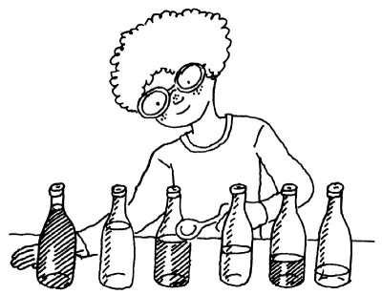
Strike up some stunning notes!
©2007 PUBLICATIONS INTERNATIONAL, LTD.

What You'll Need:
- Newspapers
- Five or six empty glass soda bottles
- Water
- Dark-colored nail polish
- Food coloring
Spread out the newspapers. Practice making a tone by blowing into the top of a glass soda bottle. When you have it mastered, fill the bottles with different levels of water. (If you've had some music lessons, you could try tuning the bottles to specific notes.)
Arrange the bottles from left to right, low notes to high notes. Practice playing an easy song. Make a water level mark on each bottle with dark-colored nail polish. (Mark the notes, too, if you know them.)
Let the polish dry. Using a drop or two of food coloring, put a different color in each bottle. Put your thumb over the end of each bottle, and gently swirl the water to mix the color in.
Now you can practice your songs on your soda bottle pipe organ!
If you want to try and make other instruments:
https://lifestyle.howstuffworks.com/crafts/seasonal/music-activities-for-kids.htm

Health
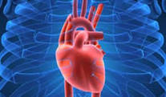
Heart: Your heart is the main organ in your body that without it you would not be able to survive. The main job or function of the heart is to pump blood throughout your body; firstly oxygen rich blood, and then circulating oxygen depleted blood back to be reoxygenated. Your heart beats approximately 60-80 times per minute based on age and physical activity. When we think about our hearts over the course of a lifetime that’s a lot of work and strain put onto this muscle. As we age and grow, so does our heart.

Make a clenched fist. Your heart size at this moment in your life is about the same size as the fist you just made.

Watch the video in this link From Britannica Online Encyclopedia to get a better understanding of how the heart works. www.britannica.com/science/heart

As a post learning activity, ask each member of your family to make a gently clenched fist.
Using a piece of paper in landscape form, have the oldest member of your household place their fist palm down on the paper at the left. Trace around their hand.
Print their name below their traced fist. Continue on with the rest of those that you live with.
When complete, place this diagram on your fridge or wall space.
Colour if you wish.
Notice the size difference between an adult heart and a child sized heart. If you have younger siblings, make sure you included them, if able, in the drawing.
What do you notice about the size?

