Good evening! This is Ms. McGrath with another message for all Gr. 8 Raiders and their families. Today is Sunday, February 7th, 2021
This week all of the High Schools in our area will be posting Virtual Open House videos on their school websites (in lieu of the normal Open House activities due to Covid) beginning Monday, February 8th.
We encourage all Gr. 8 students to check out every High School before they complete and return their High School Registration forms to us.
Forms can be returned on Friday, February 12th or Tuesday, February 16th. All forms must be at RVMS no later than 9:00 am on Wednesday, February 17th in order to be checked and sent to the District office by noon on that day.
Click on the school logo for school websites below:
Harbour View High School

St. Malachys Memorial High School
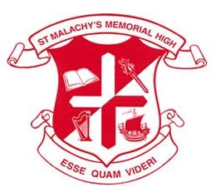

Saint John High School
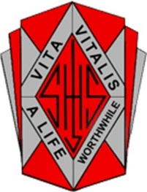

As always, if you have any questions, please do not hesitate to contact me at Trudy.McGrath@nbed.nb.ca or, on my direct line, at 738-6511.
Good evening! Stay Safe!

