I | I | F | Y | T | H | Z | T | S | D | B | W | A | F | P | A | S | N | P | A
S | M | R | G | M | B | E | P | S | I | V | G | N | J | R | E | A | I | G | P
O | E | P | J | O | R | I | S | E | S | X | L | C | A | P | I | V | S | E | G
V | X | S | O | R | P | W | Q | L | C | E | R | Q | K | C | O | E | L | W | O
W | L | A | I | S | T | W | F | E | O | B | Y | L | I | I | I | K | N | T | O
N | D | B | B | H | S | H | E | P | V | D | X | S | J | R | V | M | N | D | Y
F | L | N | S | P | R | I | N | O | E | B | U | W | B | R | J | E | B | M | S
E | L | D | V | Z | W | E | B | H | R | M | F | T | F | K | M | M | R | I | R
B | E | C | A | U | S | E | S | L | Y | X | E | T | S | E | H | C | I | R | U
H | Z | F | F | B | B | U | D | O | E | H | O | L | G | D | Z | P | O | T | Q
L | Q | Q | P | W | A | E | M | C | P | S | W | A | P | D | B | I | W | T | L
L | S | K | J | M | E | K | M | X | R | M | R | T | E | O | Z | N | K | B | I
X | B | Y | A | N | Z | T | I | C | K | U | O | X | R | O | E | P | T | F | T
X | T | B | I | S | H | B | A | B | O | F | C | C | S | M | E | P | B | J | N
P | E | P | B | O | T | G | D | C | H | T | K | C | F | V | U | M | E | V | U
X | B | M | U | Q | F | A | N | C | U | N | F | R | I | E | N | D | L | Y | V
D | F | G | X | M | C | E | X | K | H | V | I | H | I | B | C | B | I | B | A
X | H | Y | V | R | L | D | F | W | R | Z | D | Y | H | V | Q | K | E | J | V
T | L | X | H | A | L | R | A | T | L | Y | O | M | M | P | P | K | V | W | L
E | T | I | R | O | V | A | F | N | T | X | F | M | D | W | E | R | E | W | G

BECAUSE | BELIEVE | COMPOSER
DISCOVERY | ENCOURAGEMENT | FAVORITE
FRIENDS | HOPELESS | IMPOSSIBLE
MUSICIAN | PEOPLE | RICHEST
TERRIBLE | THOUGHT | UNFRIENDLY
UNTIL | VERY | WERE
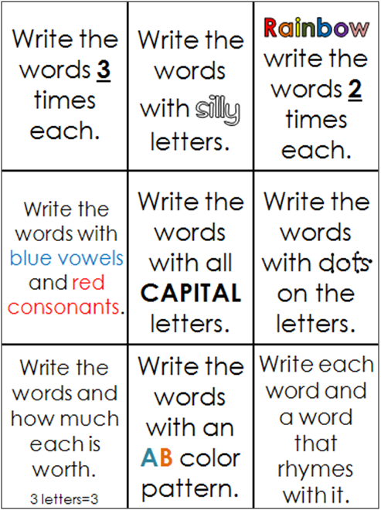
Study the word on the page, then cover them up and try to write them all from memory. Check your words when done and make any corrections.

composer
discovery
encouragement
hopeless
impossible
musician
richest
unfriendly
Write as many words that you find from the classroom. Use a different color for each word:
Draw a picture to go with each of the following words:
composer

discovery

encouragement

hopeless

impossible

musician

richest

unfriendly
What words can you make using the following letters? Can you make a word using all of the letters?

e e o h l l p s s y

Write a sentence to go with each of this month’s words:
composer: ___________________________________________________
___________________________________________________________
discovery: ___________________________________________________
___________________________________________________________
encouragement: ______________________________________________
___________________________________________________________
hopeless:____________________________________________________
___________________________________________________________
impossible: __________________________________________________
___________________________________________________________
musician: ___________________________________________________
___________________________________________________________
richest:_____________________________________________________
___________________________________________________________
unfriendly:__________________________________________________ ___________________________________________________________

Cut out the following letters and then try to make as many different words as you can. Make a word using all of the letters.
p
s
s
o
b
m
i
i
l
e

