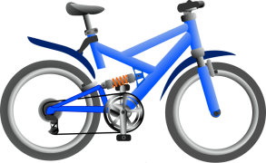
2015-2016 RIDE TO READ CONTEST
DOAKTOWN LIBRARY & ELEMENTARY SCHOOL
FOR STUDENTS IN GRADE KINDERGARTEN, GRADE 1, 2 & 3

Sponsored by LANDMARK # 51 Masonic Lodge

__________________________________________________________________ ___________
Contestant’s Name Grade

______________________________________________________________________ Entry Deadline: June 10, 2016
BOOK TITLE:

What did you like about the book? __________________________________________________________________

____________________________________________________________________________________________________________

________________________________________ ________________________________________
Parent/Teacher/Library Staff Signature Date

2015-2016 RIDE TO READ CONTEST
DOAKTOWN LIBRARY & ELEMENTARY SCHOOL
FOR STUDENTS IN GRADE KINDERGARTEN, GRADE 1, 2 & 3

Sponsored by LANDMARK # 51 Masonic Lodge

__________________________________________________________________ ___________
Contestant’s Name Grade

______________________________________________________________________ Entry Deadline: June 10, 2016
BOOK TITLE:

What did you like about the book? __________________________________________________________________

____________________________________________________________________________________________________________

________________________________________ ________________________________________
Parent/Teacher/Library Staff Signature Date

