Outcome: N4 relate improper fractions to mixed numbers
Students will be able to convert improper fractions to mixed numbers as well as draw them.

Video to review:
https://youtu.be/-imFslMIN1g
Activity 1
- Write as many improper fractions as you can with the numbers 3, 6, 7 and 8.
- Convert these fractions to mixed numbers
- Draw a picture using a pattern, fraction, rod or number lines using the example below.
For example:
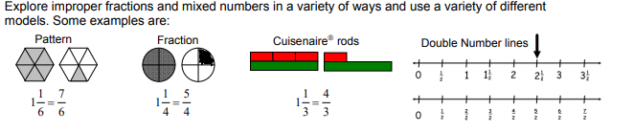

Activity 2
Create a set of equivalent mixed number and improper fraction cards. Start with 5 matches. Turn upside down and turn over 2 random cards for a match. If they match keep them. Play with a partner or race the clock and see how quick you can get all the cards to match yourself. Add more cards as you go. ( or match a fraction with a picture)

