

October 23, 2018

Dear Parent/Guardian:

On **Friday, Feb 1st** and **Friday, March 1st,** our school will be going to Crabbe Mountain to ski as part of the Phys. Ed curriculum.  **Storm date: Friday, March 15th**

Our itinerary is as follows:

* Leave the school at approximately 8:30 am - arrive at Crabbe at 9:00
* Leave Crabbe at 2:00 to arrive back at NMS by 2:30.
* Lunch can be purchased at the lodge cafeteria or students may bring a bag lunch.

*The cost of the trip is $25 per student*. This includes a lift ticket, rentals and a lesson.

*If students provide their own equipment and/or hold a Season’s Pass to Crabbe Mountain, the cost is $10 per student*

We would like to see all students participate if possible. If cost is a prohibiting factor, please let us know.

If you have any questions related to this trip, please do not hesitate to contact Mrs. Anderson or the school office at 575-6010.

**Please detach and return school permission slip along with the Crabbe Mountain waiver to your child’s homeroom teacher.**

MC900234446[1]***PARENTS please note: If you choose to provide the transportation for your son/daughter to Crabbe Mountain, they will still be required to participate in the Ski in School Program including the lesson and the ability assessment. They will be expected to follow school rules and will be under the direction of school staff and chaperones.***

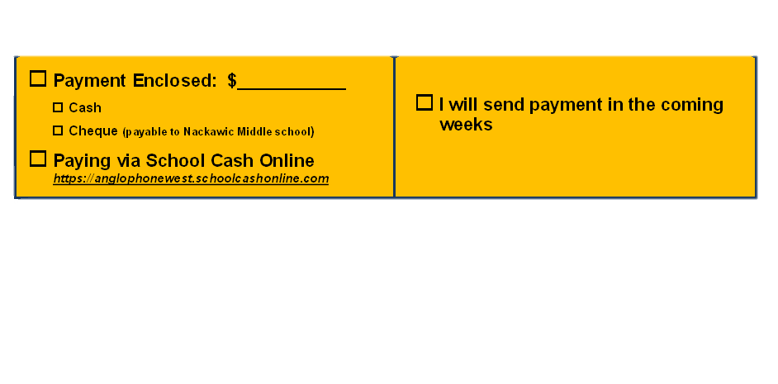

*************************************************************************************************************

**I agree to allow my son/daughter to participate in the field trip(s) as outlined above.**

**___________________________ _________________________ Student Name**  **Homeroom/ Grade**

**___________________________ _________________________ Parent Guardian Signature**  **Date**

***(PLEASE COMPLETE ATTACHED Crabbe Mountain WAIVER)***

**CRABBE MOUNTAIN “SKI/SNOWBOARD IN SCHOOL” PROGRAM PERMISSION AND WAIVER FORM**

**PLEASE READ CAREFULLY**

**PERMISSION**

**I GIVE MY SON/DAUGHTER ________________________________________________**

Permission to participate in the “Ski in School” program to be held at Crabbe Mountain

**DATE: __________________________________**

**Crabbe Mountain will not be held responsible for any injury or damage which may occur or result from using the facilities at Crabbe Mountain.**

**Signature: ______________________________________________**

**Phone #: _____________________ (H) ________________________ (W)**

**Medicare #: ______________________________**

**Helmets are mandatory and will be provided by the hill!**



**PARENTS’ GUIDE ON HOW TO DRESS YOUR CHILD FOR A DAY ON THE SNOW**

This parents’ guide is designed to encourage the proper introduction of skiing safety to your children. This should be a safe and fun environment for your child within his/her own ability. This involves all aspects of skiing.

Send your child with clothing that can adapt to any weather changes. A sunny day can often turn into a windy blizzard. Wear layers of clothing. Your child can add or take off clothing to accommodate temperature and condition changes.

1. Warm jacket

2. Sunscreen/lip protection

3. Turtleneck shirt

4. Sweater

5. Neck tube

6. Long underwear

7. Ski pants

8. Warm dry socks (only wear one pair in your ski boots)

9. Gloves, mittens (not wool)

10. Goggles/sunglasses

Some helpful health hints before your child hits the slopes:

-He/she should have a good night’s sleep.

-Eat a well-balanced breakfast

-Drink plenty of liquids

-The extremities are where most body heat is lost – head, feet and hands should all be well protected.