Grade Four Lesson Plans Week Four (May 4-8, 2020)

Day One

Part One: Numeracy

Outcome(s): N11-addition/subtraction of decimals N5- multiplication facts and related division facts to 9 × 9

- Math Facts Practice:
- Sign in to Sum Dog and practice your math facts for 15 minutes!

- Decimals:
- Click this link for a review of how to add decimals https://www.youtube.com/watch?v=SKRbgU_A1VU (STOP AFTER 5 MINUTES 40 SECONDS)
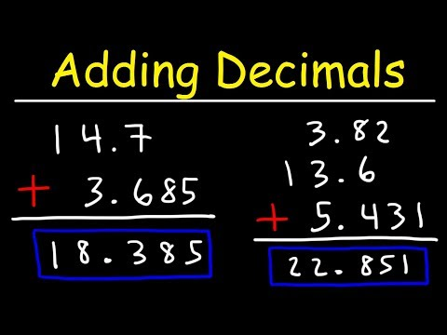

- When we add money, we are just adding decimals. The only difference is that we add this symbol $
- Open the attached document called “Snow Man Money”. You can print the sheet or copy onto paper. Compare your work to the answer page that comes after the questions.

- Game Time! Decimal Dice-You need a partner, 3 dice, paper and pencil. Roll three dice to create a decimal. For example: 2, 3 and 5=5.32 or 2.35 etc. Roll to make a second number. Add these two numbers while your partner takes their turn. Compare your answers. Person with the greatest sum wins.
Part Two: Literacy

Outcome(s): GCO 4-Students will be expected to select, read, and view with understanding a range of literature, information, media, and visual texts.

- Let’s Read!
- Click https://classroommagazines.scholastic.com/support/learnathome/grades-3-5-week-4.html
- Select Week 4 and then scroll down to Day 16. Click to read the story called A Small World.
- Check out the two great videos at the bottom of the page or check out the writing activities.

- Word Work with Words Their Way -Open the attachment called WTW and complete these activities.
- Word Sort Preparation
- Put last week’s words in the recycle bin and use the same baggie for the new words this week
- Print off your words and headings and cut them out OR write each word/heading on a small square of paper.
- Read each word, then lay out your headings. Sort the words using your headings. Check your work.
- Mix up the words and sort again. Check your work and make changes if needed.

- Speed Sort
- Shuffle your cards and lay out the headings.
- Use a timer to see how quickly you can correctly sort your cards.
- Record your finish time. Try two more times and record your results.
- Put your words/headings in a baggy or somewhere safe so you can use them all week.

Day Two

Part One: Numeracy

Outcome(s): N11- Demonstrate an understanding of addition and subtraction of decimals N5- Describe and apply mental mathematics strategies to determine basic multiplication facts and related division facts to 9 × 9

- Math Facts Practice:
- Sign in to Sum Dog and practice your math facts for 15 minutes!

- Decimals:
- Watch part of this video about how to add money
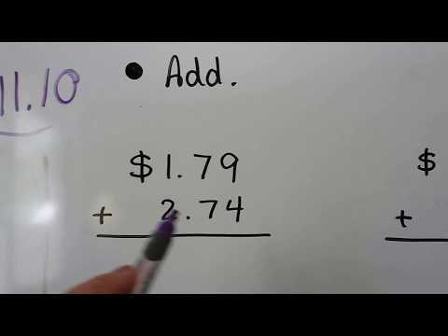
https://www.youtube.com/watch?v=ipXJocWnhIw STOP AT 5 MINUTES 40 SECONDS

- Open the attached document called “toy shop money”. You can print the sheet or just copy them onto paper. Afterward, see how you did by comparing your work to the answer page that comes after the questions.

- Game Time! Your choice- play “Strike Out”, “Decimal Dice” or “War” with cards. Have fun!

Part Two: Literacy

Outcome(s): GCO 4-Students will be expected to select, read, and view with understanding a range of literature, information, media, and visual texts. GCO 8- Students will be expected to use writing and other forms of representation to explore, clarify, and reflect on their thoughts, feelings, experiences, and learnings; and to use their imaginations.

- Let’s Read!
- Click https://classroommagazines.scholastic.com/support/learnathome/grades-3-5-week-4.html
- Select Week 4 and then scroll down to Day 17. Click to read the story called Lego Builder.

- Let’s Write!
- Watch the video "Veronica the LEGO® Master". Think about the things you have built with blocks or LEGO. How is your building process similar to Veronica's? How is it different?
- Draw a plan for a LEGO model you would build. How many LEGO bricks would you need to create it? What shapes of LEGO bricks would you need?

Day Three

Part One: Numeracy

Outcome(s): N11- Demonstrate an understanding of addition and subtraction of decimals N5- Describe and apply mental mathematics strategies to determine basic multiplication facts and related division facts to 9 × 9

- Math Facts Practice:
- Sign in to Sum Dog and practice your math facts for 15 minutes!

- Decimals:
- Watch this video about how to add and subtract money https://www.youtube.com/watch?v=EPdkGwXjf7c
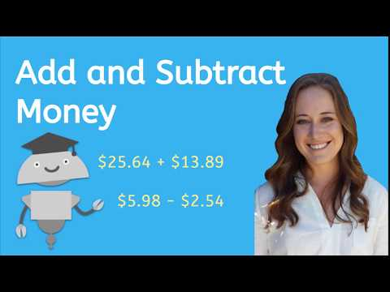

- Open the attached document called “money circles”. You can print the sheet or just copy them onto paper. Afterward, see how you did by comparing your work to the answer page that comes after the questions.

- Game Time! Play Decimal Dice, Strike Out or War with a partner.

Part Two: Literacy

Outcome(s): GCO 4-Students will be expected to select, read, and view with understanding a range of literature, information, media, and visual texts.

- Let’s Read!
- Click https://classroommagazines.scholastic.com/support/learnathome/grades-3-5-week-4.html
- Select Week 4 and then scroll down to Day 18. Click to read the story called Saving the Dolphins (don’t forget about the Text to Speech option on the left).
- After you read, scroll to the bottom of the page and check out some of the things in the multimedia section.

- Words Their Way Activities
- Word Hunt
- Write your headings on a piece of paper.
- Take out your reading at home book and find words to match the headings.
- Write each word under the correct heading.
- Try to find at least 3 for each category

- Blind Sort
- Write your headings on a piece of paper.
- Ask someone to choose 10 words from your sort.
- As your partner reads the word, you write it in under the correct heading.
- When you finish, check for correct spelling and headings.

Day Four
Part One: Numeracy

Outcome(s): N11- Demonstrate an understanding of addition and subtraction of decimals N5- Describe and apply mental mathematics strategies to determine basic multiplication facts and related division facts to 9 × 9

- Math Facts Practice:
- Sign in to Sum Dog and practice your math facts for 15 minutes!

- Decimals:
- Watch this video for another explanation of what to do when you subtract money START THE VIDEO AT 5 MINUTES 45 SECONDS https://www.youtube.com/watch?v=ipXJocWnhIw

- Open the attached document called “subtract money”. You can print the sheet or just copy them onto paper. Afterward, see how you did by comparing your work to the answer page that comes after the questions.

Part Two: Literacy

Outcome(s): GCO 4-Students will be expected to select, read, and view with understanding a range of literature, information, media, and visual texts. GCO 8- Students will be expected to use writing and other forms of representation to explore, clarify, and reflect on their thoughts, feelings, experiences, and learnings; and to use their imaginations.

- Let’s Read!
- Click https://classroommagazines.scholastic.com/support/learnathome/grades-3-5-week-4.html
- Scroll down to Day 19 and click the article called “Dog Dectectives”.
- After reading, scroll to the bottom of the page and click the link to watch the “Dogs With Jobs” video.

- Let’s Write! Choose one of these activities:
- Ask someone in your family to prepare two or more items that have strong smells, without telling you what they picked. Then close your eyes and have them place the items on a table. Now, with your eyes closed, smell each item. Can you guess what it is? Can other family members guess what it is? Write a paragraph describing your results.

- Watch the video "Dogs With Jobs" below. Then think about another job dogs could do that was not described in the video or in the story. How would you train a dog to do that job? Make a drawing that shows the dog at work. Include step-by-step written instructions on the training.

Day Five
Part One: Numeracy

Outcome(s): N11- Demonstrate an understanding of addition and subtraction of decimals N5- Describe and apply mental mathematics strategies to determine basic multiplication facts and related division facts to 9 × 9

- Math Facts Practice:
- Sign in to Sum Dog and practice your math facts for 15 minutes!

- Decimals:
- Watch this video for another explanation of how to subtract money amounts https://www.youtube.com/watch?v=98hch48GYtM
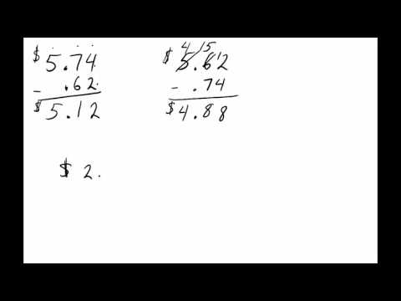

- Open the attached document called “fix the money mistakes”. Carefully read the directions and see if you can solve the questions correctly. You can print the sheet or just copy them onto paper. Afterward, see how you did by comparing your work to the answer page that comes after the questions.

Part Two: Literacy

Outcome(s): GCO 4-Students will be expected to select, read, and view with understanding a range of literature, information, media, and visual texts.

- Let’s Read!
- Click https://classroommagazines.scholastic.com/support/learnathome/grades-3-5-week-4.html
- Scroll down to Day 20 and click the article called “Yo-Yo Pros”.
- After reading, scroll to the bottom of the page and watch the “Betty Gallegos in Action” video.

- Word Work with Words Their Way
- Sentences
- Choose 5 words from your sort and write one sentence for each word.
- Have someone check your work for: capitals, periods, and correct spelling.
- Choose 5 more words from your sort and repeat.
- When you’ve finished, put the words and headings in the recycle bin.

SCIENCE AND PHYSICAL EDUCATION IDEAS ARE ON THE NEXT PAGE

Scienc and Physical Education Grade 3-5 | 4-8 May 2020
Science
Spring is in the air! The grass is starting to grow and soon the first flowers of 2020 will start to show their colours. You know the best way to lear about flowers is to start with dirt. What is dirt and why do things grow in it? Can flowers grow without dirt? Watch the video below to learn a little about dirt and why it is so important!
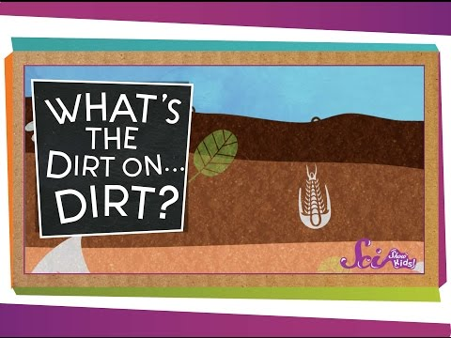 | Did you know there are different layers to dirt? Want to see them? Let’s try a little expirement!  You will need:  - Glass jar or other see-through container with lid  - Soil from your yard (ask an adult first)  - Water  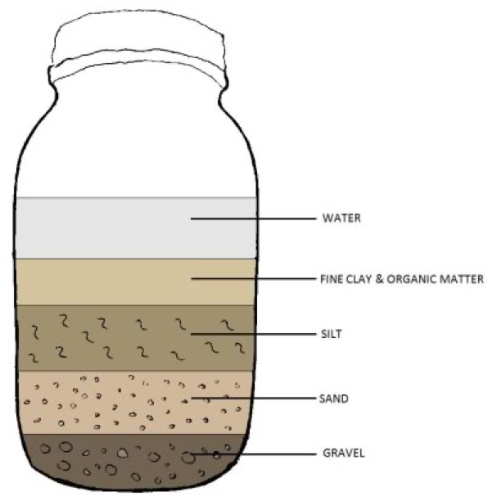  1. Measure out 2 cups of soil from the bag you brought from home. (Don’t forget to remove plant material and rocks so you can achieve accurate results!)  2. Put the soil into the quart-size jar.  3. Add water until the jar is almost full! (You might see air bubbles rising!)  4. Close the lid tightly and shake the jar for about 3 minutes or until everything is mixed.  5. Set the jar in a safe place and leave it for 1-3 days or until the particles have all settled. Do not mix again.  6. After the sediment has settled, you will see three distinct layers in your jar.  7. Draw or take a picture of the different layers of soil and share it with us!
You can try this with soild samples from different areas! I bet you will see different results! Be sure to share your projects with me! Alison.bush@nbed.nb.ca

Physical Education
Physical Education is self directed at home but if you are looking for a couple of suggestions check out these!
Get out side!!  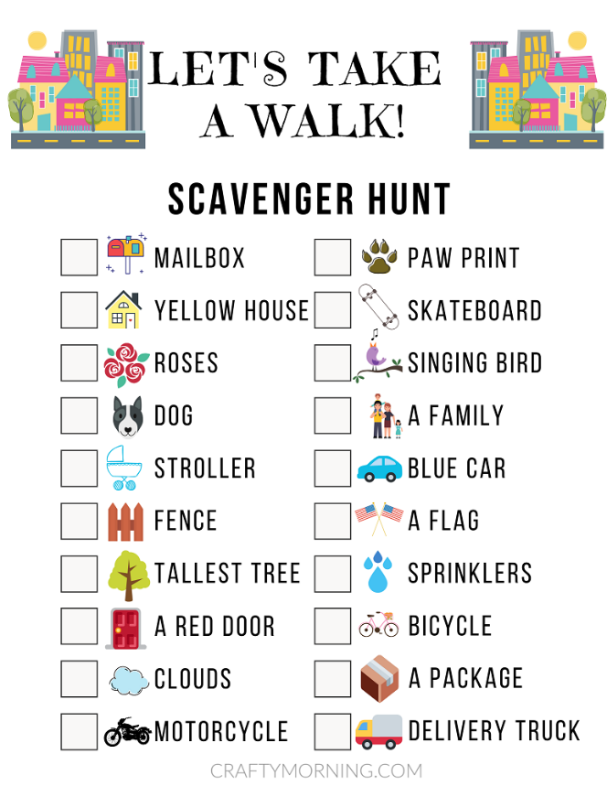  Go for a walk! Make it fun by trying a neighbourhood scavenger hunt!  Try this one or make your own! Share it with us!  https://cdn.craftymorning.com/wp-content/uploads/2020/04/Neighborhood-Scavenger-Hunt-4.pdf |  |  |  |  | I hope you keep practicing your Jump rope skills!  https://www.youtube.com/watch?v=n7u1gvoXdG0  For the Advance Skippers Here are some tricks!  https://www.youtube.com/watch?v=UTntXRW4wYk  Stuck inside?  Why not try some cup stacking! Use plastic cups or any disposable cups! 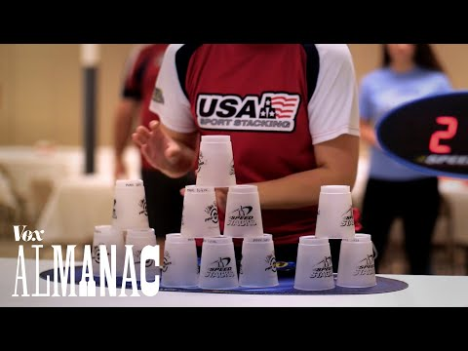It is a great way to develop hand-eye cordination!  Check out these videos to learn the differnet ways to stack! If you want take a moment to shoot a video and share it with us!  https://www.speedstacks.com/learn/?lang=en
 |  |  | Weekly Challenge – What can you make with a single piece of paper?
Online resources:
https://scratch.mit.edu/ or www.code.org
- Students who wish to access their account can email alison.bush@nbed.nb.ca for their login and password.
https://musiclab.chromeexperiments.com/Song-Maker/ - Make some music. Share your links with Ms. Bush!
https://www.incredibox.com/demo/ - Make beatbox rhythms on this site! A definite favourite in the older grades!
http://isleoftune.com/ - a creative music making site!

