Week 5 Continuation of Learning May 11-15, 2020.
Grade 2 Belyea

Hello Everyone,
On Wednesdays I will be checking my email, from 10-11 am to answer any questions you may have. I really like what parents are doing at home and appreciate your support.
In addition to the activities suggested, students are encouraged to:
- Read daily for 30 minutes- Take time to read to or with your child and encourage them to read independently.
Scholastic Read at home: divided up by day 1, 2 etc.., with activities and reading.
This is a great link for SCIENCE
2.https://classroommagazines.scholastic.com/support/learnathome/grades-1-2.html
Grades1-2
https://classroommagazines.scholastic.com/support/learnathome/grades-3-5.html Grades 3-5

3. EPIC books- available during the day
https://www.getepic.com/ - Our class code is zgc2046

This is a science resource that ASD-W sent teachers to share about birds:
https://evergreen.us6.list-manage.com/track/click?u=6e3aa88e67&id=8f017a5d00&e=9899ddd14f
READ:
Use your toys to act out a book that you have read or a show you have watched this week. Will you change the ending or keep it the same?

- ZEARN numeracy site- continue you mission by doing a few minutes a day.
- www.zearn.org

Literacy Learning at Home

Here are some options for you to choose from to help improve your literacy
skills while you are at home. Challenge yourself to try one each day and have fun!

WRITE:
Keep a daily journal of the signs of spring. Write down any changes you notice outside from day to day. Are there buds on the trees yet? Have any flowers sprouted or grown taller? Do you notice the grass turning green? Add illustrations to your journal to document the changes you see.

EXPLORE
Create Think of an incredible moment with a special person and the place. a storyboard using stick figures. Sketching helps you remember details.

CREATE:
Go through a photo album or photos on your phone and tell your child the story of that photo (beginning, middle, end, where it took place, who was there). Have your child choose a different photo and tell a story that matches the photo.

SHARE:
Spread out a blanket in your yard or find a cozy window spot. Invite a family member to join you. Begin cloud watching. What do you see, what do you think, what do you wonder? What objects do the clouds remind you of?

Numeracy- choose one a day to try/visit Zearn/Play a game

Grade Two Choice Board
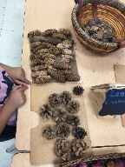  Counting collections  Choose an amount of nature objects to find outside and start to gather them.  or  Gather a collection of nature items and then count them.  -Organize your counting collection in groups of 10 to make it easier to count. Can you make 100?  -Can you count your collection by 5s?  -Can you count by 3s?  -What counting collection could you count inside? | Number Talk  How do you see this image?  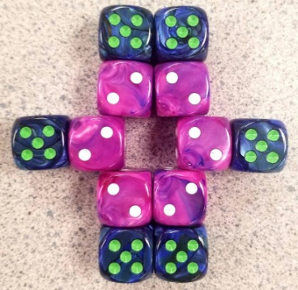  Explain other ways you can see it. | 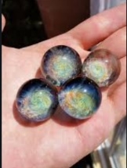  Guess my Missing Part  -Place a collection of 10 small items in your hand. (marbles, coins, rocks, macaroni)  -Put your hands behind your back then show your partner one of your hands  with some of the collection in it.  -Your partner must decide how many are still in the hidden hand.  Challenge: When ready play with a larger collection up to 20 items.
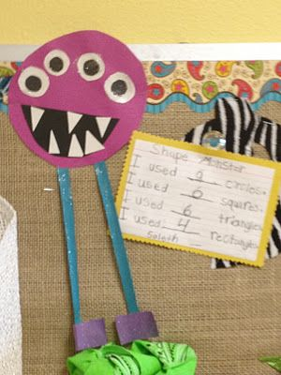  Shape Monsters  Use a variety of 2D shapes to make, draw, or paint a 2D shape monster.  When your monster is finished, count how many of each 2D shape you used. | Magic Square  Using the digits from 1-9 only  once, place the numbers on the  grid so the sum of each row and  each column equals 15. | 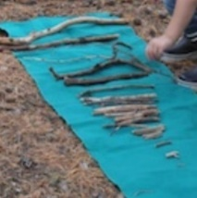  Measuring Sticks  1) Find a variety of sticks that are different lengths. Order them from shortest to longest or shortest to tallest.  2) Choose a stick. Find two more sticks that are longer/shorter or the same length as your chosen stick.
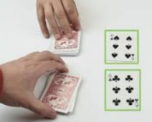  Fast facts  Use a deck of cards with face cards removed. Deal out half the cards to each player with the cards facing down in a pile. Both players take the card on the top of their pile and lay it face up in the middle. The first player to call out the sum of the two cards wins both cards. If it is a draw the cards are left on the table. Turn 2 more cards over and whichever player wins, picks up all the cards in the middle.The winner is the player with the most cards once all the card have been used.  Variation: Play with the same procedure but find the difference. | Pattern Art  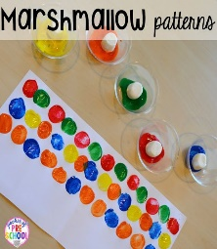  Use markers, crayons, paint or bingo daubers to create pattern caterpillars.  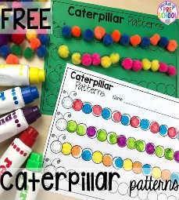  Try making some of the following pattern caterpillars AB, AAB, ABB, ABC, AABB, ABBC, ABCD.  Don’t forget antennas, eyes and a smile! | Make a Math Book  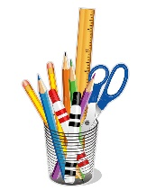  Get out some paper and create your own math book to share with someone else!  It could be about counting, patterns, shapes or adding and subtracting. There are so many math ideas to explore!

