Pink Shirt Day 2023
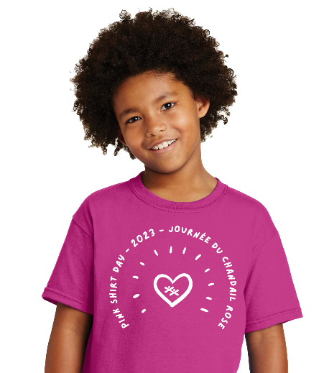

Dear Families,
Pink Shirt Day is coming up on February 22! This is a day that we celebrate kindness, and we wear pink to show our support. This year, we are participating in a school fundraiser that allows families to purchase a pink kindness t-shirt and support our school at the same time. Each T-shirt costs $12/$14 and the proceeds - $2.50* from every shirt ordered comes back to our school to fund a kindness centered purchase! If you are interested in purchasing T-shirts for your family, they are available in both children’s and adult sizes. Please complete the order form below and return the form to school by Friday, January 27, 2023. Payment can be made online, via School Cash only. We will not be accepting any cash. Thank you for supporting our School!
(* The $2.50 rebate does not apply for shirts in sizes Adult 2xl-5xl due to the higher production costs, but they can certainly still be ordered)

Pink Shirt Day 2023 - School order form
Student’s Name: |  |  |  |  |  | Classroom Teacher:
Parent’s Name: |  |  |  |  |  | Phone Number:
Child Sizes - $12 |  |  |  |  |  | Adult Sizes (Unisex) - $14
Size: | XSm  (2-4) | Sm  (6-8) | Med  (10-12) | Lrg  (14-16) | XL  (18-20) | Sm | Med | Lrg | XL | 2XL | 3XL | 4XL | 5XL | Total Cost:
Quantity

