HALLOWEEN SPIRIT @ HUBBARD
Our Halloween Fun Night is BACK!!! Save the date for a night of games, candy and fun for everyone! More details to follow soon.
Along with our most popular fundraiser of the year, we will be having some school spirit fun! Please see below so you will be prepared!

 | TUESDAY  25TH | WEDNESDAY  26TH | THURSDAY  27TH | FRIDAY  28TH |  |  | HALLOWEEN MONDAY  31ST
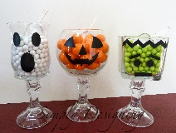 | Candy Guess this Week  .25 cents per ticket  A chance to win one of 3 candy jars of treats!
THEME |  |  | Crazy Hair Day |  |  | Orange & Black  Day
 | Halloween Door Decoration Competition Begins! |  | Halloween Scavenger Hunt,  (completed by class, with teacher) | Halloween Intercom  Bingo! |  | Candy Guess Winner Announced Today!  Halloween Door Winner Announced Today!
Noon | Grade 3  Sock-hop  $1 | Grade 4  Sock-hop  $1 | Grade 5  Sock-hop  $1 |  |  | Monster Mash  Outdoor Spot Dance  FREE  Prizes to be won!
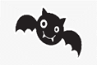 |  |  | HALLOWEEN FUN NIGHT!  6PM TO 7:30PM  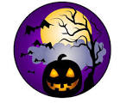 |  |  | 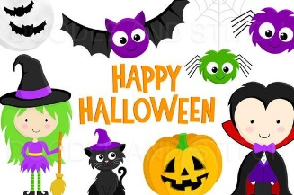  STAY SAFE TONIGHT!

