Introduction to Determining Limits in Piecewise Functions

In this section, you will investigate how one-sided limits are applied to piecewise functions. You first saw piecewise functions when you wrote the equation for the absolute value of a linear or quadratic function in Pre-Calculus 110.
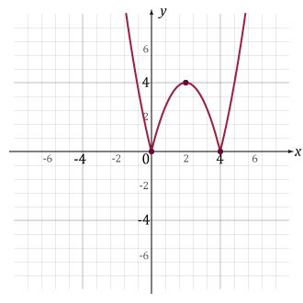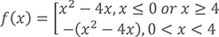
A piecewise function is one in which multiple functions (or sub-functions) are used to define it over different parts of its domain. For example:
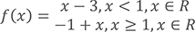
The corresponding graph looks like this:
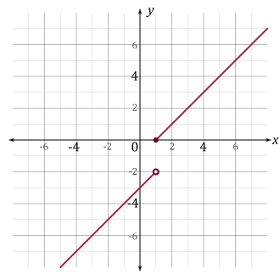
Therefore, this piecewise function is discontinuous at x = 1.
Let's investigate the limits as x approaches 1:
Based on the one-sided limits above, what do you know about the limit of f (x) as x approaches 1?
Because the left- and right-sided limits are not equal as x approaches 1, then the limit of the function does not exist as x approaches 1.

