Music Through the Decades
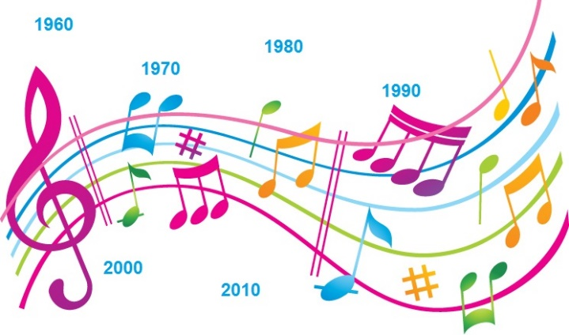

Your Assignment: Choose a decade between the 1950’s and the 2000’s. Then, do research on that decade. You need to show at least 5 of the following:

Popular songs | Popular genres | Popular artists
Popular dances | Big Events | Important topics of the time
Movements | Important changes | Other

- Choose one (appropriate) song to show to the class that you believe sums up this decade. Explain why you think so.
- Present your work in a way of your choice. Some options are: PowerPoint, Scrapbook, photo album, Bristol board, etc. If you have other ways you would like to present it, please see Mrs. Miner for approval.
You will have 4 weeks to work in the BBT lab – You do not need to spend all of your time on the computers. You will have one week to work in class.

Due Date: April 16th

^{Rubric:}
Required Elements | Possible | Score
Information: You have given a significant amount of information about your chosen decade. The information is relevant, and you have spoken about key people, events, songs, and artists of the time. There is no information that is not about your decade. | 20
Pictures: 5+ pictures that relate to the information within your project. More if necessary. | 5
Quotes: 3 direct quotes about the decade or from popular people/artists. | 6
Song and explanation: Your song is from the correct decade and you have explained why it is relevant. | 4
Feedback to others: You have listened to others and have commented on their songs and decades. | 5
Comments:

Total:

Other things you could mention…
- Key political figures
- Oscar winning films
- Fads of the decade
- Broadway plays
- Speeches or direct quotes from influential people
- Clothing fashions
- Inventions
- Radio or TV shows
- Music of the time (MP3 audio for extra credit)
- Popular entertainers
- Sports figures / happenings
- Significant books
- Significant scientific or humanitarian advancements
- Important businesses or industries
- Wars or military conflicts occurring during the decade

