There are lots of different parts in a long division equation. Make sure you know what they mean and how to identify them.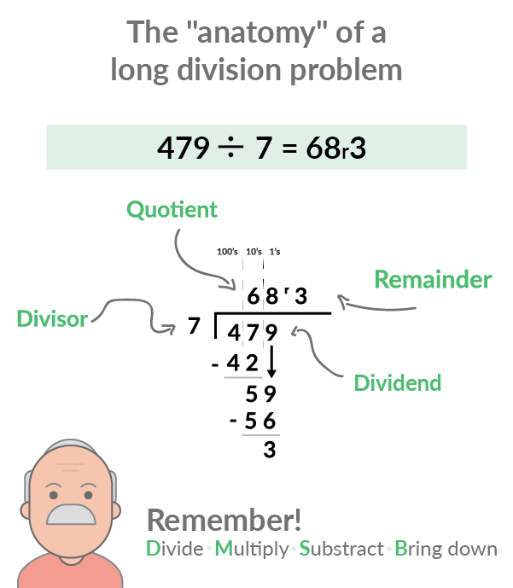

The dividend is the number on the right side of the equation, under the line. It represents the amount being divided.
The divisor is the number on the left -- it’s the one doing the dividing.
The quotient is the number on the top. It represents the answer, or the number of units in each place value once the equation has been completed.

The remainder is the number on the top right. It represents the units left over that can’t be evenly divided into the quotient.

Example: 46 ÷ 2

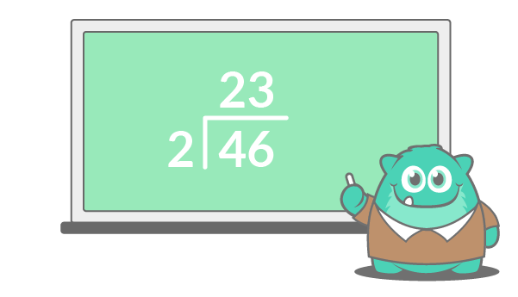
How many times does 2 fits into 4? If you want to share 4 objects between 2 people, how many objects does each person get?
Put the 2 above 4. Then, repeat the step with the second digit in the dividend.

