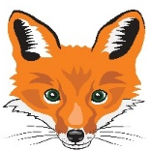
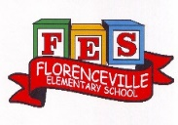
FLORENCEVILLE ELEMENTARY SCHOOL
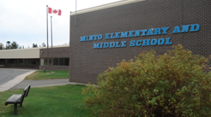
At FES our vision is to be a community where everyone is empowered to be lifelong learners.
HOME LEARNING PLAN
April 27- May 1 2020

4/5 Shaw | CLASS BLOG: https://spoirier.edublogs.org/
Laurea Shaw | Laurea.shaw@nbed.nb.ca, (H) 506-375-4779, (C) 506-323-2214
Sarah Mahar  Bridget Nugent | Principal: sarah.mahar@nbed.nb.ca; Vice-Principal: bridget.nugent@nbed.nb.ca
Cindy Crowhurst | Resource: cynthia.crowhurst@nbed.nb.ca
Dianne Lord | Guidance: dianne.lord@nbed.nb.ca
School | florencevilleelementary@nbed.nb.ca http://web1.nbed.nb.ca/sites/ASD-W/fes

Suggested Learning Activities
Literacy
Oral Language- Listening to music and shows in French is a great way to review and develop your oral language. Here are some suggestions of things that you can listen to and watch. (You can slow the speed of videos down when you are watching YouTube.)  Listen to these songs:  L’arbre est dans ses feuilles https://www.youtube.com/watch?v=ZE6tuXy4Xfw)  Le printemps, Matt Maxwell https://www.youtube.com/watch?v=yKKWNJ8qsss  Quel temps fait-il? -Alain le Lait https://www.youtube.com/watch?v=eBvJVOuBPXI  Ecoutons la radio, Gregg LeRock https://www.youtube.com/watch?v=vNKLgZreJ-4  Videos/shows to watch:  Demain, les énergies renouvelables - L'énergie éolienne  https://www.youtube.com/watch?v=1O2OX6-wRb0  D'où vient le vent? https://www.youtube.com/watch?v=QX7jTTbe9pQ  Do you want to challenge yourself? Watch this: Du vent dans les voiles - C'est pas sorcier  https://www.youtube.com/watch?v=L4JBaZY3A28 | Reading – (Students are encouraged to read in both French and English throughout the week). Talk about books that you read (or movies that you watch) by discussing some of the following questions:  - If you had to pick two main characters in the story, who would they be?  - Did the setting (where the story took place) play a role in the story? Could the story have happened somewhere else?  - What did you like best about the story?  - If you didn’t like the story, what was it that you disliked?  Here is a French book that you can listen to on YouTube called Le Lapin de printemps https://www.youtube.com/watch?v=zYWxXErpndo  If you do not have French books at home, there are websites that you can access French books. Explore these and read (or listen to) French books that are a “good fit” for you (not too hard, not too easy). https://boukili.ca/fr  https://www.readinga-z.com/worldlanguages/french/leveled-books/
Word Work:  -Visit this website to play a Spring Word Game https://www.logicieleducatif.fr/francais/mots/mots-printemps.php (springtime word scramble)  -Using the spring word list below (or word wall list) to practice 5 words a day by rolling a dice and following the instructions: | Writing – Here are a few writing ideas for this week. You can choose one to work on throughout the week or a different one each day. If you want to go back to last week’s ideas, please do so. Don’t forget to make sure that you use capital letters and punctuation where they belong. Think about who will enjoy (or learn from) reading your writing after you are finished.  - What makes spring a great season? Tell what you like to do in spring. What are some things you can do in spring that you cannot do in any other season?  - Sit outside (or look out your window). What do you see? What do you hear? What do you smell? What do you feel?  - Create a scavenger hunt for your family. Write out a list of things that they need to find outside and see who can find them all.  - Weather observations: Go outside at the same time each day and write your observations. What is the temperature? Is it windy? What direction is the wind coming from? What does the air feel like? You could create an observation chart or use the one your teacher provides.

Numeracy  Material needed for this project:  Plastic container  Toothpick  Paper/math number sheet  Pencil | Fun and challenging Math  Spring is here and with spring comes flowers!!! Outside you should see many flowers or weeds peeking up through the snow that has dry seeds on them.  - Go outside and collect a bunch of seeds in a plastic container.  - Once inside, count your seeds. Using a toothpick could make it easier to separate your seeds. You might choose to put them in groups of 2, 5, 10’s or more, while you’re counting them.  - Once you know how many seeds you have, write the number down on the math number sheet.  - Write your number of the week in all the different ways that is mentioned on the sheet. If you are not able to print out the math number sheet, you can copy the information onto a sheet of paper you have at home. This will become your number of the week.  Once you are done counting your seeds, do an art project with them. Be creative and have fun!
Other areas of interest/learning experiences | Sciences & Arts:  - Your challenge this week in Sciences is to create a Pinwheel (you can do this using recycled materials, I.e. cereal boxes, newspaper etc.)  - Observe your pinwheel outdoors and try to discover how windspeeds and directions may affect your pinwheel.  - Try standing in different spots around your house and write down your observations.  Example  Place What I saw Time  Stood on the deck The pinwheel was moving very fast. 10:00 am  Arts: Be creative, use tons of colours on your pinwheel. Try different recycled materials!  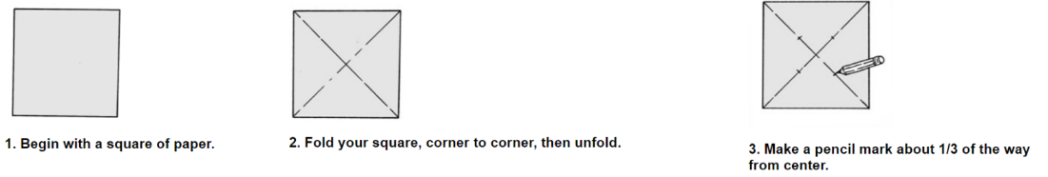  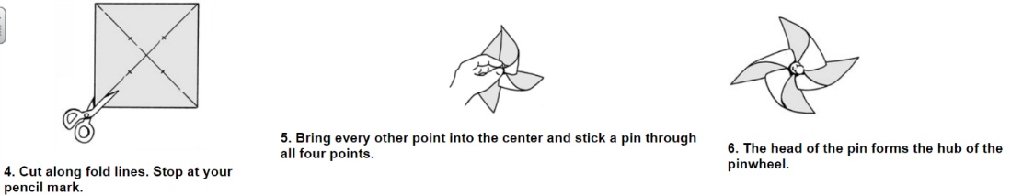  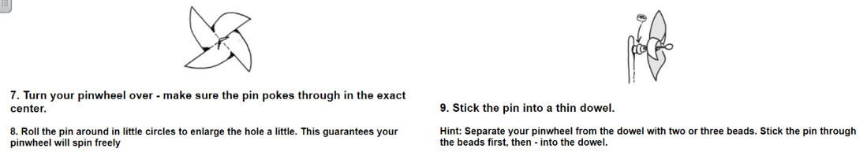
English Language Arts | Reading:  I know many of you love to read, so keep it up! If you haven’t already checked out EPIC! Books please do so and sign in with our class code: clv2908  If you run out of books at home, another great source is the soraapp.com. You can use the website version or download the free app on your tablet or phone. You will need your school username and password to access the books. This is the same username and password that you used for Fresh Grade. (*school name is New Brunswick Department of Education and Early Childhood- not Florenceville Elementary  April is Poetry Month, so feel free to check out this website: poetry4kids.com. There are a variety of poems on this site. Some will make you laugh and some will make you think!  Writing:  I know you all love to write and love to write about many unique, interesting topics. Now would be a good time to start keeping a journal of this part of our lives. If you prefer fiction, one idea might be to write an “I Survived…” story about these times. Maybe you would even like to try some poetry this week. J
Mindfulness | Here are three ideas of things you can do to help you feel calm, relax and mindful during spring.  - Clean your bedroom. Get rid of clutter and things you no longer use (donate when it’s appropriate, recycle what you can and reduce the number of things you keep.) Having a clean bedroom can help you feel relaxed and calm.  - Find a new recipe that you would like to try. Ask your parents if it would be okay to try this recipe, write down the steps and help prepare.  - Watch for birds. Bird watching can be very peaceful and relaxing. Take note of the birds you see and try not to spook them away. Bird watching requires you to be very calm and quiet.
Looking Ahead | Next week, we will begin planning some “Spring Planting.” If possible, when you are grocery shopping, could you pick up a packet of seeds or two for your child. DO NOT worry if you don’t, they can be creative and use seeds that they find in their foods or dried on trees and flowers from last summer.

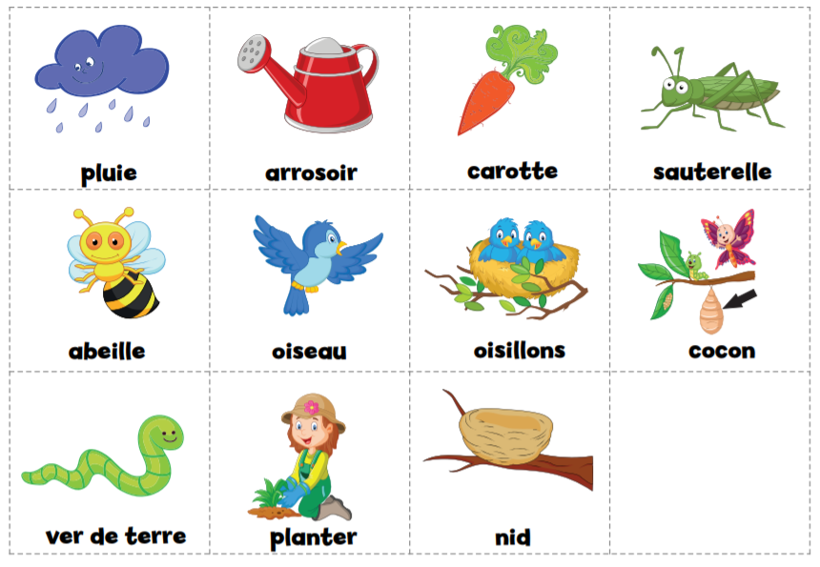
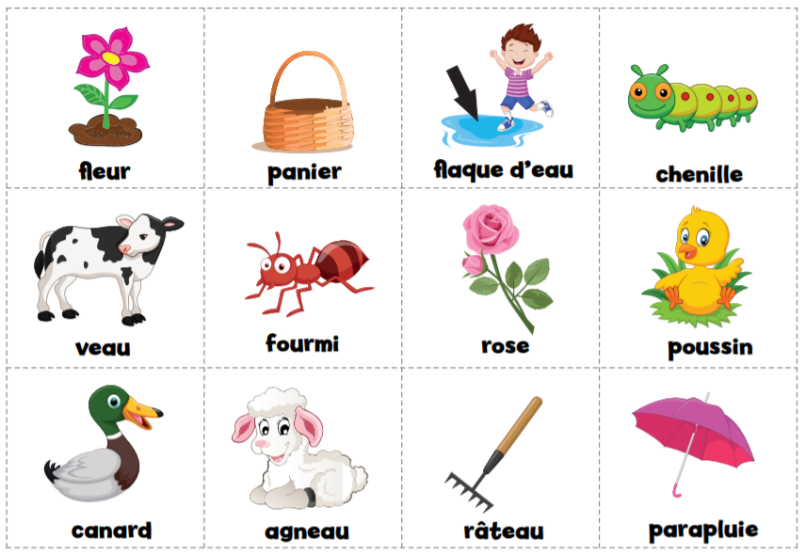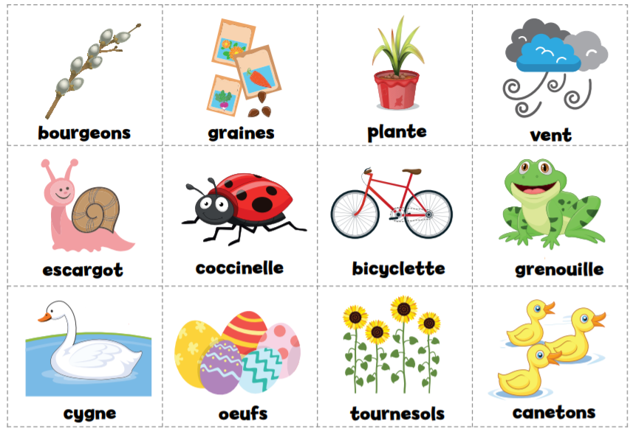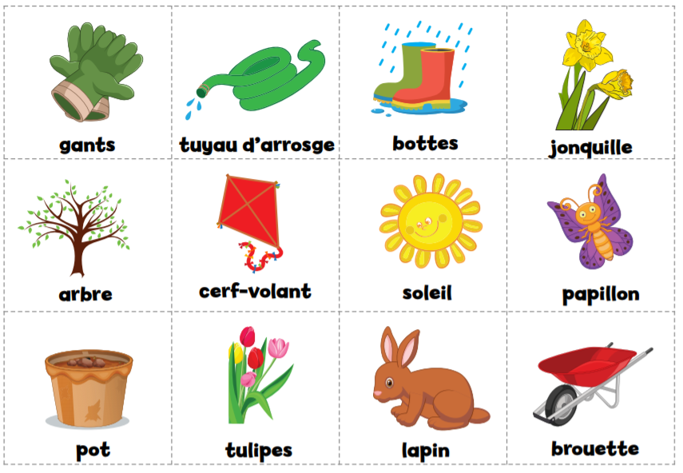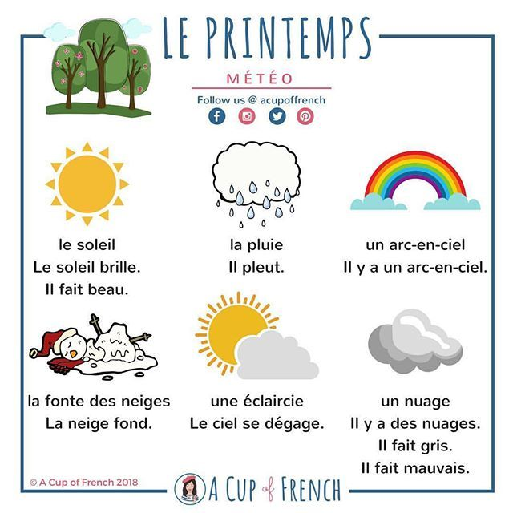

Mon nombre est:

Tableau de valeur de position :

Centaines de millier | Dizaines de milliers | Milliers | Centaines | Dizaines | Unités
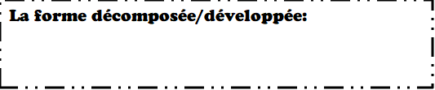
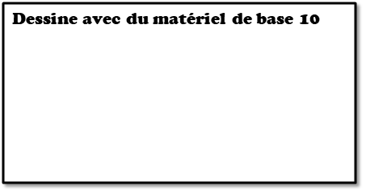
20 de plus
300 de plus
50 de moins

 | météo | température | vent
lundi
date : _________
mardi
date : _________
mercredi
date : _________

jeudi
date : _________

vendredi
date : _________

