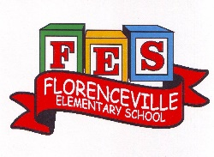
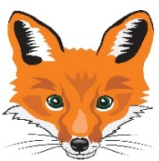
Florenceville Elementary School

At FES our vision is to be a community where everyone is empowered to be lifelong learners.

PRIMARY HOME LEARNING PLAN

Grade: | Grade 2 French Immersion
TEACHER | Molly Kearney: molly.kearney@nbed.nb.ca  Charlotte Dufort: charlotte.dufort@nbed.nb.ca
Sarah Mahar  Bridget Nugent | Principal: sarah.mahar@nbed.nb.ca;  Vice-Principal: bridget.nugent@nbed.nb.ca
Cindy Crowhurst | Resource: cynthia.crowhurst@nbed.nb.ca
Dianne Lord | Guidance: dianne.lord@nbed.nb.ca
School | florencevilleelementary@nbed.nb.ca

In accordance with the communication sent from our Minister of Education, Dominic Cardy, on April 2, 2020, Home learning opportunities to support literacy and numeracy outcomes will be made available online weekly by Teachers.
Families are encouraged to:
-Support their children to complete the options below for an average of one hour per day.
-Read aloud with their children daily; and
-consider daily physical activity and free play as an important part of their child’s mental health and skill development.
Subjects | Description of Learning Activities
GENERAL INFO | Week 6: May 19th- May 22nd  Visit blog this week and take time to explore different pages  BLOG: madamekearney.edublogs.org
Science: | - Mini TFO:  https://www.youtube.com/watch?v=2hnxDEM6riI  - Bird watching sheet below lesson plan  -Go outside and watch for birds. When you see one, complete the bird watching sheet.  - Be creative at home and find a science experiment online to try!  -Post pictures of videos on the Facebook page to share!  Examples: https://www.youtube.com/watch?v=4MHn9Q5NtdY
Literacy: Vocabulary Games | Vocabulary games (at the bottom of this document to print if possible)  -La phrase secrete (new version for week 7)  - Print paper or snap shot page.  - One person choose a sentence and writes it down without the other one seeing.  - Then the player has to try to guess the sentence by using the correct sentence structure.  -How to play Zut! (2 players or more)  Print on cardstock and cut words individually or write the word on the end of Popsicle sticks.  - Rock paper scissor to know who goes first.  - 1st player turns a card and must read it correctly and then create a sentence using the word. The player keeps the card.  - 2nd player takes a card and reads the word and then creates a sentence using the word.  ** If a player does not read the word correctly, they return the card in the game.  **If a player gets a card with ZUT! , they must return all the cards they had back in the game pile.  Try to get all the words without getting the cards with ZUT!  Have fun! Good luck!
Literacy:  Online | - Sight words (5 minutes):  -donne  -donner  -dors  -elles  -fort  Link: https://youtu.be/42Yd0RUjRv4  You can then create a sentence using the words. Don’t forget your capital letter and the period at the end.  - CONTINUE : Spend 15-20 mins of reading & activities on the Litteratout site  EXTRA: Another great blog is www.asdw2fi.weebly.com
Literacy:  Video links | Zou jour de pluie  https://www.youtube.com/watch?v=_6ed6sVf_ks  Mini TFO :  https://www.youtube.com/watch?v=kMeoeuQ-cXg  Toupie et Binou : Le rock du dodo  https://www.youtube.com/watch?v=cT2LjUkBLRo  “Le printemps”  https://www.youtube.com/watch?v=0I95awpaDpY&feature=youtu.be
Literacy: Reading | - ONLINE BOOKS :  Histoire-passe-partout  https://coucou.telequebec.tv/contes/44616/passe-partout/une-sortie-de-peche  L’arbre de Marco  https://coucou.telequebec.tv/contes/47654/passe-partout/l-arbre-de-marco  beaucoup d’histoires  https://coucou.telequebec.tv/contes  beaucoup d’histoires  https://ici.radio-canada.ca/jeunesse/scolaire/emissions  Read books that you have at home. Try reading to a parent, sibling, stuffie, or find a quiet place to read to yourself. Get creative! Find a comfy spot outside to read.  Maybe have a FLASHLIGHT day!!  Literal response questions (read the lines): Find the page that tells us…..What happened first? Next? Who are the characters? What is the setting?  Inferential response questions (read between the lines): What does this picture tell us about the story? Why did this character say …..? How is this character feeling?  Personal Connections: Has anything like this happened to you? What is your favourite part and why? Does this character and yourself have anything in common?  When you’re reading this week, think about the characters you’ve met. (Suggestions)  · What’s the character (s) like?  · How is the character similar to you?  · How is the character different than you?  · How was the character feeling / acting?
Numeracy:  Online | - Continue with IXL  https://ca.ixl.com/  https://www.ixl.com  - Video: Compter par 10  https://www.youtube.com/watch?v=SIYLlgGjSAM&list=PLMb4QBzxFwX-UyVbCbS6HUnFOg-AnHKoS&index=13
Numeracy:  Activities to try at home | Patterns  MATH 1) Grade 2 - Review Patterns: earlier this year, we worked on patterns with 3-5 elements in the core. Our core also needs to repeat at least 3 times in our pattern. This week, we will review creating, extending, and correcting patterns at home.  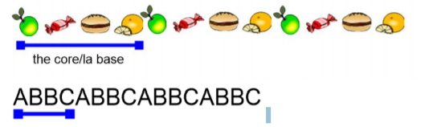  Activities to try: ◊Create a pattern at home using: toys, blocks, dolls, money, a drawing of different shapes, etc. Make sure your core has 3, 4, or 5 elements (things) in it and that your core repeats at least 3 times ◊Ask a family member to create a pattern and see if you can identify the core of their pattern ◊Create a pattern and see if somebody in your house can extend (continue) your pattern. Switch roles, and try to extend a pattern that somebody in your house made for you. ◊Create a pattern with a good core, and then make a mistake somewhere else in the pattern. See if somebody in your home can fix your mistake. Switch roles and try to correct the mistake in a pattern made for you. ◊  Online games:  https://www.abcya.com/games/patterns  https://www.abcya.com/games/fuzz_bugs_patterns  Math Monster  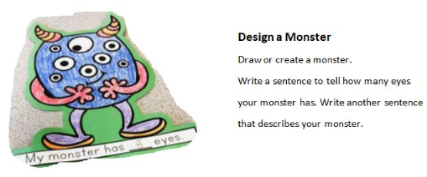
Numeracy:  Games | 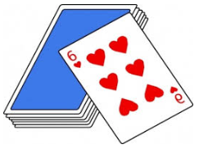  - Addition War  (for two players)  Take a deck of cards and remove the Jacks, Queens and Kings. Each player gets half the deck of cards. Place your pile of cards face down. Each player flips over one card from their pile at the same time. Both players mentally add the two cards together and say the sum of those two cards out loud. The person saying the sum out loud correctly first gets to keep both cards. The game continues until there are no cards left in the piles. The player who collected the most cards at the end wins the game.  - “Go Fish Make 10”  To work on numbers that make 10, you can play “Go Fish Make 10”. See the link below to learn how to play. All you need is a deck of cards with Kings, Jacks and Jokers removed. The Ace is worth one and the Queen is worth 0.  Link: https://www.youtube.com/watch?v=YV-bqdaOWi4  In French, the student starts by saying: Ex: J’ai 2. As-tu 8?  The other player says: Oui, j’ai 8. Or Va pêcher! (if he/she  doesn’t have the number).  - KODABLE  -Madame McBrine told us about Kodable and that students used it last year in her class… she is SO AWESOME and made us our own profile on her Kodable account!  Coding Log-in info:  visit www.kodable.com  - Click "Login" top right hand corner  - Click on "School Profile"  - Enter your class code: MmeMcBrine  - Pick your class (2ième année) and start exploring
Numeracy Videos | - Counting backwards from 20. (compter à rebours)  https://www.youtube.com/watch?v=yTeSxbafgXg  - Listen to a French counting video for numbers 70-100.  Title: « Les chiffres de 70 à 100 – Alain le lait » https://www.youtube.com/watch?v=AnOXzJfLuU4
Physical Education/ Getting outside | MOVING WITH PURPOSE! MAY 2020 (below)  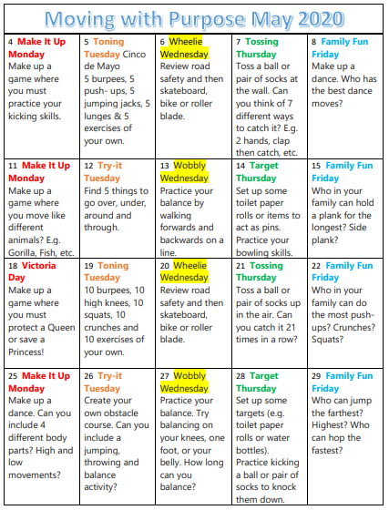  Cosmic Kids Yoga  https://www.youtube.com/user/CosmicKidsYoga  Moovlee  https://www.youtube.com/channel/UCsSS5kMpKCaJ_HhTM9-HKHg/featured  Kids HIIT workout  https://www.youtube.com/watch?v=lc1Ag9m7XQo  Dance Along with Kidz Bop to “Memories”  https://www.youtube.com/watch?v=gFEuf3Bvj0c&list=PLMr-d2PLsO95ydptpBnsxdQNSKc9iUNU0&index=4
Art | Choice 1: how to draw a butterfly  Use link: https://www.youtube.com/watch?v=MIAiglTFgLk  Or:  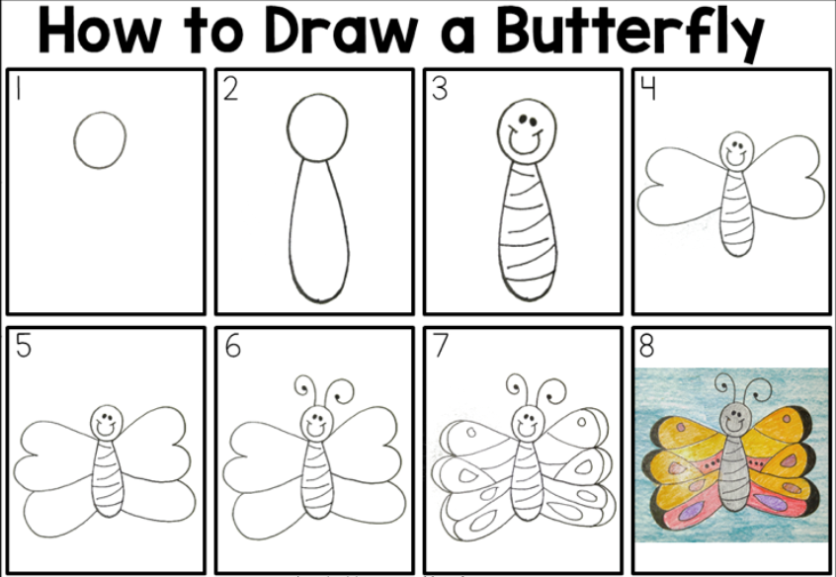  Be creative, add your own designs, ideas and colors  Choice 2: Draw outside with your sketchbook  -We sent sketchbooks home when families came to get things from the school  -Take your sketchbook outside and draw in nature!  Choice 3: Make a birdhouse from recycled materials at home… continued from week 6  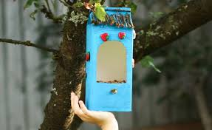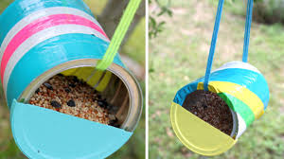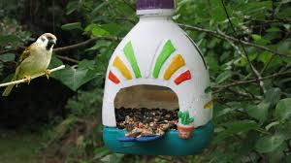  Je fabrique une maison pour les oiseaux!  - Utilise le matériel recycler. (Use recycled material)  - Utilise ton imagination. (Use your creativity)  Then ask a parent to post your bird house.  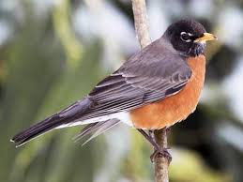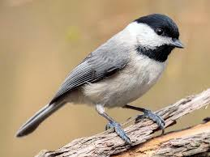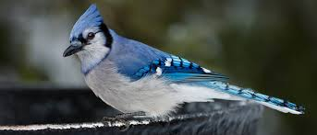

ZUT!

ensuite | alors | mes | tes
veux | vais | ces | est
ils | elle | ZUT! | comment
boit | trois | jamais | pourquoi

garçon | je suis | aime | amie
aider | ZUT! | père | nouveau
jeu | petit | petite | grand
ZUT! | ZUT! | grande | sous

sur | sous | dans | ton
son | ZUT! | ta | sa
parfois | vert | encore | blanche
ZUT! | ZUT! | brun | violet

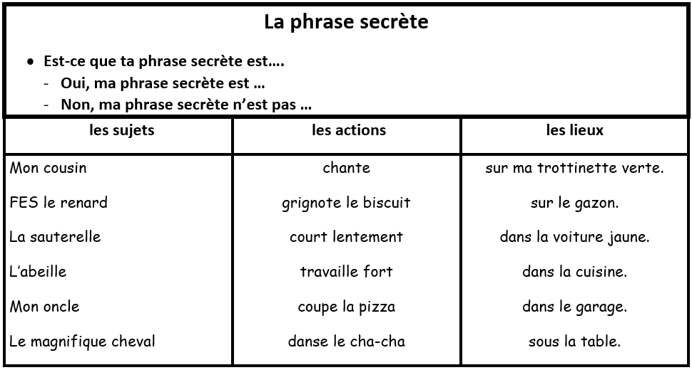

Bird watch:
