PRIMARY HOME LEARNING PLAN

Grade: | Kindergarten/Grade 1 Rachel Doucette
TEACHER | Rachel.Doucette@nbed.nb.ca
Sarah Mahar  Bridget Nugent | Principal: sarah.mahar@nbed.nb.ca; Vice-Principal: bridget.nugent@nbed.nb.ca
Cindy Crowhurst | Resource: cynthia.crowhurst@nbed.nb.ca
Dianne Lord | Guidance: dianne.lord@nbed.nb.ca
School | florencevilleelementary@nbed.nb.ca

In accordance with the communication sent from our Minister of Education, Dominic Cardy, on April 2, 2020, Home Learning Opportunities to support literacy & numeracy outcomes will be made available online weekly by Teachers.
Families are encouraged to:
- Support their children to complete the options below for an average of one hour per day.
- Read aloud with their children daily.
- Consider daily physical activity and free play as an important part of their child’s mental health and skill development.
I have created a webpage with Videos and resources to help you along your way. Everything on this plan is also on the Web Page.

Please Visit Mrs. Doucette’s Primary Concerns
https://mrsrdoucettefes.weebly.com/
Dear Parents: This learning plan is very long for a few reasons. First, there are several pictures. Second, because I wanted to explain everything out. Third, because I teach 2 grade levels. Please do not be scared by its size. Just do what you can and have fun.
Subjects | Description of Learning Activities
Literacy | Word Work  Sight words  - Song for list 1 https://www.youtube.com/watch?v=gIZjrcG9pW0&t=3s  - Song for list 2 https://www.youtube.com/watch?v=E0vWOwIflTs&t=1s  Reading  Asking Leveled questions after you read  - Hand (Literal Questions that can be found in the book)  - Find the page in the book that tells about …  - Tell me what happened in the book. What happened first? Next? Then? Last?  - Head (Inferential Questions ask kids to think more deeply)  - How is the character feeling? How do you know?  - What do you think the character should do? Why?  - Heart (Personal Connection questions that ask student to reflect on the book in a way that relates to them)  - Has anything like this happened to you? Tell me about that.  - What did you like? Why? What did you not like? Why?  Picture response: Ask your child to draw a picture of something they liked or learned from the book.  Writing  Kindergarten: Here are some things you can say to help guide your child through the writing process. https://mrsrdoucettefes.weebly.com/writing.html  - Planning: “Tell me what you are writing about?”  - Detailed picture: “How will you show where you are? Trees? A car? The kitchen table?”  - Labeling: “Tell me the first sound of “car”. Do you hear /c/? What letter says /c/? Let’s write that over top of the car. Now what sound do you hear after /c/ in car? Do you hear /ar/? What says /ar/? Let’s write that to the right side of the c.”  - Planning sentence: “Tell me the sentence you want to write.”  - Clapping words “Let’s clap the words and remember to end with a period”  - Using word wall: If you notice a word that is a word wall word, point it out and help your child find it.  - Inventive spelling: Pull apart words with beginning, middle and end sounds. Ex. Dog is /d/ /o/ /g/.  - Spaces between words: Be sure to remind them of a finger space between words, so we can see the words separately for reading.  - Periods: If they plan their periods and go back to their planning, they will remember to put a period at the end.  - Link to guided lesson https://www.youtube.com/watch?v=iXoQIqzibQE  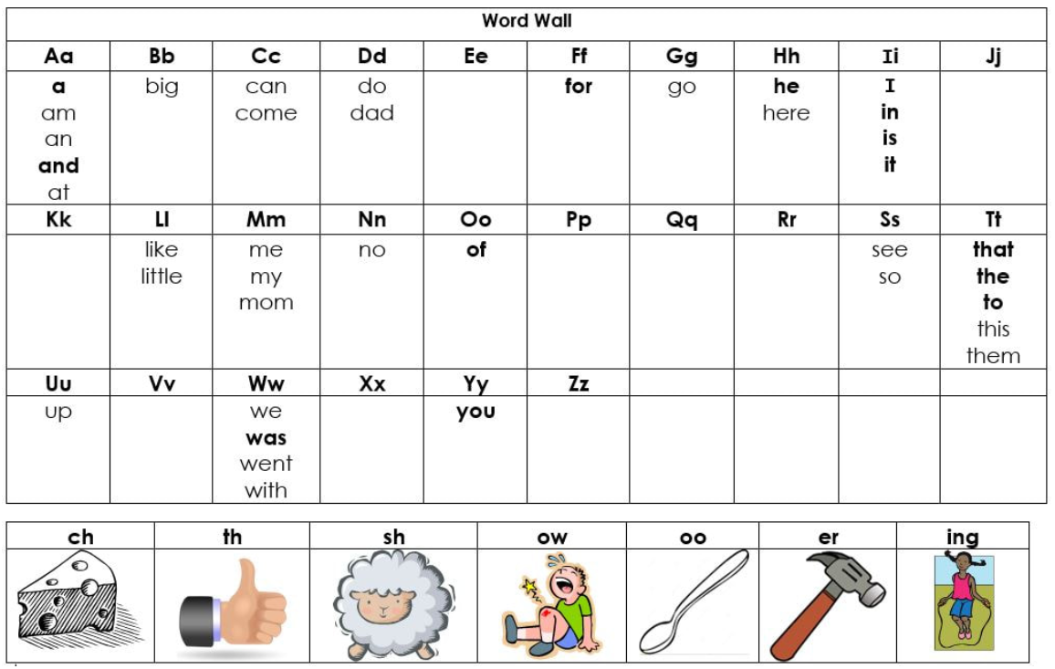  Grade 1: Here are some things you can say to help guide your child through the writing process. https://mrsrdoucettefes.weebly.com/writing.html  - Planning: “What are you writing about? Tell me the story? What were you doing? What happened first? What happened next? How did it end? How did you feel?”  - Detailed picture: “How will you show where you are? Trees? A car? The kitchen table?”  - Title: What is the piece about? My Walk? Space? Dogs?  - Opening sentence: “What were you doing and when?” or “What do you feel about your topic?” Ex. I was eating supper. Or I think space is interesting.  - Adding detail: “What happened first, next, then, last? How did you feel? What did it look like, smell like, sound like?”  - Punctuation: “Should we use a period, question mark, or exclamation mark?”  - Word wall word spelling: If you notice a word that is a word wall word, point it out and help your child find it.  - Inventive spelling using phonics (Blends, R controlled vowels, endings)  - Link to guided lesson https://www.youtube.com/watch?v=GhZH_1sIVvI  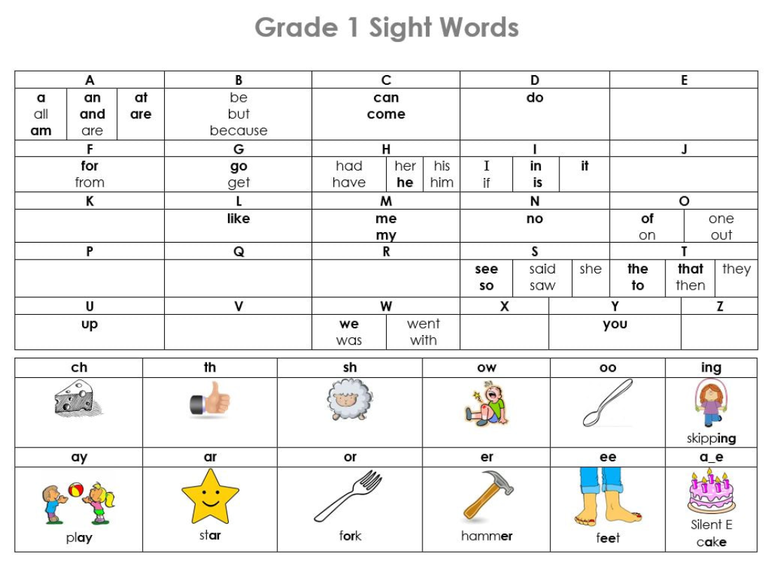  Phonological Awareness  Kindergarten: Segmenting Sounds for spelling: Pull the sounds apart.  - Video lesson link: https: https://www.youtube.com/watch?v=clgsRKy2Dz0&t=1s  /at/ word list /an/ word list  bat cat hat can fan pan  sat mat pat man ran van  Grade 1: Segmenting Syllables for spelling: Break words into parts  - Video lesson link: https://www.youtube.com/watch?v=oqhObw1tqKk  strawberry straw~ber~ry animal an~im~al  dinosaur di~no~saur helicopter hel~i~cop~ter  money mon~ey jellybean jell~y~bean  cookie cook~ie computer com~pu~ter  3 to 3  - Here’s a cup of tea https://www.youtube.com/watch?v=sYy5eRmLKqo  - 1,2,3,4,5 https://www.youtube.com/watch?v=9ptY9spE8Ro  - Simple Simon https://www.youtube.com/watch?v=hbsNcSWgrPc  - Story: 3 Billy goats Gruff https://www.youtube.com/watch?v=vbIJ85-QQVs&t=12s
Numeracy | Pattern  Kindergarten: Use items from around your house to make an AB Pattern. An AB pattern uses two items that repeat in a back and forth order as seen below. *** If you like, you can do this activity with 3 items that repeat. ABC, AAB, ABB  Parents:  You can start the pattern and have your child extend it  You can give 2 or more materials and have your child create it.  You can make a pattern and have your child read it. Make some mistakes on purpose and see if you child can find the mistake.  You can make 2 or 3 patterns. Make one pattern with mistakes. Have your child tell you which one has mistakes and how they know.  Grade 1: Use items from around your house to make a Pattern with 3 to 5 items that repeat. An AB pattern uses two items that repeat in a back and forth order. Your child needs to try patterns with various combinations that repeat, such as: ABC, AAB, ABB, AABC, ABBC, ABCC, ABCD, etc. I have included examples above and below.  Parents:  You can start the pattern and have your child extend it  You can give 3 or more materials and have your child create it.  You can make a pattern and have your child read it. Make some mistakes on purpose and see if you child can find the mistake.  You can make 2 or 3 patterns. Make one pattern with mistakes. Have your child tell you which one has mistakes and how they know.  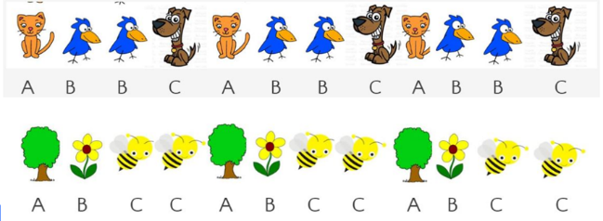  Counting  Everyone is always counting. We count the days, we count money, we count how many apples are left before we need to get more. So, let’s count anything and everything.  Kindergarten:  ​Parents:  - Continue with having your child count things around the house and in nature. Make sure when they count, they are matching one number name to one item.  - Make sure your child organizes the items as he/she counts. Counting items in a jumble is hard for the eyes to track, and leads to mistakes. Counting items in lines or ordered groups will help children keep track of what has been counted, and what still needs to be counted to find the total.  - When your child finds the total, have them record the number on paper as well and represent the number with dots, lines, or another simple mark. Please encourage an ordered drawing of these marks, either in a line, or in a group that looks like the dots on a dice. Having them draw in groups help children to see smaller groups inside of larger groups, which opens the door to addition and subtraction. Please refer to the images below.  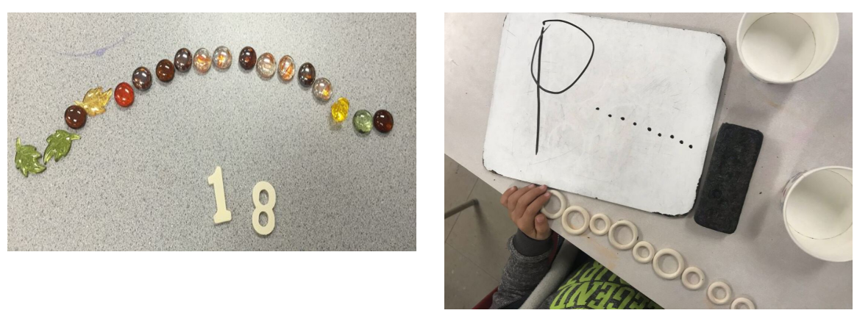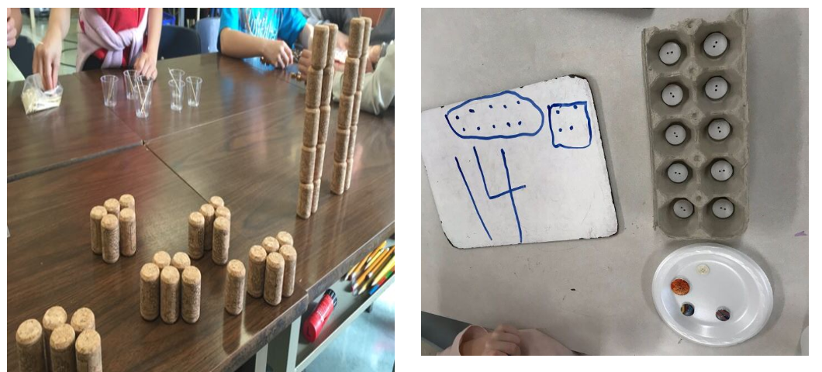  Grade 1:  Parents:  - Continue with having your child count things around the house and in nature. Make sure when they count, they are matching one number name to one item.  - Make sure your child organizes the items as he/she counts. Counting items in a jumble is hard for the eyes to track and leads to mistakes. Counting items in lines or ordered groups will help children keep track of what has been counted, and what still needs to be counted to find the total.  - When your child finds the total, have them record the number on paper as well and represent the number with dots, lines, or another simple mark. Please encourage an ordered drawing of these marks, either in a line, or in a group that looks like the dots on a dice, or a ten frame. Please refer to the images above.  ***In grade 1, we start to look at numbers that can be broken down into groups of 2s, 5s, and 10s. Encourage your child to organize the items they find in these groups and practice their skip counting.  Links to counting songs  Count to 10 https://www.youtube.com/watch?v=HkkYaj0m6cg Count to 10 and back https://www.youtube.com/watch?v=DR-cfDsHCGA  Count to 20 https://www.youtube.com/watch?v=D0Ajq682yrA Count to 20 and back https://www.youtube.com/watch?v=By2hmo323xM&t=192s  Count to 100 https://www.youtube.com/watch?v=bGetqbqDVaA Count from 100 -1 https://www.youtube.com/watch?v=-iwgJmW1uvg&t=1s  Count by 2s https://www.youtube.com/watch?v=eTCcqQxT5Gk Count by 5s https://www.youtube.com/watch?v=5FaBDqOmiyI  Count by 10s  https://www.youtube.com/watch?v=-gmEe0-_ex8  Subitizing  Link to Song https://www.youtube.com/watch?v=1L8bIDeW5co&t=17s  Mental math  Practice Doubles Facts  Link to song https://www.youtube.com/watch?v=8jOzhiACB68&t=5s  Link to song https://www.youtube.com/watch?v=M9YQ4phTB0E  Addition & Subtraction  Addition Stories: Addition is the act of joining groups together to make larger groups. This week, I would like you to work on addition stories up to 20, but the stories should only increase by 1 or 2 at a time. I would like for you to start telling the stories, and eventually, have your child make some up for you. Keep the numbers simple. Some will want to give you big numbers to solve. Just redirect them to numbers less than 20. For example:  - "I had 6 crayons. Then I found 2 more. How many crayons do I have now? "  - "At the park, there were 16 dogs. 2 more dogs came. How many dogs are at the park now?"  - "Mom made 12 cup cakes. I made 1 cup cake. How many cupcakes do we have altogether?"  ***If you would like, your child can represent the story in a picture, and/or include the number sentence that matches the story.  (Number sentence = 3 + 3 = 6.)  Subtraction Stories: Subtraction is the act of separating groups to make smaller groups. This week, I would like you to work on subtraction stories with numbers to 20, but the stories should only decrease by 1 or 2 at a time. I would like for you to start telling the stories, and eventually, have your child make some up for you. Keep the numbers simple. Some will want to give you big numbers to solve. Just redirect them to numbers less than 20. For example:  - "I had 13 crayons. Then I broke 2. How many crayons do I have now?”  - "At the park, there were 16 dogs. 2 dogs ran away. How many dogs are at the park now?"  - "Mom made 12 cup cakes. I ate 1 cup cake. How many cupcakes do we have left?"  ***If you would like, your child can represent the story in a picture, and/or include the number sentence that matches the story.  (Number sentence = 7 - 2 = 5 or 5 - 3 = 2)
Wellness | Let’s get moving  Link to Dance https://www.youtube.com/watch?v=KVE-T2_vLpY  Link to Dance https://www.youtube.com/watch?v=52pdktAMDe4&t=2s  Link to Yoga https://www.youtube.com/watch?v=X655B4ISakg&t=1263s  Link to Movement Song https://www.youtube.com/watch?v=dNL6RwymoNg&t=1s
Make Explore Create | Look around your house. Do you have some Paper Rolls? Do you have some egg cartons? What can you make?  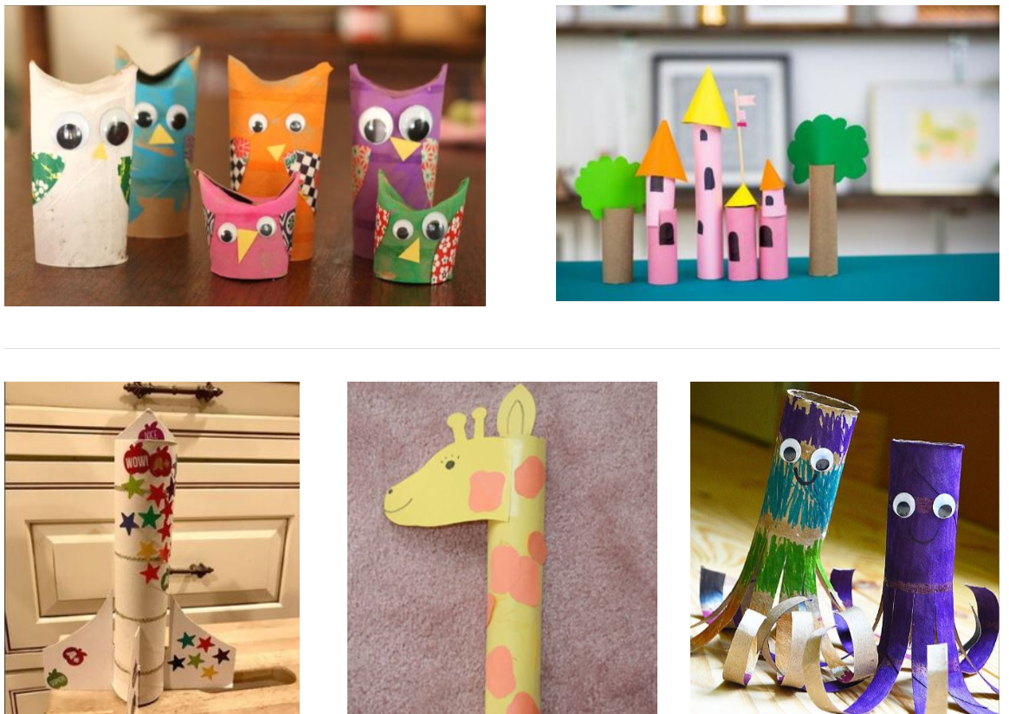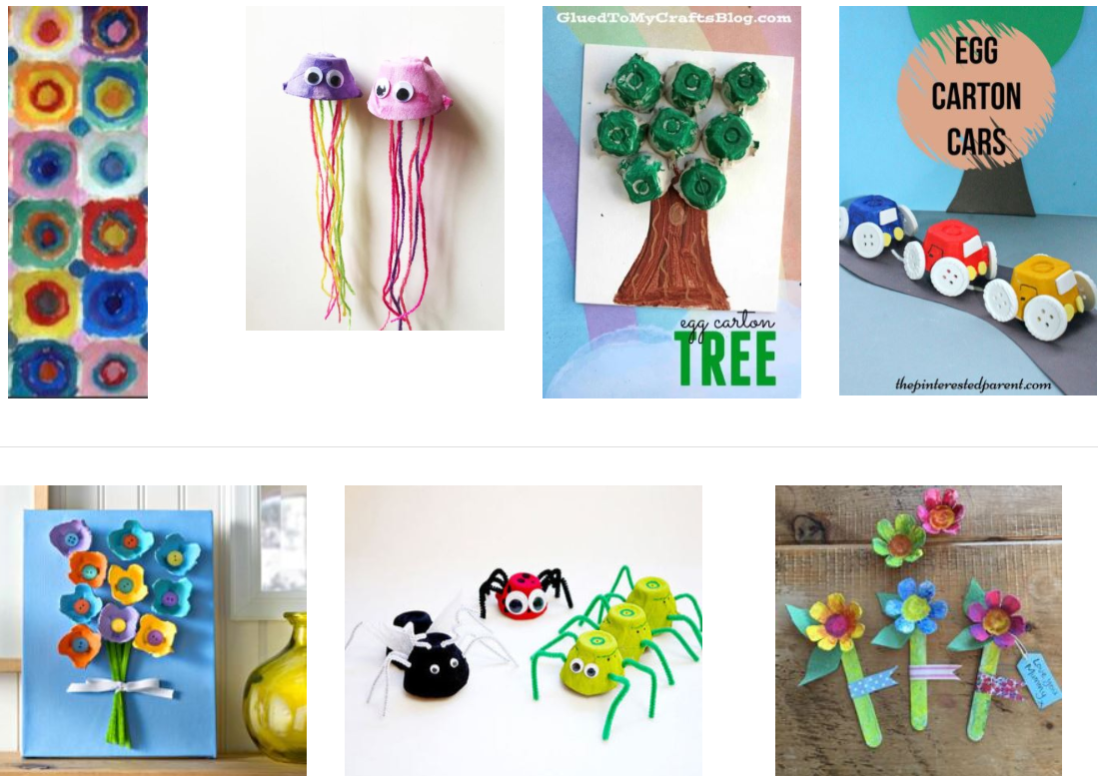
- Starfall.com is a great website/app. www.starfall.com
- There are great songs on The Singing Walrus Channel on You Tube.
https://www.youtube.com/user/SingingWalrusMusic

