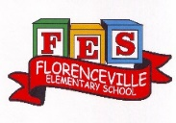
FLORENCEVILLE ELEMENTARY SCHOOL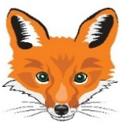
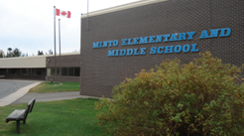
At FES our vision is to be a community where everyone is empowered to be lifelong learners.
HOME LEARNING PLAN
June 1-5, 2020

Class | 5B
Teena Bishop | Teena.bishop@nbed.nb.ca
Sarah Mahar  Bridget Nugent | Principal: sarah.mahar@nbed.nb.ca;  Vice-Principal: bridget.nugent@nbed.nb.ca
Cindy Crowhurst | Resource: cynthia.crowhurst@nbed.nb.ca
Dianne Lord | Guidance: dianne.lord@nbed.nb.ca
School | florencevilleelementary@nbed.nb.ca

In accordance with the communication sent from our Minister of Education, Dominic Cardy, on April 2, 2020 Home learning opportunities to support literacy and numeracy outcomes will be made available online weekly by Teachers.

Families are encouraged to:
-Support their children to complete the options below for an average of one hour per day.
-Read aloud with their children daily; and
-consider daily physical activity and free play as an important part of their child’s mental health and skill development.

Subjects | Description of Learning Activities
Literacy
This week we will do some virtual traveling!!

Oral Language- Listening to music and shows in French is a great way to review and develop your oral language. Here are some suggestions of things that you can listen to and watch. (You can slow the speed of videos down when you are watching YouTube.)  Chanson:  Compilation vidéos pour enfants  https://www.youtube.com/watch?v=peUqPaI89hc  Listen to these videos as we travel virtualy around the world:  National Geographic Kids is a geat site to go on to tour many countries in the world. Let’s start with Canada!  https://www.youtube.com/watch?v=-N7g5dIN0i0  And let’s not forget our capital:  Ottawa - la capitale du Canada - Version internationale | Tourisme Ottawa  https://www.youtube.com/watch?v=Chp76aJmxbU  Let’s move on to Egypt!  Egypt: Nile River / Are We There Yet?  https://www.youtube.com/watch?v=glEBxUm1WAk  Egypt: Mummies – Travel Kids in Africa  https://www.youtube.com/watch?v=28QOM7oZQKg  Défi littératie : Trouve les mots de mon voyage dans la grille de mots mêlés. Pour un défi encore plus amusant, tu peux créer ta propre grille de mots mêlés et demande à un membre de ta famille de trouver les mots qui sont caché!  (Full size version of the crossword is with other attachments below). | Reading – (Students are encouraged to read in both French and English throughout the week). Talk about books that you read (or movies that you watch) by discussing some of the following questions:  Compréhension en lecture  Créer des liens avec l’histoire  Titre de l’histoire:_____________________  L’histoire me fait penser à...  Je visualise pendant la lecture!s…  Imagine que tu es un personnage dans le livre. Qu’est-ce que tu vois?  Qui vois-tu? Quels objets vois-tu? Quel temps fait-il? Dessine et colorie.  Le titre du livre: __________________________  While reading your book, try to make as many connections as you can with books you have read, movies you have seen, or events that has happened to you in the past.  See what you will come up with, even if it sounds a little bizarre!  If you do not have French books at home, there are websites that you can access French books. Explore these and read (or listen to) French books that are a “good fit” for you (not too hard, not too easy). https://boukili.ca/fr  https://www.readinga-z.com/worldlanguages/french/leveled-books/  Read the following French books:  - Des amis autour du monde  https://www.readinga-z.com/books/leveled-books/book/?id=101&langId=2  - Des chaussures de partout dans le monde  https://www.readinga-z.com/books/leveled-books/book/?id=917&langId=2
Word Work:  - Utilise le lien ci-dessous pour jouer un jeu sur ‘’l’ordre alphabétique’’des mots! https://micetf.fr/ruche-mots/  - Using any word list of your choice (words from mon voyage above, lists from older lesson plans, words from the game ‘’L’ordre alphabétique’’)  - Decorate or illustrate your words.  S ’amuser avec les mots  1 Écris le mot 3 fois. 2 Écris le mot avec des lettres bizarres. 3 Écris le mot en images  4 Écris le mot avec les voyelles en rouge et les consonnes en bleu. 5 Écris le mot avec des points sur les lettres. 6 Écris le mot avec des lettres MAJUSCULES.  7 Écris le mot avec des lettres minuscules. 8 Écris le mot avec une régularité AB de couleur. 9 Écris le mot en écriture cursive. | Writing – Here are a few writing ideas for this week.  You can choose one to work on throughout the week or a different one each day. If you want to go back to last week’s ideas, please do so. Don’t forget to make sure that you use capital letters and punctuation where they belong. Think about who will enjoy (or learn from) reading your writing after you are finished.  - Utilise le site si dessous pour explorer le monde. Pense à un endroit que tu aimerais visiter. Écrit pourquoi tu aimerais visiter cet endroit.  https://www.google.com/earth/education/  - Fait une liste d’activité de ce que tu aimerais faire durant ta visite.  - Créer un nouveau mot croisé en utilisant les mots d’endroit que tu as trouvé sur google earth.  - Écrit une fin différente que tu aurais préféré de ton livre.  - D’écrit qu’est-ce qui se passe avec les graines que tu as plantées.

Numeracy | Choice board  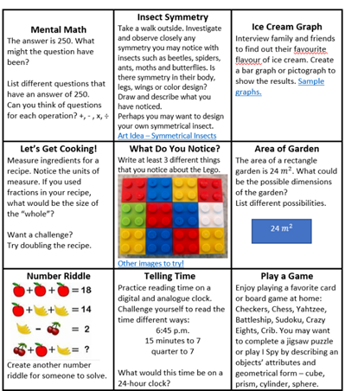
 | Math Games | Math Challenges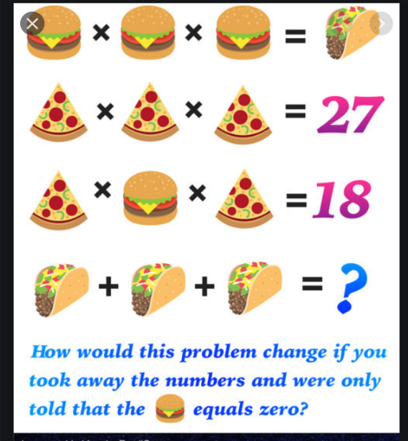  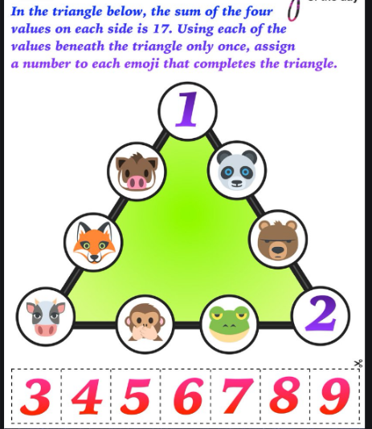Check out the FREE app Prodigy Kids Math Games or you can play this fun game online https://www.prodigygame.com
Kaboom
Using popsicle sticks or any other types of sticks, pick a few math facts (additions, subtractions, multiplications or divisions) that you and your child want to work on.

Write the facts on one end of the stick and the answer on the back or on the other end of the stick.

On a select few sticks, write the words KABOOM.

Take turns picking a stick, reading the math fact & answering.

If the answer is correct, keep the stick. If the answer is incorrect, place stick back in the jar / container.

If you pick a KABOOM stick is pulled out, the person who pulls it out must put all of their collected sticks back in the jar / container & the game continues.

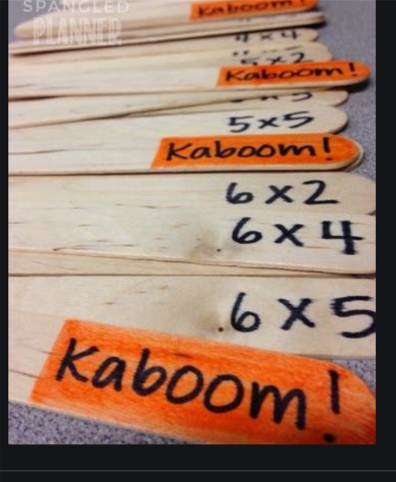

Other areas of interest/learning experiences  Science & Art & Mindfulness | Here are a few activities to choose from this week. Can you try at least one from each row?  Visit this website to learn about different countries: https://www.kids-world-travel-guide.com/ What countries would you like to visit? Why would you like to visit this country? Did you know that the New Brunswick Museum has some virtual exhibitions? You can visit their site to see them: https://www.nbm-mnb.ca/virtual-exhibitions/  Growth Mindset video: https://www.youtube.com/watch?v=ElVUqv0v1EE This article provides links to 10 virtual art gallery exhibits around the world. https://www.theguardian.com/travel/2020/mar/23/10-of-the-worlds-best-virtual-museum-and-art-gallery-tours  Review from Grade 3 &4: -Can you name all the provinces/territories and their capitals? Which province or territory would you like to visit? What would you do there? http://www.yourchildlearns.com/canada_map.htm Listen to this podcast: Benjamin Makes a Splash With His Abstract Art Zara and Leo are on a mission to hear from YOU. Listen to the mini-episodes as Big Life Kids (our listeners) from across the world tell us about their amazing adventures. In this episode, our listener Benjamin uses abstract art to find beauty in imperfect things and Zara and Leo create their own imperfect journals. https://biglifejournal.com/pages/podcast There are so many beautiful trees in blossom. Take a sketch pad and pencil outside and sketch what you see.  Visit this site for more mindfulness activities for kids: https://biglifejournal.com/blogs/blog/5-fun-mindfulness-activities-children-breathing-exercises
English Language Arts | Here are some English Language Arts activities for you to choose from over the next three weeks (May 25th - June 12th). Try to choose 2-3 to do each week.  Find a nice cozy place to read in the sun. What do you want next year’s teacher to know about you?Create something that we can pass along to that teacher to let them know a little about you. You could write, draw, make a video...the opportunities are endless. Learn how to draw Snug from DOG MAN by watching this video. https://www.youtube.com/watchlist=PLtCDOmMCDvaq8ZvzN6eVRgFZJZGpvvzvT&time_continue=2&v=6jZHKkHNR0A&feature=emb_logo  What is a book that you have read lately that you would recommend to others? Create something to share with others about that book. Some ideas: a video clip, a poster, a write up, a comic. Read some news on https://www.cbc.ca/kidsnews/ Snuggle up and read with your cat, dog or stuffed animal.  Select a favourite recipe to follow and cook supper foryour family.You could even create place cards so they will know where to sit! Create a skit/play to perform in front of your family. Have your siblings or stuffed animals join in the fun! You could even film your skit and send to others! Create a summer “bucket list” of things you hope to do this summer. They don’t have to be expensive or far away...watch a beautiful sunset, go on a hike, learn to make/do something new...

Crossword Puzzle Grid

