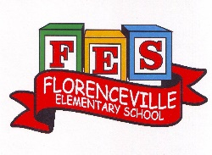
Florenceville Elementary School

At FES our vision is to be a community where everyone is empowered to be lifelong learners.

HOME LEARNING PLAN- WEEK #5

Grade: | 3/4
TEACHER | Marlee Ralston: marlee.ralston@nbed.nb.ca
Sarah Mahar  Bridget Nugent | Principal: sarah.mahar@nbed.nb.ca;  Vice-Principal: bridget.nugent@nbed.nb.ca
Cindy Crowhurst | Resource: cynthia.crowhurst@nbed.nb.ca
Dianne Lord | Guidance: dianne.lord@nbed.nb.ca
School | florencevilleelementary@nbed.nb.ca

In accordance with the communication sent from our Minister of Education, Dominic Cardy, on April 2, 2020, Home learning opportunities to support literacy and numeracy outcomes will be made available online weekly by Teachers.
Families are encouraged to:
-Support their children to complete the options below for an average of one hour per day.
-Read aloud with their children daily; and
-consider daily physical activity and free play as an important part of their child’s mental health and skill development.
Subjects | Description of Learning Activities
Literacy | Reading:  Option #1: Log in to your Raz-Kids account and begin reading  www.kidsa-z.com (All log-in info has been sent to parents. Please let me know if you haven’t received it or are having trouble logging in)  Option #2: Read books that you have at home. Try reading to a parent, sibling or find a quiet place to read to yourself.  Option #3: Check out the rhymes, oral stories and thought problem posed in this week’s From 3 to 3 videos, listed below.  Writing:  Option #1: Write about something that you choose. (Students are encouraged to have choice when writing. If they are working on their own stories or have something different that they would like to write about, that is great! This option is for those students.)  Option #2: Create a book with a sibling or a parent. Decide together who the main character of your story will be and what adventures they will go on. Take turns adding illustrations and words to your book.  Option #3: Find a family heirloom or a meaningful family object (picture, dish, piece of art, photo). Draw a picture of the object or describe it. Write about why it is special to you and your family.  Option #4: Do you prefer playing indoors or outdoors? Make a pros and cons list. Write for 5 minutes without stopping about why one is better than the other.  Option #5: Write a thank you letter to your mail carrier, garbage collector, and/or delivery person. Attach it to your door or garbage can.  From 3 to 3: Watch this week’s From 3 to 3 videos. The answer is provided for last week’s thought problem, along with a new thought problem.  https://drive.google.com/file/d/1ZltE_IttS7nbL9--lXK5wYaqQLzKidni/view?usp=sharing  Listen to chapter two of the novel Seven Day Magic by Edward Eager:  Part One  https://drive.google.com/file/d/1rI1wZZ1ncitvK1Ti9cKR0tOVC-ONrAS5/view?usp=sharing  Part Two  https://drive.google.com/file/d/1CGgTlmnkDF1C4by8oGIrZDA-Fpb_xg6A/view?usp=sharing
Numeracy | Option #1: Log in to your Sumdog account and review your mental math strategies. All log-in information has been sent to parents. Please let me know if you haven’t received it or are having trouble logging in.  Option #2: Would you rather…? Justify or explain why you chose your answer.  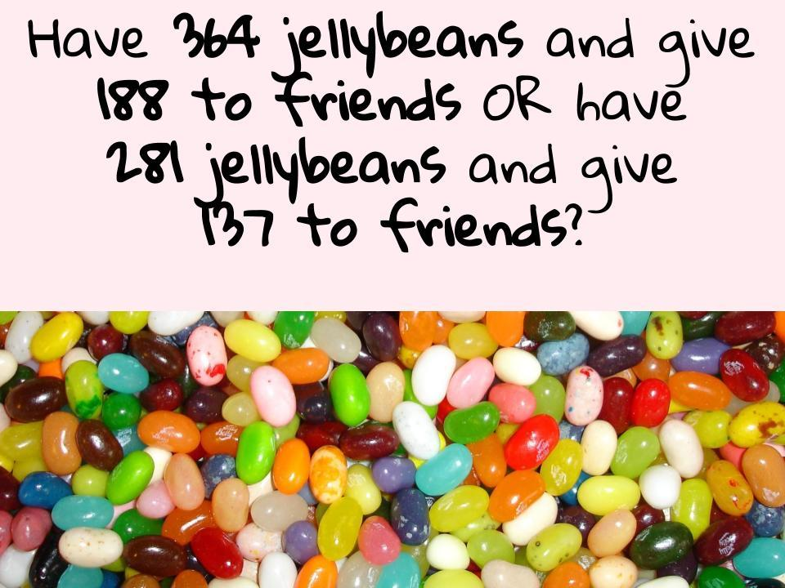  Option #3: You have a total of $1.45 in coins in your pocket. What are all the possible combinations of coins you could have?  Option #4: Practice reading time on a digital and analogue clock. Challenge yourself to read the time different ways: 6:45 p.m. 15 minutes to 7 quarter to 7 What would this time be on a 24-hour clock?  Option #5: The answer is 250. What might the question have been? List different questions that have an answer of 250. Can you think of questions for each operation? (+, - , x, ÷)
Other areas of interest/learning experiences | Science: This week, begin to think about what your perfect garden would look like. What would you plant? Where would you put it in your yard? See the pictures below for further prompts.  