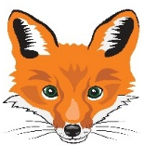
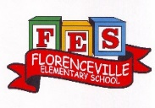
FLORENCEVILLE ELEMENTARY SCHOOL
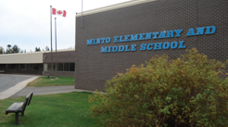
At FES our vision is to be a community where everyone is empowered to be lifelong learners.
HOME LEARNING PLAN
May 19- 22, 2020

Teena Bishop | teena.bishop@nbed.nb.ca
Sarah Mahar  Bridget Nugent | Principal: sarah.mahar@nbed.nb.ca;  Vice-Principal: bridget.nugent@nbed.nb.ca
Cindy Crowhurst | Resource: cynthia.crowhurst@nbed.nb.ca
Dianne Lord | Guidance: dianne.lord@nbed.nb.ca
School | florencevilleelementary@nbed.nb.ca

In accordance with the communication sent from our Minister of Education, Dominic Cardy, on April 2, 2020 Home learning opportunities to support literacy and numeracy outcomes will be made available online weekly by Teachers.

Families are encouraged to:
-Support their children to complete the options below for an average of one hour per day.
-Read aloud with their children daily; and
-consider daily physical activity and free play as an important part of their child’s mental health and skill development.
Subjects | Description of Learning Activities
Literacy
Oral Language- Listening to music and shows in French is a great way to review and develop your oral language. Here are some suggestions of things that you can listen to and watch. (You can slow the speed of videos down when you are watching YouTube.)  Listen to these songs:  C’est le printemps:  https://www.youtube.com/watch?v=yKKWNJ8qsss  Dans mon jardin:  https://www.youtube.com/watch?v=BsuodT8iAMQ  Savez-vous planter les choux  https://www.youtube.com/watch?v=iAGV2pcLaAg  Sème, sème dans le jardin  https://www.youtube.com/watch?v=OpSxyCG5LE8  Quel temps fait-il aujourd’hui?  https://www.youtube.com/watch?v=eBvJVOuBPXI  La chanson des légumes:  https://www.youtube.com/watch?v=NTPQJUugCJM&list=PLPpLiNCESKpV28I-Zd5KTSil8p56oTDMp&index=2  Here is a French book that you can listen to on YouTube called; Jack et le haricot Magique.  https://www.youtube.com/watch?v=5V299ph2_yc  & Je mangerais bien un enfant  https://www.youtube.com/watch?v=7FChMwHlNjw  Défi littératie : Trouve les mots du printemps dans la grille de mots mêlés. Pour un défi encore plus amusant, tu peux créer ta propre grille de mots mêlés et demande a un membre de ta famille de trouver les mots qui sont caché!  (Full size version of the crossword is with other attachments below).  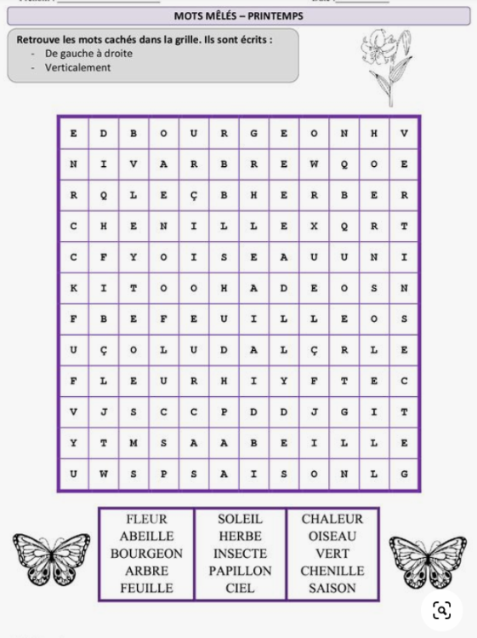 | Reading – (Students are encouraged to read in both French and English throughout the week). Talk about books that you read (or movies that you watch) by discussing some of the following questions:  Avant la lecture:  - Quel est le titre de ce livre?  - Qui est l’auteur de ce livre?  - Qui est l’illustrateur?  - Est-ce un text informatif ou fictif?  Pendant la lecture:  - Où se déroule l’histoire?  - Quel est le problème de l’histoire?  Après la lecture:  - Quelle question poserais-tu à l’auteur?  - Aimerais-tu lire un autre livre par cet auteur?  Try to make as many connections as you can with books that you are currently reading and books that you have read in the past.  For example, Mme. Savoie’s favourite book is Harry Potter and the prisonner of Azkaban and the connection I can make with that book is that Harry and I both go to school. We both have 2 best friends. Harry and I both wear glasses. We are both very adventurous.  See what you will come up with, even if it sounds a little bizarre!  Here are a few other types of connections you can make with a book.  - Connection with your own life  - Connection with another book that you have read.  - Connection with a movie that you have seen.  If you do not have French books at home, there are websites that you can access French books. Explore these and read (or listen to) French books that are a “good fit” for you (not too hard, not too easy). https://boukili.ca/fr  https://www.readinga-z.com/worldlanguages/french/leveled-books/
Word Work:  - Utilise le lien ci-dessous pour jouer un jeu sur ‘’l’ordre alphabétique’’des mots! https://micetf.fr/ruche-mots/  - Using any word list of your choice (gardening list  below, words from older lesson plans, words from  the game ‘’L’ordre alphabétique’’) play the game  below. If you don’t have a dice, you can create  one out of paper / cardboard, you could also use  playing cards numbered 1 to 6 or even just write  number on paper and pick out of a bowl! | Writing – Here are a few writing ideas for this week.  You can choose one to work on throughout the week or a different one each day. If you want to go back to last week’s ideas, please do so. Don’t forget to make sure that you use capital letters and punctuation where they belong. Think about who will enjoy (or learn from) reading your writing after you are finished.  - Pense a ton repas favorit. Comment écrirais-tu cette recette pour expliquer à un ami comment faire le repas à sa maison.  - Créer une recette avec des ingrédients que tu peux trouver dans ton jardin. (A recipe card can be found with attachments below to help guide your writing).  - Créer une liste d’ingrédients et d’outils nécessaire pour faire ta recette. Place les ingrédients en ordre alphabétique.  - Invente une histoire à propos d’une fourmi qui vit dans ton jardin.  - Créer un nouveau mot croisé en utilisant les mots des aliments que tu as dans ton jardin.  - Répond aux questions de la lecture (en haut) écrit ta réponse en français.  - Dans ton jardin, que vois-tu?  - Que penses-tu qu’il se passe dans ton jardin?

Numeracy  Material needed for this project: see recipes 😊 | Cooking: this week your challenge is to get in the kitchen and do some cooking. Here are a couple of recipes that you can chose from. Or you could look up a recipe online or in a recipe book at home. Don’t forget to take a picture of what you make and send it to us.  This recipe comes from the Ricardo Cuisine website:  https://www.ricardocuisine.com/recettes/5765-pancakes-dodues There is even a demonstration video if you follow this link.  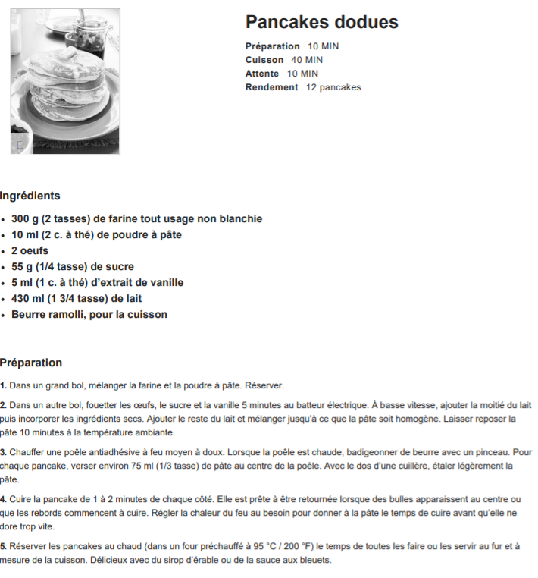  This recipe comes from the website Gimme Some Oven:  https://www.gimmesomeoven.com/strawberry-banana-smoothie-recipe/  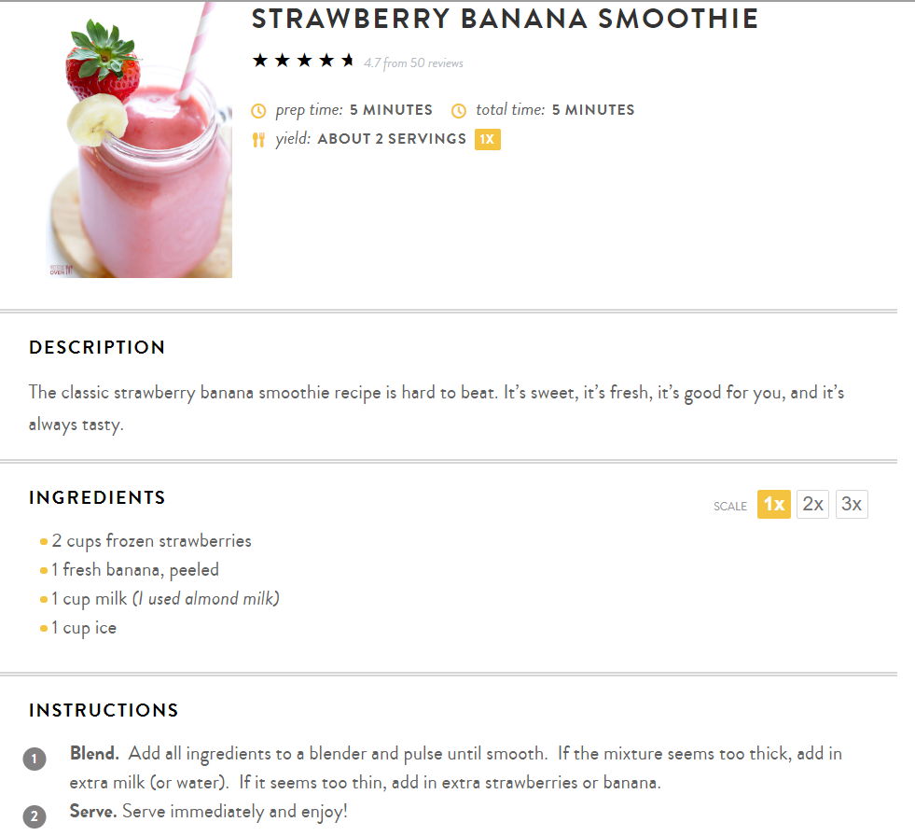  Some questions to consider when cooking:  -What would you do if you wanted to make your recipe for the whole class?  -What if you wanted to make the recipe just for you?  -How do you use math in the kitchen when you are cooking?  -What makes a recipe easy to follow?  -What do you do to stay safe in the kitchen?  -What are some different ways that you measure when cooking?
 | Math Games | Math Challenges  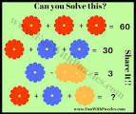  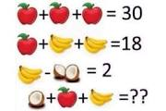  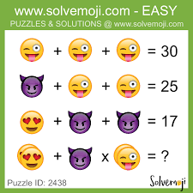
Garbage Can Game

Materials needed: number cube (dice), paper, pencil
Play with a partner or small group.

Roll a number cube 5 times for a 4 digit number (7 times for a six digit number). Use the numbers rolled as digits to create the largest 4 (or 6) digit number possible. You may throw one digit in the garbage can each round. Players may not move a digit once it is written down.

When the numbers have all been created, each player takes a turn reading their number aloud to the group. The other players listen carefully to see if they read their number correctly. If they read their number correctly, they receive one point. The player with the greatest number also receives one point.

The player with the most points at the end of 5 rounds is the winner.

Check out the FREE app Prodigy Kids Math Games or you can play this fun game online https://www.prodigygame.com
Other areas of interest/learning experiences  Science & Art: | Science:  This week in Science you will be doing two different research projects to get your vegetable garden design completed!  - When planting a vegetable garden, there are some veggies that don’t do so well when planted next to others and some that are compatible with each other. You are to research which vegetables are compatible.  - Before you start your second research, write down the names of all the insects and wildlife that live around you that could damage your garden. Fortunately for us, there are vegetables, flowers or herbs you can plant to keep those critters away so you can reap an abundant crop in the fall.  You are to research which flower, herb or plant that would be beneficial to have in your vegetable garden.  Art:  Here is another great challenge going your way! You are to make a fox using materials you have inside and/or outside your home. Take a picture of it and send it to me. A collage will be created and posted on the FES website and Home & School Facebook page. Please send me your pictures or post them on the FES Home & School page before May 25th.  Voici une recette pour faire de la pâte à modeler:  1 tasse de fécule de maïs  ½ d’une tasse de lotion à mains  Colorant alimentaire  Here is a recipe to make cloud dough:  1 cup of corn starch  Half a cup of hand or body lotion or hair conditioner  Food coloring  Here’s a video link to a moon dough demonstration:  https://www.youtube.com/watch?time_continue=2&v=Pt97zl_gwnk&feature=emb_logo
English Language Arts | English Language Arts ~ from Mrs. Mahar  Hello everyone! It has been nice to hear from some of you. I love getting emails and seeing some of your writing or even a sway! You are all so creative and I miss teaching you.  I hope you have still been reading lots and writing as well.  Reading:  Keep reading as much as you can! I hope some of you are trying SORA- I know there are lots of great books on there. Try to read at least 30 minutes each day. I know many of you love to read, so keep it up!  For SORA, you can use the website version or download the free app on your tablet or phone. You will need your school username and password to access the books. (*school name is New Brunswick Department of Education and Early Childhood- not Florenceville Elementary). Send me an email if you need help!  (this is what the app looks like)  If you didn’t get a chance last week to listen to this story on youtube, you can do it this week. It is called, If I Built a School, by Chris van Dusen. Here is the link: https://www.youtube.com/watch?v=jQFDyHmf9Bo  Writing:  The book, If I Built a School, suggests lots of ways to make school different. Some of the ideas are very far-fetched or set in the future, but they give you lots of think about. You have now been learning at home for several weeks. I know there are many things you are missing about coming to FES every day to learn. I am guessing there are also parts that you also like about learning at home. So, think about this…  If you built a school, what would it look like? Think about:  - Classrooms  - Playgrounds  - Recess/lunchtime  - Phys. Ed/Music/Art/Library  What would your perfect school look like? You could explain it, draw about it (make sure you label it) or even write a fiction piece that takes place in your “ideal school”. I would LOVE to hear your ideas!  If you can, send me an email at sarah.mahar@nbed.nb.ca. Have fun and stay safe!
Mindfulness | Physical Activity:  Make sure to check out the Physical Activities that Ms. Nugent has posted on the school website.  See the alphabet movement sheet below for your activity challenge this week. Try to do these 3 different times during the week. Play the moves that match the letters of your full name. To challenge yourself more, play the moves that match the letters of all your family members names.  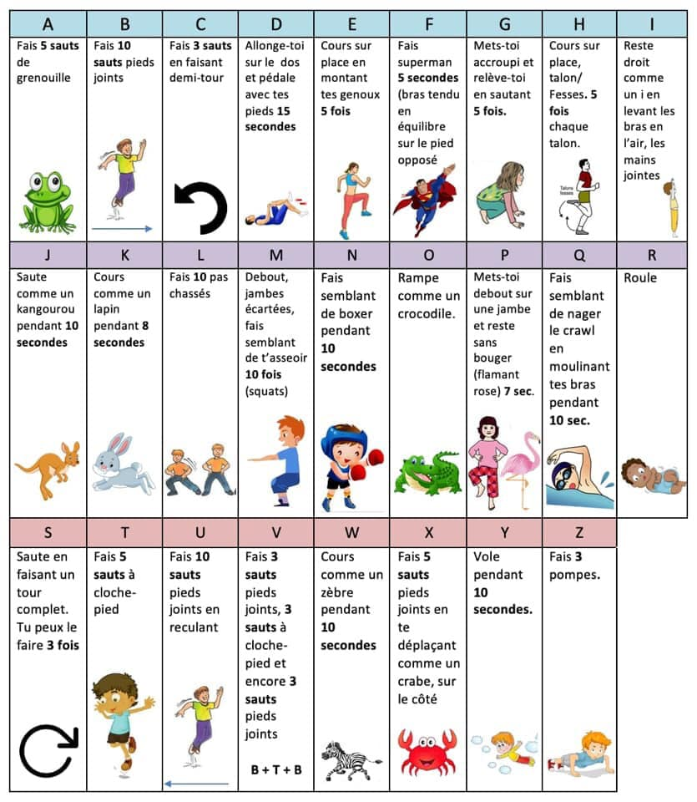Copy taken from Elisa Groppi’s Facebook page

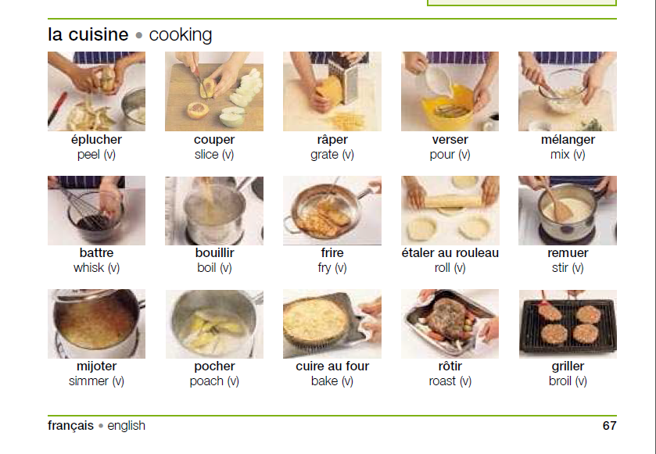

Crossword Puzzle Grid

