Florenceville Elementary School

At FES our vision is to be a community where everyone is empowered to be lifelong learners.

HOME LEARNING PLAN- WEEK #2

Grade: | 3/4
TEACHER | Marlee Ralston: marlee.ralston@nbed.nb.ca
Sarah Mahar  Bridget Nugent | Principal: sarah.mahar@nbed.nb.ca;  Vice-Principal: bridget.nugent@nbed.nb.ca
Cindy Crowhurst | Resource: cynthia.crowhurst@nbed.nb.ca
Dianne Lord | Guidance: dianne.lord@nbed.nb.ca
School | florencevilleelementary@nbed.nb.ca

In accordance with the communication sent from our Minister of Education, Dominic Cardy, on April 2, 2020, Home learning opportunities to support literacy and numeracy outcomes will be made available online weekly by Teachers.
Families are encouraged to:
-Support their children to complete the options below for an average of one hour per day.
-Read aloud with their children daily; and
-consider daily physical activity and free play as an important part of their child’s mental health and skill development.
Subjects | Description of Learning Activities
Literacy | Reading:  Option #1: Log in to your Raz-Kids account and begin reading  www.kidsa-z.com (All log-in info has been sent to parents. Please let me know if you haven’t received it or are having trouble logging in)  Challenge (for students choosing this option): I will award 100 points to each student who reads for a total of two hours using the Raz-Kids website/app, for the week. Points will help you customize your avatars and Raz Rockets.  Option #2: Read books that you have at home. Try reading to a parent, sibling or find a quiet place to read to yourself. Get creative! Make a fort and read in your fort with a flashlight.  Writing:  Option #1: Write about something that you choose. (Students are encouraged to have choice when writing. If they are working on their own stories or have something different that they would like to write about, that is great! This option is for those students.)  Option #2: On a sheet of paper, draw a heart that takes up the entire page. Fill it with your favorite memories, places, people, things. You can also include things that you know or are interested in as well as things that you imagine. Keep this heart in a safe place in case you need ideas to write about in the coming weeks.  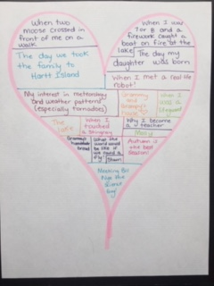  Option #3: Choose something on your heart map to write about. Remember, to choose small moments so that you can stay focused while writing and provide as many detail as possible about that one moment. When the topic or event becomes too broad it becomes much harder to paint a picture in the minds of your readers.  Option #4: Ask a family member to tell you the recipe for your favorite family meal or treat. Write it down while making sure to include ingredients, amounts, instructions. Keep it in a safe place as a keepsake or to make later with an adult.
Numeracy | Option #1: Log in to your Sumdog account and review your mental math strategies. All log-in information has been sent to parents. Please let me know if you haven’t received it or are having trouble logging in.  Option #2: Encourage your child to skip count. This can be done by having them skip count objects around the home (ie. Pieces of cereal, beads, socks, etc.). Incorporate estimation by having them estimate the quantity of household items that they’re about to skip count first. Was their estimation close? Remind your child that estimating is more than just a random guess. Encourage them to make thoughtful estimations  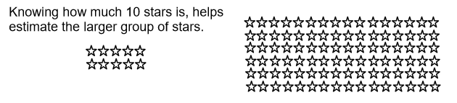  Option #3: Encourage your child to count change that you have around the house (you may want to clean the money first due to virus risks and wash hands after). Ask them to count out a certain amount for you, in different ways (including counting the amount in the most efficient way, with the least amount of coins). Talk about coin names and their values.  Option #4: Solve this word problem: If one bee helps pollinate 10 plants or flowers in one minute, how many plants or flowers could the bee possibly help pollinate in 5 minutes, 15 minutes, 30 minutes and one hour? For students who are not using multiplication yet, you may choose to only have them solve the 5 minute and 15 minute parts.  Use repeated addition to help you or build on a known multiplication fact.  Example of repeated addition: 5 + 5 + 5 + 5 = 20  Example of turning repeated addition into multiplication: 5 x 4 =20
Other areas of interest/learning experiences | Science: I have provided many options for science. Do not feel obligated to do them all. Choose which option(s) work best for your family.  Option #1: Read the following article about what animals eat (omnivores, herbivores and carnivores)  Option #2: Watch “What’s a Food Chain?”  Option #3: Play the Food Chain Game on a desktop or the Build a Food Chain Game on a phone or tablet.  Option #4: When playing outside, make a list of the living things that you see or find. Add to your list other animals that you have seen at your home in the past. Think about where they fit in the food chain.

