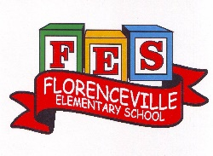
Florenceville Elementary School

At FES our vision is to be a community where everyone is empowered to be lifelong learners.

PRIMARY HOME LEARNING PLAN

Grade: | Grade 2 French Immersion
TEACHER | Molly Kearney: molly.kearney@nbed.nb.ca  Charlotte Dufort: charlotte.dufort@nbed.nb.ca
Sarah Mahar  Bridget Nugent | Principal: sarah.mahar@nbed.nb.ca;  Vice-Principal: bridget.nugent@nbed.nb.ca
Cindy Crowhurst | Resource: cynthia.crowhurst@nbed.nb.ca
Dianne Lord | Guidance: dianne.lord@nbed.nb.ca
School | florencevilleelementary@nbed.nb.ca

In accordance with the communication sent from our Minister of Education, Dominic Cardy, on April 2, 2020, Home learning opportunities to support literacy and numeracy outcomes will be made available online weekly by Teachers.
Families are encouraged to:
-Support their children to complete the options below for an average of one hour per day.
-Read aloud with their children daily; and
-consider daily physical activity and free play as an important part of their child’s mental health and skill development.
Subjects | Description of Learning Activities
Literacy | Week 4: April 27th – May 1st  Visit blog this week and take time to explore different pages  BLOG: madamekearney.edublogs.org  - Look at new page: « Le cycle de vie des organismes » (the life cycle of organisms) to explore new videos  - REVISIT : Sign word dice game (attached as link) CONTINUED FROM WEEK 2  Instructions:  -Roll the die and say the word, spell the word  -You can also play again and you have to use the word in a sentence.  -Put a check mark or a button every time you get a turn  - REVISIT : La phrase secrete (they know how to play & attached as link)  Instructions:  Print paper or snap shot page.  One person choose a sentence and writes it down without the other one seeing.  Then the player has to try to guess the sentence by using the correct sentence structure.  - Sound work: le son “ch”  On the blog:  -Go to the page “Sound Work”  -There will be a video link to play the story of Charles Chat, which works on the sound “ch”.  -Make a list of the words you hear in the story with the sound “on”. How many did you find?!  -If you have access to a printer, you can print document to work on the sound “on”  -At the bottom of the page, “Les sons (songs)” the song “Charles Chat” will be there for students to sing along to.  - CONTINUE : Spend 15-20 mins of reading & activities on the Litteratout site  -Students worked on this site earlier in the year  -Last week we sent username and passwords through email with instructions:  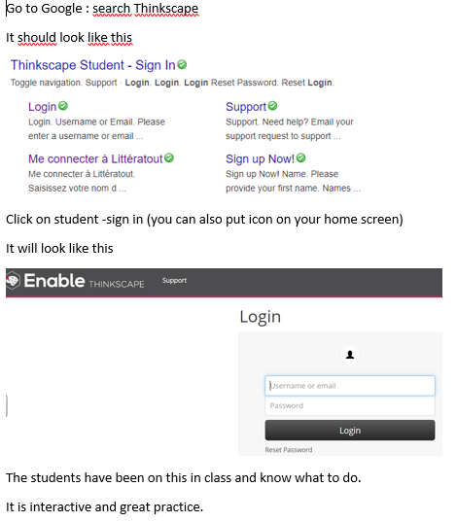  EXTRA: Another great blog is www.asdw2fi.weebly.com
Numeracy | Try these sites.  - Game:  https://stevewyborney.com/2017/02/splat/  - https://ca.ixl.com/  https://www.ixl.com  -We have set up accounts on IXL website for each student. Username and passwords will be sent home to sign in, select grade level and get started!  Info from site:  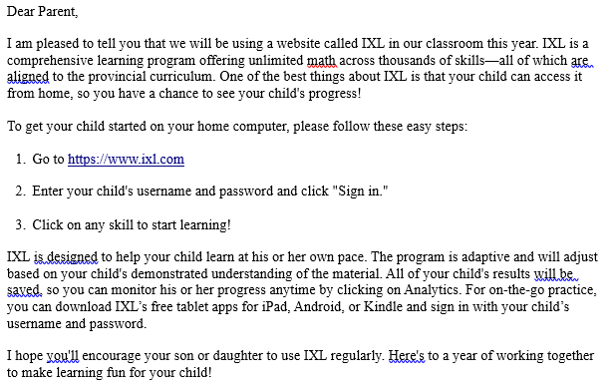  - www.sumdog.com  -Accounts have been set up with sum dog as well (username and passwords will be sent through email). Take this week to explore!  Info from site:  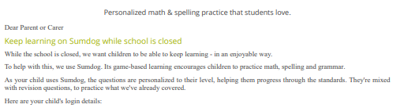  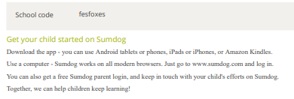  - Revisit game “La carte secrète” (now on on blog in “Math Activities” page)
Other areas of interest/learning experiences | STEAM:  How to draw a robin bird  https://www.youtube.com/watch?v=jyvfLcCiD-w  Rainbow challenge:  