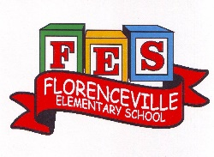
Florenceville Elementary School

At FES our vision is to be a community where everyone is empowered to be lifelong learners.

HOME LEARNING PLAN

Grade: | 2/3 Antworth
TEACHER | Dianne Antworth: dianne.antworth@nbed.nb.ca
Sarah Mahar  Bridget Nugent | Principal: sarah.mahar@nbed.nb.ca;  Vice-Principal: bridget.nugent@nbed.nb.ca
Cindy Crowhurst | Resource: cynthia.crowhurst@nbed.nb.ca
Dianne Lord | Guidance: dianne.lord@nbed.nb.ca
School | florencevilleelementary@nbed.nb.ca

In accordance with the communication sent from our Minister of Education, Dominic Cardy, on April 2, 2020, Home learning opportunities to support literacy and numeracy outcomes will be made available online weekly by Teachers.
Families are encouraged to:
-Support their children to complete the options below for an average of one hour per day.
-Read aloud with their children and have them read an additional 30 minutes daily; and
-consider daily physical activity, exploration, music, art, creating, free play, as an important part of their child’s mental health and skill development.
Subjects | Description of Learning Activities
Literacy | Spend a few minutes to set up Epic Student’s Home account, as some parents may have received e-mail. If not, please go to the link below and / or send me an email.  https://www.getepic.com/  Write Miss Antworth a letter, as everyone should have received something in the mail over the last few days😊
Numeracy | 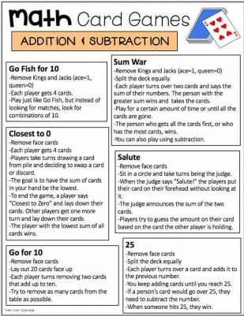
Other areas of interest/learning experiences | Art:  Using only materials found outside, create an Easter egg or Easter bunny!

