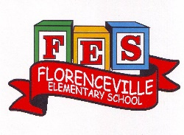
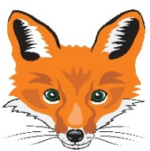
Florenceville Elementary School

At FES our vision is to be a community where everyone is empowered to be lifelong learners.

HOME LEARNING PLAN

Grade: | 2/3 Antworth
TEACHER | Dianne Antworth: dianne.antworth@nbed.nb.ca
Sarah Mahar  Bridget Nugent | Principal: sarah.mahar@nbed.nb.ca;  Vice-Principal: bridget.nugent@nbed.nb.ca
Cindy Crowhurst | Resource: cynthia.crowhurst@nbed.nb.ca
Dianne Lord | Guidance: dianne.lord@nbed.nb.ca
School | florencevilleelementary@nbed.nb.ca

In accordance with the communication sent from our Minister of Education, Dominic Cardy, on April 2, 2020, Home learning opportunities to support literacy and numeracy outcomes will be made available online weekly by Teachers.
Families are encouraged to:
Support their children to complete the options below for an average of one hour per day.
Read aloud with their children and have them read an additional 30 minutes daily; and
consider daily physical activity, exploration, music, art, creating, free play, as an important part of their child’s mental health and skill development.
Subjects | Description of Learning Activities May 25th – 29th
Literacy | Reading  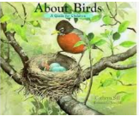  Option #1 About Birds – A Guide for Children by Cathryn Sill  https://www.youtube.com/watch?v=zTpO62xXX1E  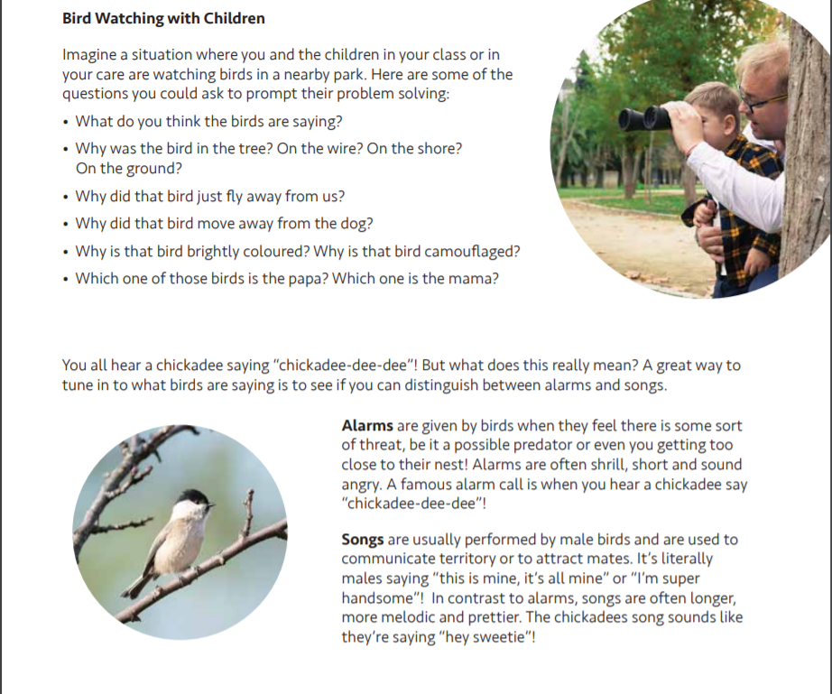  This will lead into our Writing / Science activities for the week  Activity Ideas:  Research a bird species or another animal that you may have seen or know that lives in your area or in our province of New Brunswick.  Use the Child friendly search engine, “Kiddle” (it’s Google for kids) to help them research. https://www.kiddle.co/  Option #2: Log into your Epic account and begin reading  www.epic.com (Parents have been sent emails. Please let me know if you are still having trouble logging in)  Log into your Raz-Kids account and begin reading  www.kidsa-z.com (All parents should have received an email. Please let me know if you haven’t received it or are having trouble logging in)  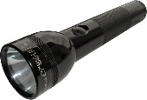  Option #3: Read books that you have at home. Try reading to a parent, sibling, stuffie, or find a quiet place to read to yourself. Get creative! Find a comfy spot outside to read.  Maybe have a FLASHLIGHT day!!  Literal response questions (read the lines): Find the page that tells us…..What happened first? Next? Who are the characters? What is the setting?  Inferential response questions (read between the lines): What does this picture tell us about the story? Why did this character say …..? How is this character feeling?  Personal Connections: Has anything like this happened to you? What is your favourite part and why? Does this character and yourself have anything in common?  When you’re reading this week, think about the characters you’ve met. (Suggestions)  - What’s the character (s) like?  - How is the character similar to you?  - How is the character different than you?  - How was the character feeling / acting?  New Spring Riddles / Thought Problems, “From 3 To 3”: Students can feel free to do both if they would like! Discuss the riddle and have them justify their answer (prove it based on the clues in the riddle). Remember the thought problem has a truth and a lie. Discuss what is true and what is not!  Step 1: Discuss it orally.  Step 2: Write about it – first with an illustration then 1-2 sentences.  Rhymes, Oral Story & Thought Problem  There Was An Old Man in a Barge  Help  Humpty Dumpty  Elephant and the Quarrel  Growing Up  Oral Story, The Leaky Bucket  Thought problem  https://drive.google.com/file/d/1dfR5fd2Bf3YVwGPALSKmtYJGW4L2VjHc/view?usp=sharing  Read Aloud  The Donkey and the Rock  https://drive.google.com/file/d/1RjOD_kHm1hiS3dNYy9HkKvoBhR8eddPS/view?usp=sharing  Read Aloud  Listen to Chapter five of the novel Seven Day Magic by Edward Eager:  https://drive.google.com/file/d/1aB4kpQ2wOqI68bL8xerklqdT-lQ4tsRw/view?usp=sharing  Writing Suggestions  - Read, write and draw about the bird or animal you researched that lives in New Brunswick.  - What do they look like?  - What do they eat?  - What does it need in it’s surrounding to survive? (Habitat)  - Any interesting facts?  - Other information you find.  - Create a LIFE CYCLE – thinking back to our growth tower in the class Use play dough, materials you may find around your home or draw / create a poster and please send a picture to me to share  - Write in your personal journal / continue keeping a diary similar to WORM.  - Make a word web for a feelings word or a word web of all the feelings a character had from a story you read.  - Write out your list of similarities and differences between you and one of your characters that you chose from your reading.
Numeracy | Continue with mental math games and log into your sumdog account.  Are you trying the challenges?!?  Classroom Games to Review at HOME  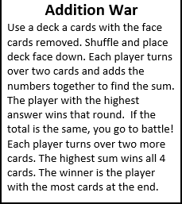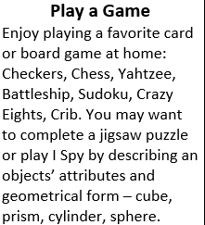  Measurement Continued  Option 1:  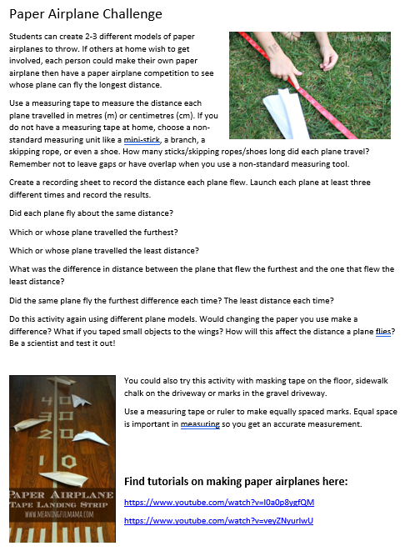  Option 2:  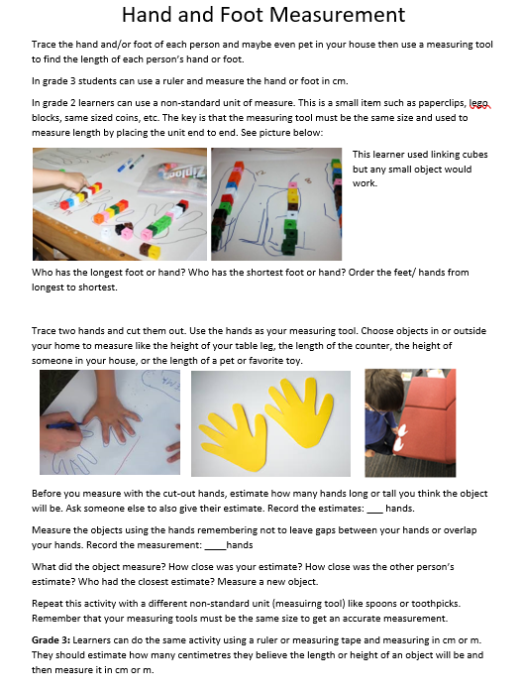  Option 3:  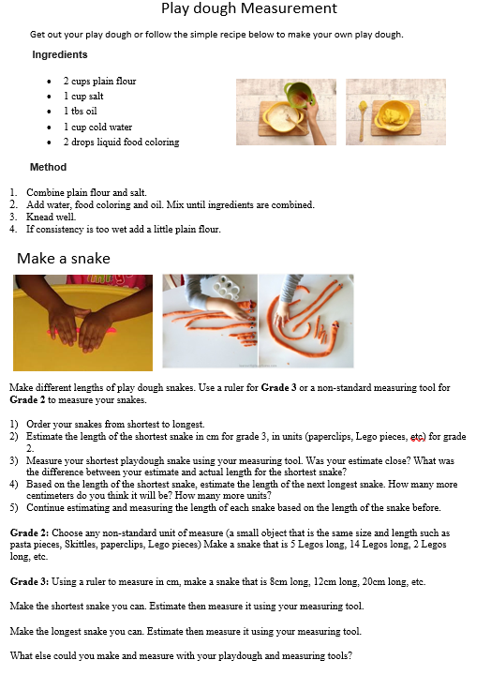

Other areas of interest/learning experiences | Art / Science / Outside Suggestions  Option 1: Make a birdhouse from recycled materials at home…  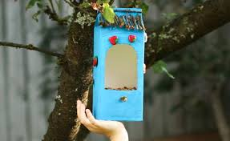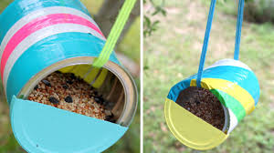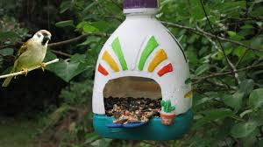  I can make a bird house!  - Use recycled materials.  - Use my creativity.  Then ask a parent to post your bird house.  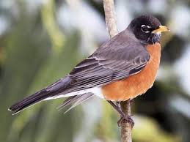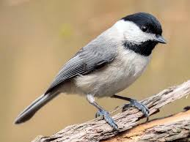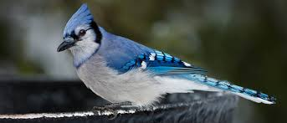  Option 2: Draw outside with your sketchbook  - Sketchbooks were sent home when families came to get things from the school  -Take your sketchbook outside and draw in nature!

