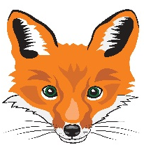
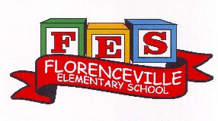
FLORENCEVILLE ELEMENTARY SCHOOL
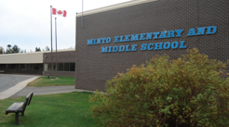
At FES our vision is to be a community where everyone is empowered to be lifelong learners.
PRIMARY HOME LEARNING PLAN

Grade: | 1/2
TEACHER | Andree Charlebois : andree.charlebois@nbed.nb.ca
Sarah Mahar  Bridget Nugent | Principal: sarah.mahar@nbed.nb.ca; Vice-Principal: bridget.nugent@nbed.nb.ca;
Cindy Crowhurst | Resource: cynthia.crowhurst@nbed.nb.ca
Dianne Lord | Guidance: dianne.lord@nbed.nb.ca
School | florencevilleelementary@nbed.nb.ca

In accordance with the communication sent from our NB Minister of Education, Dominic Cardy, on April 2, 2020 Home learning opportunities to support literacy and numeracy outcomes will be made available online weekly by teachers.

Families are encouraged to:
-support your children to complete the options below for an average of one hour per day
-read aloud with their children daily
-consider daily physical activity and free play as an important part of their child’s mental health and skill development.

Subjects | Description of Learning Activities – Week of May 11th – 15th
Literacy | Activity 1: Keep doing the Literacy and Math activities from the following websites. I received an email from IXL to tell me that my students have answered 2500 Math questions in just 2 weeks! Wow!! I’m so impressed!  https://www.getepic.com/  https://www.abcya.com/  https://www.starfall.com/h/  https://ca.ixl.com/  Activity 2: I am enjoying reading your letters for those who are writing back to me! Thank you so much! Please write to me – I love hearing from you!  Also write a letter to a family member or a friend!  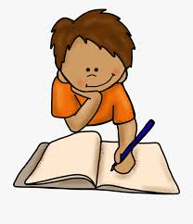  Activity 3:  Enjoy reading “The Rainbow Fish”  https://www.youtube.com/watch?v=QFORvXhub28  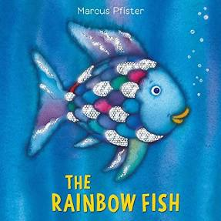  We have read this in class and the students really enjoyed it!  *As you read it together, think about how you are like the Rainbow Fish and how you are like the little blue fish. Who can you turn to for advice (like the octopus)?  *What do you think is the message in this story? (It is about kindness, sharing, helping others).  *Discuss the vocabulary – ask your child what “million dollar” words the author used (really good descriptive words)?  Activity 4: Word Work (Gr. 2 but if students in Gr. 1 want to play, go for it!)  See the attachments to this email. Have fun playing the 2 Snakes and Ladders games with the same sounds /au/ and /aw/. If you can’t print it, draw it on paper!  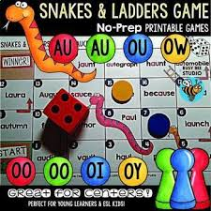  Activity 5: “From 3 to 3” Oral Program: Continue to have fun with these new Spring rhymes and oral story! All students can enjoy both the gr. 1 and 2 rhymes!  Gr. 1: https://www.youtube.com/watch?v=1F_KY__nddA  Gr. 2: https://drive.google.com/file/d/1jL_YPE4XatNQMY46EqSY_AnDbduAaMnZ/view  Activity 6: Word Work: Sound Toss  Outdoor Fun!! With outside chalk, write down these blends and digraphs on the pavement. Toss a rock or stick, say the sound and a word that has that sound (either at the beginning, middle or end of the word). See the attachment in this email.  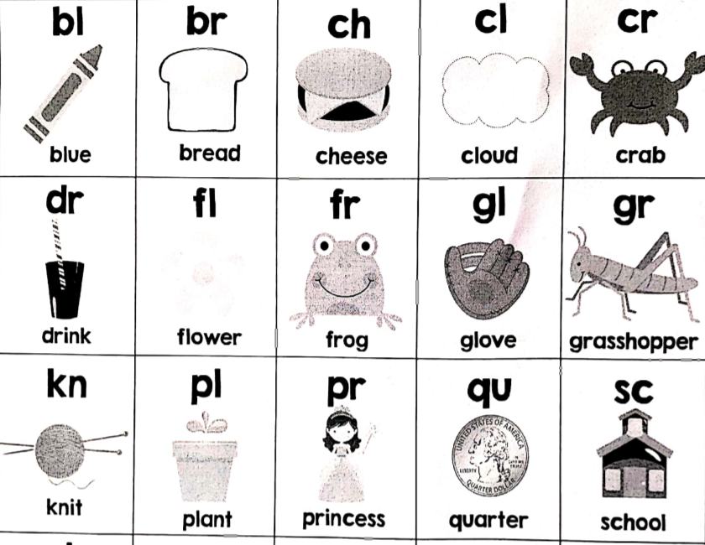
Numeracy | Activity 1: Addition and Subtraction Facts Practice. Keep practicing and have fun timing yourself! See the attachments for a new addition/subtraction facts sheet. Remember: answer the ones you know first then use your mental math strategies to solve the rest (doubles +/- one, +/- two; doubles; partner numbers to 10).  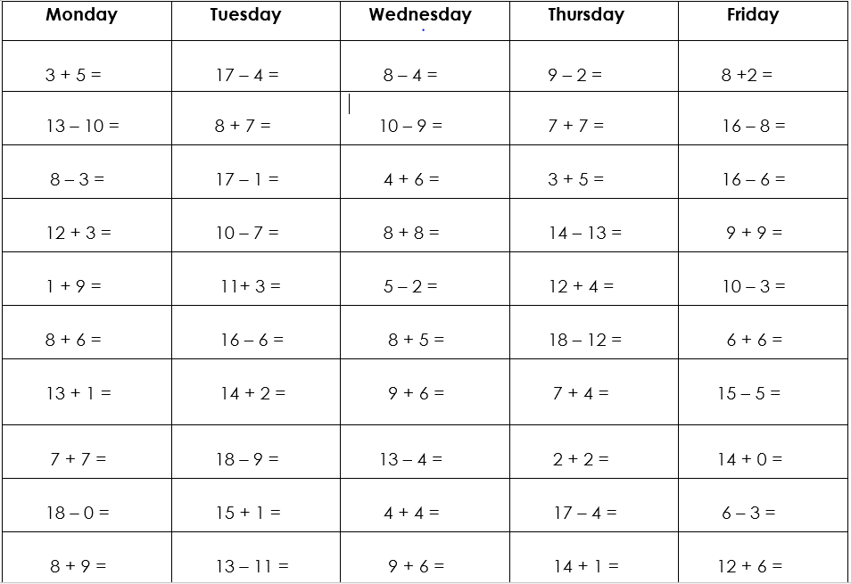  Activity 2: Graphing!  Step 1: Go outside with your family and look at all the things you can collect in nature: rocks, sticks, pinecones, and leaves you see (these are just examples). Record the data (see below) using tally marks. Below is an example.  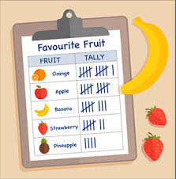  Step 2: Create a pictograph to show your findings! Remember to include a title and labels.  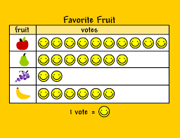  Activity 3: Place Value (tens and ones)  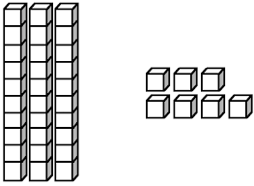  We have been working with base ten models in Gr. 2 but if your child in grade 1 is ready to use them, please have fun with this activity!  *Draw some base ten models and cut them out.  *Or use popsicle sticks (put an elastic around a group of 10) or bags of macaroni and this represents a group of 10.  *Lay out the models or bags and ask your child “How many?”  See the example on the next page.  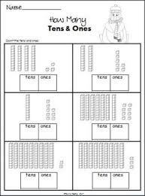  First question: Have your child count by tens first, “10, 20, 30, 40 then ones…. 41, 42, 43. Have them write the answer on their whiteboard.  **Please see the attachments “Seven Hats Base Ten” and “Place Value with Tens and Ones” for more practice! If you cannot print these, draw your own!  Also: A fun game! Create your own – have one partner close their eyes, create a number with the base ten materials (or bags of 10 and ones) and the person opens their eyes and guesses the number! Take turns.  Activity 4: Continue to work on Math problems with:  https://ca.ixl.com/
Other areas of interest/learning experiences | Outside Play: Go for a walk and find things to graph (see details above).  Phys. Ed: Have fun dancing and skip counting with Jack Hartmann:  https://www.youtube.com/watch?v=q_yUC1NCFkE  Count by 5s Fitness Fiesta with Jack Hartmann:  https://www.youtube.com/watch?v=Sh8YmvJuJ8A  Keep “Moving with Purpose” – see attachment that was sent last week with fun activities for each day of the month of May!

