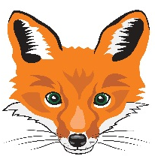
FLORENCEVILLE ELEMENTARY SCHOOL
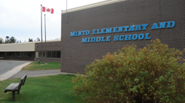
At FES our vision is to be a community where everyone is empowered to be lifelong learners.
PRIMARY HOME LEARNING PLAN

Grade: | 1/2
TEACHER | Andree Charlebois : andree.charlebois@nbed.nb.ca
Sarah Mahar  Bridget Nugent | Principal: sarah.mahar@nbed.nb.ca; Vice-Principal: bridget.nugent@nbed.nb.ca;
Cindy Crowhurst | Resource: cynthia.crowhurst@nbed.nb.ca
Dianne Lord | Guidance: dianne.lord@nbed.nb.ca
School | florencevilleelementary@nbed.nb.ca

In accordance with the communication sent from our NB Minister of Education, Dominic Cardy, on April 2, 2020 Home learning opportunities to support literacy and numeracy outcomes will be made available online weekly by teachers.

Families are encouraged to:
-support your children to complete the options below for an average of one hour per day
-read aloud with their children daily
-consider daily physical activity and free play as an important part of their child’s mental health and skill development.

Subjects | Description of Learning Activities – Week of June 8th – 12th  **PLEASE RE-VISIT ACTIVITIES FROM PREVIOUS PLANS**
Literacy | Activity 1: Continue to read, read, read!! There are hundreds of books on the following sites:  https://www.getepic.com/  https://www.abcya.com/  https://www.starfall.com/h/  www.kidsa-z.com  ***Epic sent me an email to say my students have read 172 books – YAY!!! Well done!! ***  Activity 2: Watch a movie!  Enjoy a movie with your family! (I love movies!) Afterwards, discuss your favourite part. Discuss the characters, setting (where it takes place), the adventure/problem and ending (was the problem solved?) Did it end the way you thought it would? Can you think of another ending? Can you relate to any of these characters or situations? Did you like a particular character? Why do you like this character?  Activity 2: Continue to enjoy “From 3 To 3” rhymes/oral stories. Feel free to watch both grades!  Grade 1 with Kristina: https://www.youtube.com/watch?v=V6PInjC85RE&feature=youtu.be  Grade 2 with Karah:  https://drive.google.com/file/d/1GXsBpR0n7koqRDi0uhWaXBaH0hZL_UBW/view  Read aloud “The Story of Thunder and Lightning”:  https://drive.google.com/file/d/1snWHyh6i2RaTnjffCQKsdDgTzc51e-s4/view  Activity 3: Read aloud/Reading Response to “My Many Colored Days” by Dr. Seuss  https://www.youtube.com/watch?v=iR0-5f-L_LQ  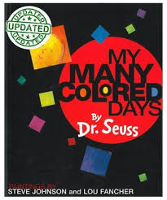  We have talked a lot about our feelings in class (especially with the Gr. 2 students with our “Zones of Regulation”: green is feeling calm, focused; yellow: unfocused, distracted; blue: sad, lazy and red: angry)! Discuss these with your child and the calming strategies that we have used to get back into the “green” zone.  This is a very stressful time for both adults and children! Discuss their feelings with each colour (as well as the other colours included in the book). What other strategies could your child (and other adults) use to help you become calm again? I like to go for a walk or listen to calming music (spa music or nature sounds). I also practice yoga.  Activity 3: Have fun writing! Choose one or all of them!!  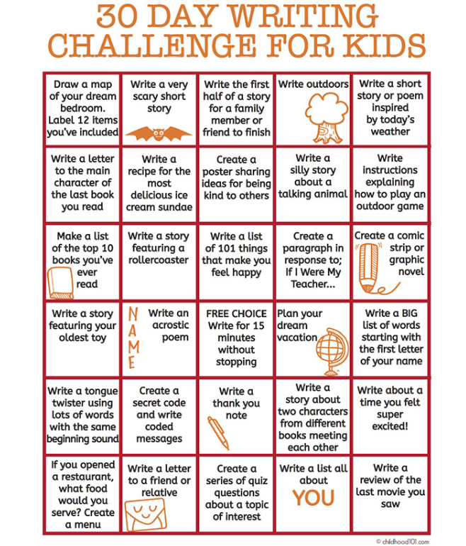
Numeracy | Activity 1: Continue having fun playing math activities from the following site!  Math Playground.com: https://www.mathplayground.com/math-games.html  Activity 2: Math/Art: Roll a Monster!  Roll a die and follow the chart to draw your monster. Colour it! Have fun! Perhaps write a story about your monster.  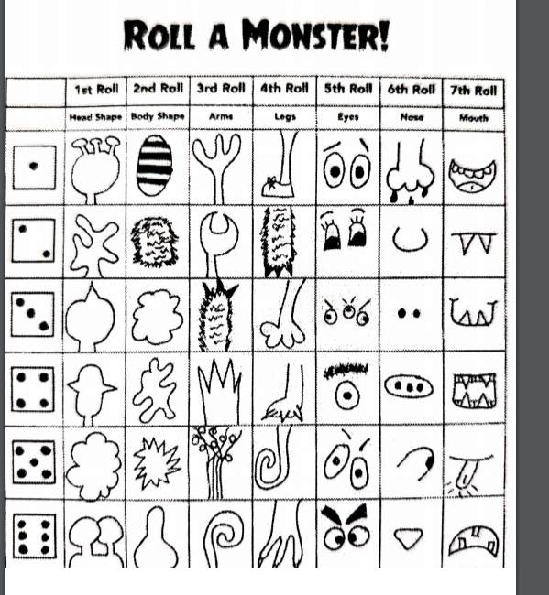  Activity 3: Card game “Doubles Go Fish”  Listen to this Jack Hartmann video: “Adding Doubles”  https://www.youtube.com/watch?v=NDqbCfplYrg&list=RDNDqbCfplYrg&start_radio=1  - Deal 5 cards to each player.  - Shuffle the remaining cards and place between the players face down.  - Each player puts down any doubles AND THEY HAVE TO TELL THE OTHER PLAYERS THE SUM. So if you put down 2 and 2, you say, “ 2 + 2 = 4).  - Take turns and ask if others have a particular card. If not, you say “Go Fish”.  - If a player runs out of cards, they take 5 from the pile in the middle.  - Play until the cards are done. The winner has the most pairs of cards but we ALL win!  Activity 4: Math Choice Board. Have fun with these different activities!  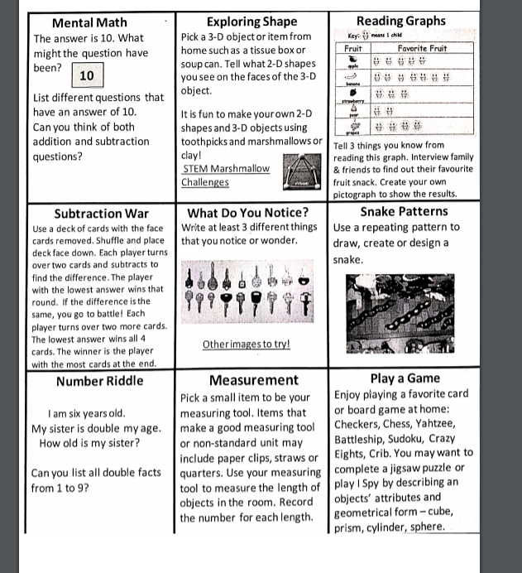  Activity 5: Math Through Art!  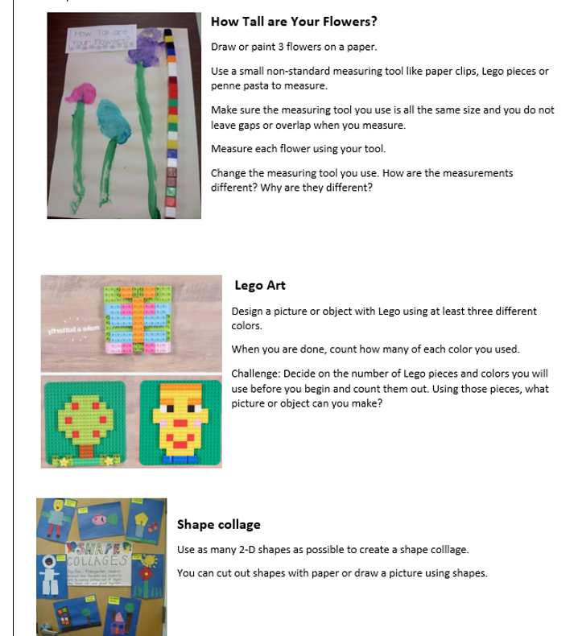
Other areas of interest/learning experiences | French: French Colours: “J’aime les voitures”  https://www.youtube.com/watch?v=IaaSprb0IXk  “Les Mois de l’annee (months of the year): https://www.youtube.com/watch?v=7_u2SigckNQ  Activity 1: Phys. Ed:  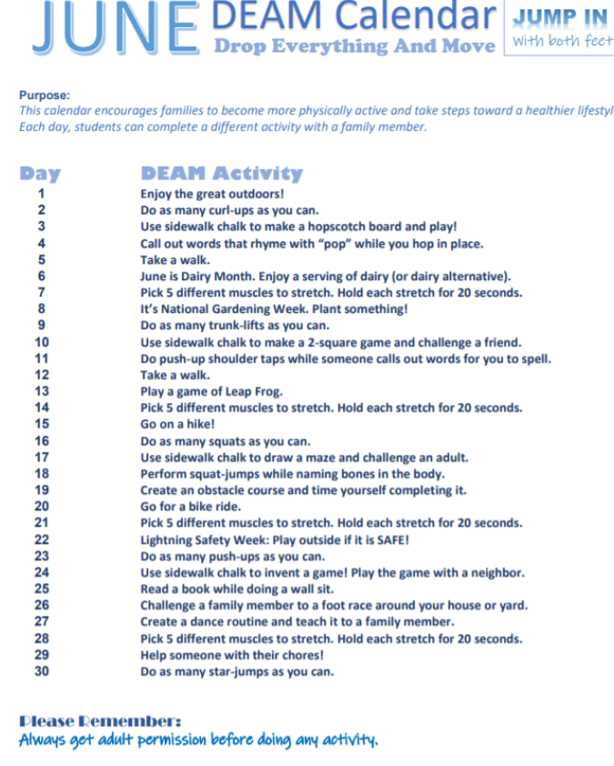  Activity 2: Phys Ed: Exercise Bingo! Play this game and have fun!  